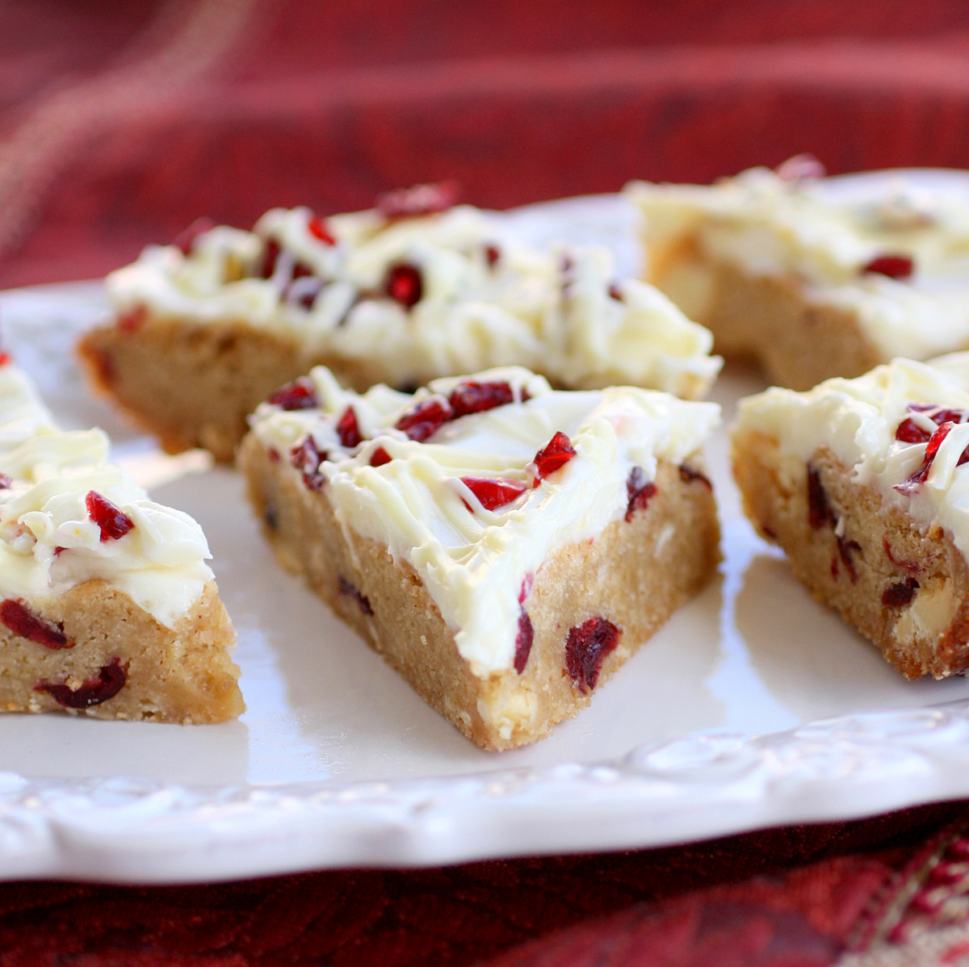
Cake
3/4 cup (1 1/2 sticks) butter, softened
1 1/4 cups packed light brown sugar
3 eggs
2 tablespoons minced crystallized ginger
1 1/2 teaspoons vanilla extract
1/2 teaspoon salt
1 1/2 cups all-purpose flour
1/2 teaspoon baking powder
3/4 cup chopped sweetened dried cranberries
4 ounces white chocolate, cut into chunks

Frosting
4-ounces cream cheese, softened
3 cups powdered sugar
4 teaspoons lemon juice
1 teaspoon vanilla extract

Also
1/4 cup chopped sweetened dried cranberries

Drizzled Icing
1/2 cup powdered sugar
1 tablespoon milk
2 teaspoons vegetable shortening

1. Preheat the oven to 350 degrees F.

2. Make cake by beating the butter and brown sugar together with an electric mixer until smooth. Add the eggs, ginger, vanilla, and salt and beat well. Gradually mix in the flour and baking powder until smooth. Mix the chopped dried cranberries and white chocolate chunks into the batter by hand. Pour the batter into a buttered 9 x 13-inch baking pan. Use a spatula to spread the batter evenly across the pan. Bake for 25 to 30 minutes, or until the cake is lightly browned on top. Allow the cake to cool.

3. Make the frosting by combining the softened cream cheese, powdered sugar, lemon juice, and vanilla in a medium bowl with an electric mixer until smooth. When the cake has cooled, use a spatula to spread the frosting over the top of the cake.

4. Sprinkle 1/4 cup of chopped dried cranberries over the frosting on the cake.

5. Make the drizzled icing by whisking together powdered sugar, milk, and shortening. Drizzle this icing over the cranberries in a sweeping motion with a squirt bottle or fill a small plastic storage bag with the icing and cut off the tip of one corner.

6. Cover the cake and let it chill out in the fridge for a couple hours, then slice the cake lengthwise (the long way) through the middle. Slice the cake across the width three times, making a total of eight rectangular slices. Slice each of those rectangles diagonally creating 16 triangular slices.

Makes 16 bars.

