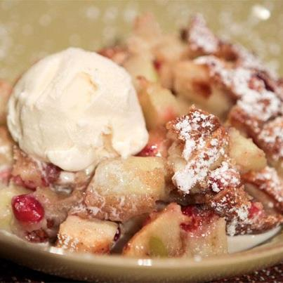
Apple-Cranberry Cobbler (Clinton Kelly's)

For the Cobbler Filling:
5 granny smith apples (peeled and chopped)
1 cup cranberries
1/4 cup white sugar
1/4 cup brown sugar
1/2 teaspoon ground cinnamon
1/8 teaspoon nutmeg
2 teaspoons cornstarch
1 lemon (juiced)
Generous pinch of salt

For the Cobbler Topping:
3/4 cup milk
1 cup AP flour
1/2 cup sugar
2 teaspoons baking soda
2 pinches of salt

8 tablespoons butter

Preheat oven to 350 degrees F.

Toss together all ingredients for the cobbler filling.

In a separate bowl, whisk together the topping ingredients.

Put the 8 tbsp butter in the pie dish and place in oven until melted. Remove dish from the oven and fill with the fruit mixture. Pour cobbler topping over the fruit.

Bake for approximately 1 hour, or until the juices are bubbling and the cobbler is golden. Tent with foil if the cobbler is getting too brown.

