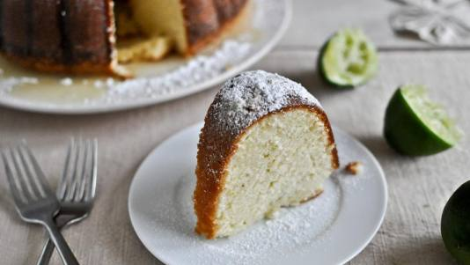
Limed-Up Cream Cheese
Pound Cake

Ingredients
- 1 1/2 cups (3 sticks) unsalted butter, at room temperature
- 1 (8-ounce) block cream cheese, at room temperature
- 3 cups sugar
- 6 large eggs, at room temperature
- 3 cups all-purpose flour, sifted
- 1/4 teaspoon salt
- 1 1/2 teaspoons vanilla extract
- 1/4 teaspoon almond extract
- Finely grated rind and juice of 1 lime

- Lime Glaze:
- 1/4 cup (1/2 stick) butter
- 1/4 cup sugar
- 3 tablespoons lime juice
- 1/4 cup powdered sugar, optional for garnish

Directions
- Preheat oven to 325F. Grease a 12-cup Bundt pan.
- To prepare cake, in a large mixing bowl, cream butter, cream cheese and sugar together on low speed for about 10 minutes until light and fluffy.
- Beat in eggs alternately with flour, mixing well after each addition; add salt, vanilla, almond extract, lime juice and peel.
- Mix until combined. NOTE: Be careful to not overbeat the eggs. If you do it could dry the cake out.
- Pour the batter into a prepared pan. Bake for 1 1/2 hours or until a toothpick or cake tester inserted in the center of the cake comes out clean.
- Allow to cool for 10 minutes. Turn onto cake plate. While cake is still warm prick top with toothpicks and pour hot glaze over warm cake.
- To prepare glaze, combine sugar, butter and lime juice in a sauce pan, bring to a boil; continue to boil for 1 minute.
- Drizzle slowly over warm cake.
- Cool cake completely before slicing.

