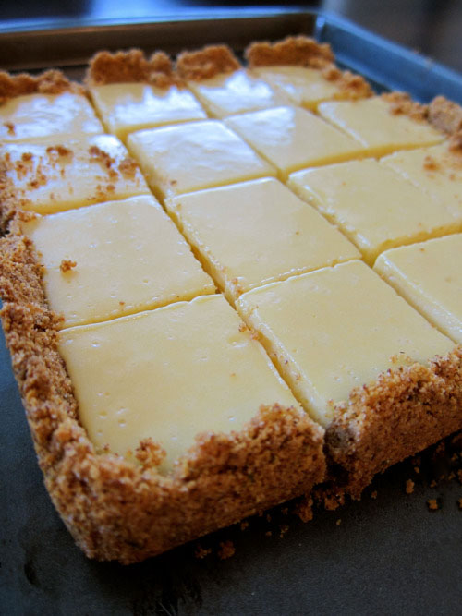
Ingredients

For The Crust
4 tablespoons (1/2 stick) unsalted butter,
melted and cooled, plus more for pan
2/3 cup almond flour or ground nuts (any you prefer)
1 cup (4 ounces) graham-cracker crumbs
1/4 cup sugar
1 tablespoons grated lime zest

For The Filling
2 large egg yolks
1 can (14 ounces) sweetened condensed milk
1/2 cup fresh lime juice (around 5 medium limes)
2 tablespoons fresh lemon juice (around 1 medium lemon)

Directions

1. Preheat oven to 350 degrees. Brush an 8-inch square baking dish with melted butter. (This step is important because it will make it easy for you to remove the parchment paper later.) Line bottom with parchment paper, leaving a 2-inch overhang on two sides.

2. To make the crust: Whisk almond flour/ground nuts with graham-cracker crumbs, sugar, and zest. Mix in butter. Press mixture into bottom and 1 inch up sides of prepared pan. Bake until lightly browned, 8 to 12 minutes. Cool crust, 30 minutes.

3. To make the filling: In a large bowl, whisk together egg yolks and condensed milk. Add lime juice and lemon juice; whisk until smooth. Pour filling into cooled crust; carefully spread to edges.

4. Bake until set, about 15 minutes. Cool in pan on rack; then chill at least 1 hour before serving. Using parchment paper overhang, lift out of pan, and transfer to a cutting board. With a serrated knife, cut into 16 squares, wiping knife with a damp kitchen towel between each cut.

