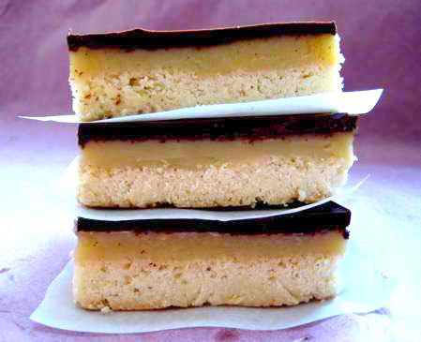
Million Dollar Shortbread

Ingredients
- 8 ounces (2 sticks) unsalted butter, softened at room temperature
- 3 cups sugar
- 2 1/4 cups flour
- 1/4 cup cornstarch
- 1/2 cup water
- 2 tablespoons salted butter
- 1/2 cup heavy cream, heated to lukewarm
- 8 ounces semisweet chocolate
- 1 1/2 teaspoons vegetable oil

Directions
Preheat the oven to 350 degrees F. Line a 9 by 13-inch baking pan with parchment or waxed paper. In a mixer fitted with a paddle attachment (or using a hand mixer), cream 8 ounces butter until soft. Add 1/2 cup of the sugar and mix until incorporated.

In a separate bowl, stir together the flour and cornstarch. Add the dry ingredients to the butter mixture and mix at low speed just until the ingredients are incorporated and the dough comes together. Turn the dough onto a floured work surface and knead it 5 to 10 times, to bring the dough together and smooth it out. Re-flour your work surface. With a rolling pin, roll the dough out to fit the sheet pan. To transfer to the sheet pan, roll the dough up onto the rolling pin, lift it up, and unroll into the pan. Using light strokes of the rolling pin, roll the dough into the corners and edges of the pan, and roll out any bumps (or press the rolled-out dough thoroughly into the pan with your fingers). Prick the shortbread all over with a fork to prevent any buckling or shrinking.

Bake in the center of the oven for 15 minutes. After 15 minutes, rotate the pan and knock it once against the oven rack, to ensure even cooking and a flat surface. Bake 10 to 15 minutes more, until very lightly browned. Let cool in the pan.

Pour the remaining 2 1/2 cups sugar into the center of a deep saucepan. Carefully pour the water around the sugar, trying not to splash any sugar onto the sides of the pan. Do not stir; gently draw your finger through the center of the sugar twice, making a cross, to moisten it. Over medium-high heat, bring to a boil without stirring. Reduce the heat to a fast simmer and cook without stirring until amber-caramel in color, 10 to 20 minutes. Immediately remove from the heat and stir in 2 tablespoons butter with a wooden spoon. Slowly and carefully pour in the lukewarm cream, stirring slowly but constantly (it will bubble up and may splatter). Pour over the baked shortbread and smooth the top. Place in the refrigerator, uncovered, to harden slightly.

When the caramel has set, melt the chocolate in the top of a double boiler (or in a mixing bowl) set over barely simmering water, stirring frequently. Stir in the vegetable oil (this will make the chocolate less brittle when it hardens). Pour over the cooled caramel and spread quickly with the back of a spatula or spoon to cover the entire surface. Let cool in the pan. With a heavy knife, cut into 1 1/2-by-3-inch bars. Store in an airtight container.

