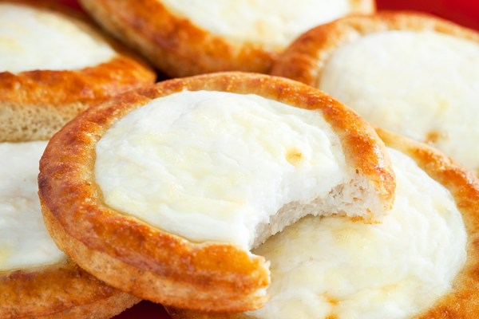
New York Cheesecake Cookies
1 1/4 cups finely crushed graham crackers (1 sleeve)
1 cup flour
1 1/2 teaspoons baking powder
1 stick (8 tablespoons) unsalted butter, softened
1/2 cup packed brown sugar
1 egg, separated
3 ounces cream cheese, softened
1/4 cup granulated sugar
2 teaspoons lemon zest
1/2 teaspoon vanilla extract
Preheat the oven to 350 degrees F.
In a large bowl, stir together the graham cracker crumbs, flour and baking powder. In a medium bowl, beat together the butter with the brown sugar using an electric hand mixer. Add the egg white and beat until well combined. Add to the graham cracker crumbs and blend until just combined.
In a separate medium bowl, beat together the softened cream cheese with the granulated sugar, egg yolk, lemon zest and vanilla until well combined. Set aside.
Using a small ice cream scoop, scoop out the cookie dough and place on a nonstick or parchment lined baking sheet. (If you do not have an ice scoop, then measure out the dough into scoops of about 2 tablespoons.) Flatten slightly, pressing your thumb in the center of the ball to create a small bowl shape. Repeat with the remaining dough. Spoon the cream cheese into the indents in the cookies.
Bake until the filling is barely set and the cookies are lightly golden, 12 minutes. Allow to cool 5 minutes on the baking sheets before removing them and cooling completely on a wire rack.

