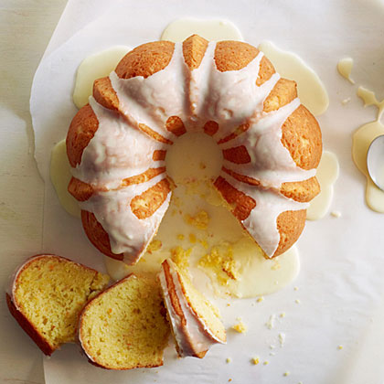
Orange Cake

Ingredients
- Cooking-oil spray
- 1 cup butter, softened
- 1 1/4 cups granulated sugar
- 3 large eggs
- 2 oranges (about 1 lb. total), ends
trimmed, then cut into chunks and seeded
- 2 1/2 cups flour
- 1/4 teaspoon salt
- 1/4 teaspoon baking soda
- 1/2 teaspoon baking powder
- 1 1/2 cups powdered sugar
- 2 tablespoons plus 1 tsp. orange juice

Preparation
- Preheat oven to 325°. Coat a 10-cup Bundt pan with cooking-oil spray. In a large bowl with a mixer on medium speed, beat butter and granulated sugar until fluffy. Beat in eggs.

- Whirl orange chunks in a food processor until mostly smooth but not puréed. Add 1 1/2 cups orange mixture to batter and beat until blended. Add flour, salt, baking soda, and baking powder to bowl and beat until smooth. Spread batter in prepared pan.

- Bake until a toothpick inserted in the center comes out with only a few crumbs clinging to it, about 55 minutes. Cool pan on a rack 10 minutes, then invert cake onto rack and let cool completely.

- Whisk together powdered sugar and orange juice in a small bowl. Drizzle over cooled cake. Let glaze set, then slice cake.

