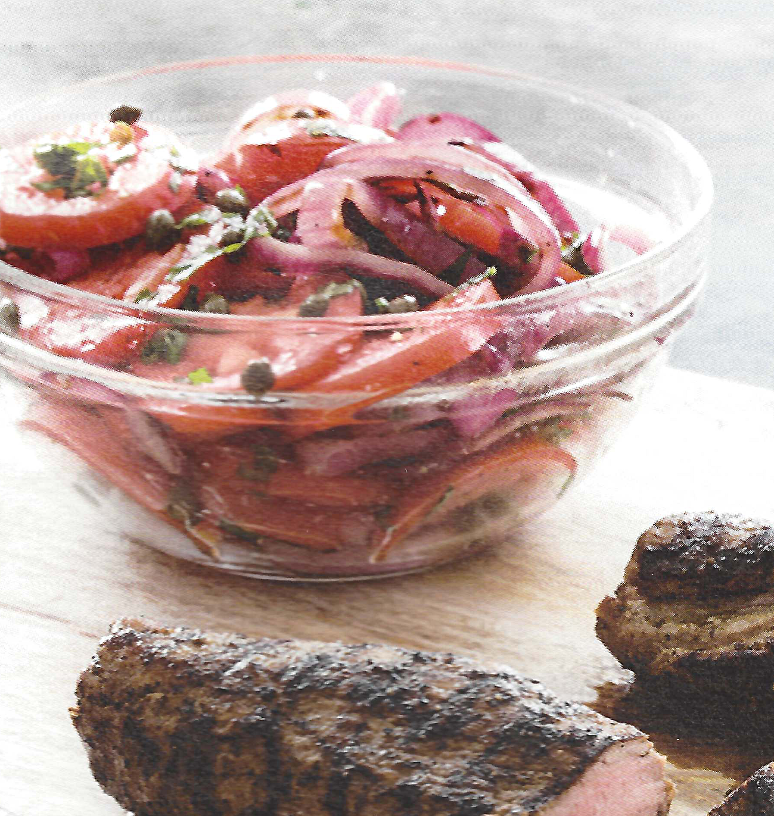
Tomato and Onion Salad (Cook’s Country)

1 red onion, sliced into ¼-inch-thick rounds
4 plum tomatoes, cored and sliced ¼ inch thick
¼ cup chopped basil
2 tbs capers, rinsed
2 tbs red wine vinegar

Olive oil
Salt and pepper

Brush onion with olive oil and sprinkle with salt and pepper. Grill onion over hot fire until lightly charred, about two minutes per side; transfer to large bowl. Add tomatoes, basil, capers, vinegar, and two tablespoons olive oil to the bowl with the onion. Toss to combine. Season with salt and pepper.

