Colombian Avocado Salsa (Ají de Aguacate)

4 scallions, cut into 1-inch lengths
2 Anaheim chilies, stemmed, seeded and cut into rough 1-inch pieces
1 habañero chili, stemmed and seeded
1¼ cups lightly packed cilantro leaves and tender stems
2 tablespoons white vinegar
Kosher salt
3 ripe avocados, halved and pitted
3 hard-cooked large eggs, peeled and chopped
2 tablespoons lime juice
1 plum tomato, finely chopped

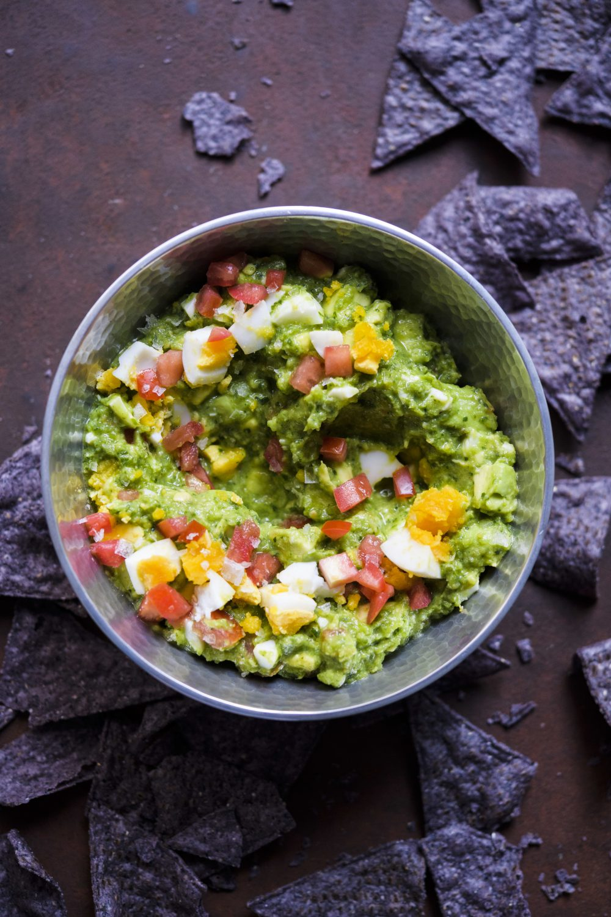
In a food processor, process the scallions and all 3 chilies until finely chopped, about 20 seconds. Add the cilantro, vinegar and 1½ teaspoons salt. Process until the cilantro is finely chopped, about 10 seconds, scraping the sides of the bowl as needed.

In a medium bowl, mash the flesh from 2 avocado halves and ⅓ of the chopped eggs with a fork until mostly smooth but with some lumps. Coarsely chop the remaining 4 avocado halves and transfer to the bowl. Add the lime juice and fold with a rubber spatula to combine.

Reserve 2 tablespoons of the chopped tomato and 2 tablespoons of the remaining chopped eggs for garnish. Mix the remaining tomato and eggs into the avocado mixture, then gently fold in the chili-cilantro mixture. Taste and season with salt.

