Salmon Candy

1 2- to 3-pound salmon fillet, skinless, preferably center-cut and wild-caught
1 cup dark brown sugar
1/4 cup kosher salt
1/2 cup pure maple syrup, preferably Grade B, plus more for glazing the fish
1 quart spring water

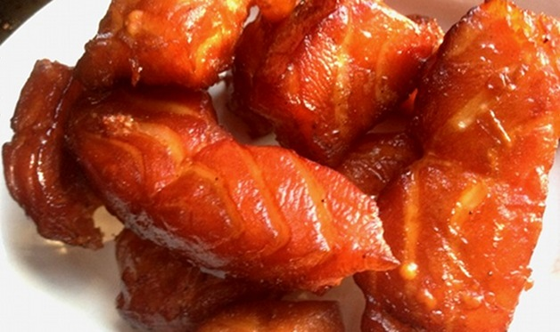
Step 1: Run your hand over the fillet to check for pin bones. Remove any you find with a kitchen tweezers or needle-nose pliers.

Step 2: Using a sharp knife, slice the salmon against the grain into strips about 1/2 inch wide and 4 to 5 inches long. (For chewier salmon candy, slice the fish lengthwise with the grain.) Transfer to a sturdy resealable plastic bag and place the bag in a bowl or baking pan.

Step 3: In a mixing bowl, combine the brown sugar, salt, and 1/2 cup maple syrup. Add the water and stir until the sugar and salt crystals dissolve. Pour this mixture over the salmon and seal the bag. Refrigerate for 8 to 12 hours.

Step 4: Drain the salmon and rinse thoroughly under cold running water. Drain well in a colander and blot dry. Discard the brine.

Step 5: Set up the grill for indirect grilling: If using a charcoal grill, place a large drip pan in the center, preheat the grill to low, then toss 1 cup of the wood chips or chunks on the coals. If using a smoker, fire it up according to the manufacturer’s instructions and preheat to low.

Step 6: When ready to cook, brush and oil the grill grate. (Salmon has a tendency to stick, so do not skip this step.) Smoke the salmon over low heat (180 to 200 degrees), replenishing the wood chips or chunks as needed, for 3 hours. Brush the salmon pieces with maple syrup, turning as needed. Continue to smoke for 1 to 2 hours more, or until the salmon is dried to your satisfaction, glazing once or twice more with the maple syrup.

Step 7: Allow the salmon to cool completely, then transfer to a resealable plastic bag and refrigerate. The “candy” will keep for at least 5 days, and likely a good deal longer.

