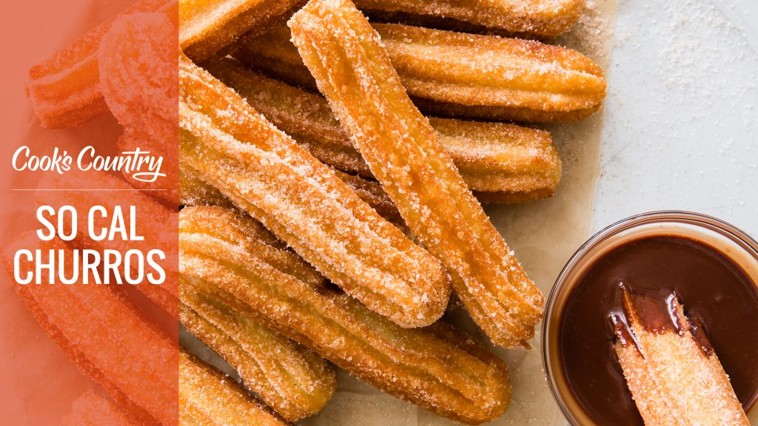So Cal Churros, brought to you by Cook’s Country, airing Sundays on THIRTEEN. Watch how this pastry dessert is made on the episode airing Sunday, November 26, 5pm – Straight from So-Cal.
Show us your cooking skills and win a Cook’s Country Prize Pack!

Why This Recipe Works
These fluted, fried pastries should be crispy on the outside and soft on the inside, much like a cream puff. Many recipes called for piping the dough directly into a vat of hot oil, but we found this process to be not only hectic but also dangerous—splashing oil made a mess of the stovetop and threatened to burn our hands and forearms. Instead, we piped dough logs onto a rimmed baking sheet and slipped them into the frying oil in batches to minimize the splashing. Piping while the dough was still warm helped us get the stiff dough through the small opening in our piping bag without a fight.

Ingredients and Directions
Makes About 18 Churros
We used a closed star #8 pastry tip, ⅝ inch in diameter, to create deeply grooved ridges in the churros. However, you can use any large, closed star tip of similar diameter, though your yield may vary slightly. It’s important to mix the dough for 1 minute in step 2 before adding the eggs to keep them from scrambling.

Dough
2 cups water
2 tablespoons unsalted butter
2 tablespoons sugar
1 teaspoon vanilla extract
½ teaspoon salt
2 cups (10 ounces) all-purpose flour
2 large eggs
2 quarts vegetable oil

Chocolate Sauce
¾ cup heavy cream
4 ounces semisweet chocolate chips
Pinch salt
¼ teaspoon vanilla extract

Coating
½ cup (3½ ounces) sugar
¾ teaspoon ground cinnamon
1. FOR THE DOUGH: Line rimmed baking sheet with parchment paper and spray with vegetable oil spray. Combine water, butter, sugar, vanilla, and salt in large saucepan and bring to boil over medium-high heat. Remove from heat; add flour all at once and stir with rubber spatula until well combined, with no streaks of flour remaining.
2. Transfer dough to bowl of stand mixer. Fit mixer with paddle and mix on low speed until cooled slightly, about 1 minute. Add eggs, increase speed to medium, and beat until fully incorporated, about 1 minute.
3. Transfer warm dough to pastry bag fitted with ⅝-inch closed star pastry tip. Pipe eighteen 6-inch lengths of dough onto prepared sheet, using scissors to snip dough at tip. Refrigerate, uncovered, for at least 15 minutes or up to 1 hour.
4. Adjust oven rack to middle position and heat oven to 200 degrees. Set wire rack in second rimmed baking sheet and place in oven. Line large plate with triple layer of paper towels. Add oil to large Dutch oven until it measures about 1½ inches deep and heat over medium-high heat to 375 degrees.
5. Gently drop 6 churros into hot oil and fry until dark golden brown on all sides, about 6 minutes, turning frequently for even cooking. Adjust burner, if necessary, to maintain oil temperature between 350 and 375 degrees. Transfer churros to paper towel–lined plate for 30 seconds to drain off excess oil, then transfer to wire rack in oven. Return oil to 375 degrees and repeat with remaining dough in 2 more batches.
6. FOR THE CHOCOLATE SAUCE: Combine cream, chocolate chips, and salt in bowl and microwave at 50 percent power, stirring occasionally, until melted, about 2 minutes. Stir in vanilla until smooth.
7. FOR THE COATING: Combine sugar and cinnamon in shallow dish. Roll churros in cinnamon sugar, tapping gently to remove excess. Transfer churros to platter and serve warm with chocolate sauce.

