FLATBREAD, BROWN GARLIC BUTTER & ANCHOVIES
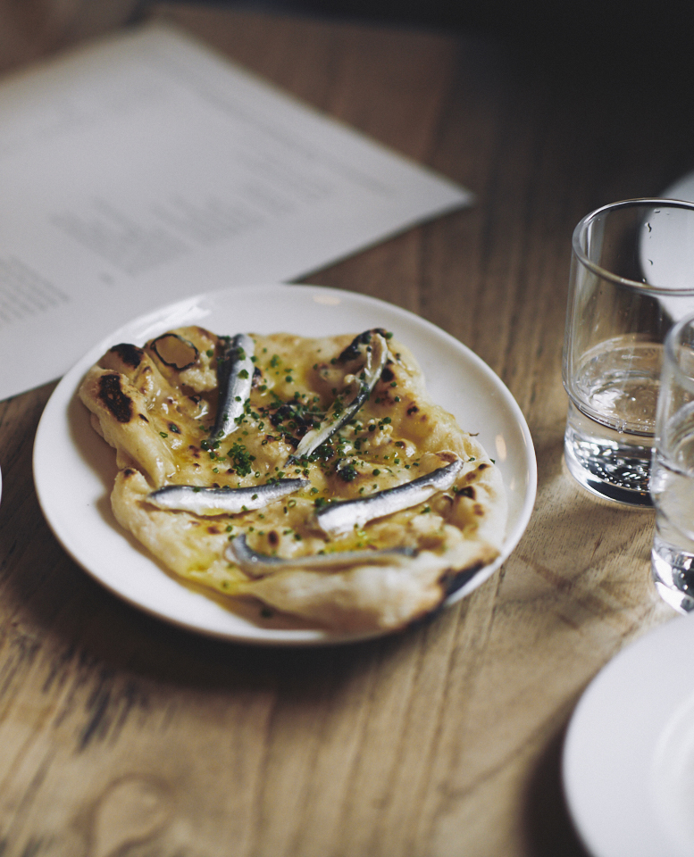
strong, white bread flour 500g
salt 10g
instant yeast 10g
unsalted butter 30g
water about 300ml
garlic
anchovies
thyme
chives
Combine the yeast with 100ml of warm water and stir, cover and leave at room temperature for 2-3 hours. This will start to ferment adding a depth of flavor to the bread.

Put the flour in a large, warm mixing bowl and add the salt and the dried yeast mix.

Add the butter and most of the water, then mix with your hands to bring the mixture together. Gradually add the remaining water until all the flour is mixed in.

Put the dough on a lightly floured board and knead for 5-10 minutes. When the dough feels smooth and silky, place it back in the mixing bowl, cover it with a warm tea towel and leave it in a warm place to rise for at least an hour until the dough has doubled in size. Tip the dough on to a floured surface, fold repeatedly until all the air is knocked out of it, then tear it into 12 equal pieces. Roll each piece into a ball.

Brown butter – Melt butter on medium heat and whisk until it turns brown, then take it off heat. Add the thyme and crushed garlic. Transfer to a metal bowl and allow to cool, keep stirring intermittently.

Heat up your oven (wood oven if you’re using one) to 475F.

Dust your work surface and roll out each piece around 6 inches. Take one piece of dough and gently place a preheated baking tray lightly dusted with flour. Place in the oven and cook for 4/5 minutes. It should start to blister and rise.

When ready, take out and brush the brown garlic butter, drape the anchovies over, season with sea salt and chives.

