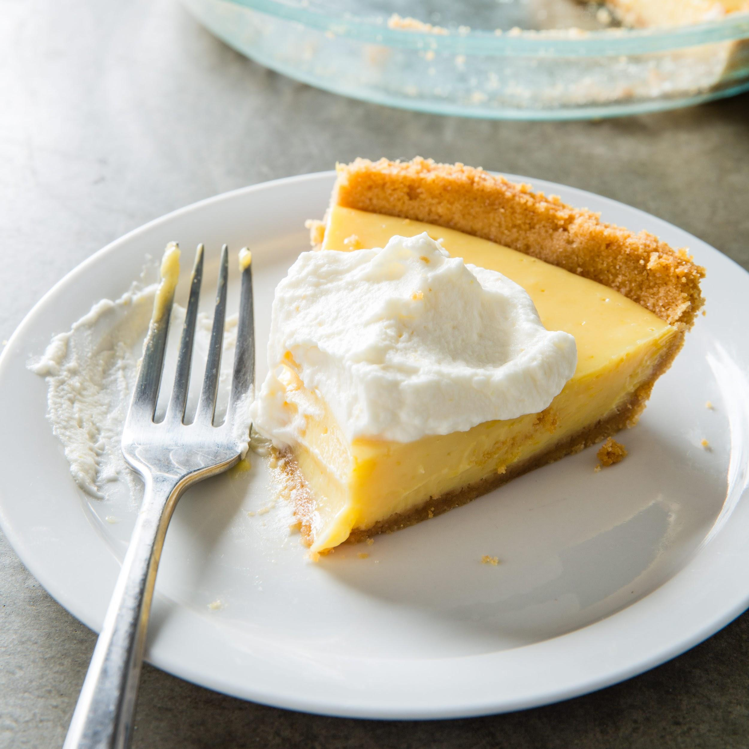
Cook's Country Sour Orange Pie
Crust:
5 Ounces Animal Crackers
3 TBS Sugar
4 TBS Unsalted melted butter
Pinch Salt
Filling:
1 (14oz) can of Sweetened Condensed Milk
6 TBS frozen orange juice concentrate (thawed)
4 Large Egg Yolks
2 TSP Grated Lemon Zest
6 TBS Lemon Juice (About 2 lemons)
1 TSP Grated Orange Zest
Pinch Salt
*NOTE*
If you can get sour oranges, omit the OJ Concentrate and Lemon Juice and use 3/4 CUP of Sour Orange Juice
Whipped Cream:
3/4 Cup Heavy Whipping Cream
2 TBS Sugar
1/2 TSP Orange Zest
1. For the Crust; Adjust oven rack to middle position and heat oven to 325F. Process crackers, sugar, and salt in food processor until finely ground, about 30 seconds. Add melted butter and pulse until combined, about 8 pulses. transfer crumbs to 9-inch pie plate
2. Using bottom of dry measuring cup, press crumbs firmly into bottom and up sides of pie plate. Bake crust until fragrant and beginning to brown about 12-14 minutes. Let cool completely, about 30 minutes.
3. For the Filling; Whisk all ingredients in bowl until fully combined, pour into cooled pie crust.
4. Bake pie until center jiggles slightly when shaken, 15-17 minutes (Mine took nearly 21 minutes). Let cool completely. Refrigerate until fully chilled, at least 3 hours, or cover with greased plastic wrap and refigerate for up to 24 hours.
5. For the Whipped Cream; Whisk cream, sugar, and orange zest in medium until stiff peaks form about 2-4 minutes. Slice chilled pie and serve with whipped cream.

