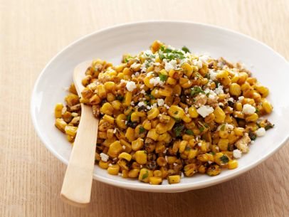
Corn with Roasted Chiles

1 red onion, diced
2 cloves garlic, finely chopped

[Preroast these]
2 roasted serrano chiles, finely diced
1 small roasted poblano chile, finely diced
1 roasted red pepper, finely diced
8 ears fresh corn, roasted, kernels removed
[Preroast these]
2 tablespoons cold unsalted butter
2 tablespoons crème fraiche
Juice of 1 lime
2 tablespoons finely chopped fresh cilantro
¼ cup cotija or goat cheese, crumbled

3 tablespoons avocado oil
Salt and freshly ground black pepper

Heat the oil in a large sauté pan over medium-high heat. Add onion and cook until soft. Add garlic and cook for 1 minute. Stir in the serranos, poblano, red pepper and corn and cook until the corn is tender, about 8-10 minutes. Season with salt and pepper.

Stir in butter, crème fraiche, lime juice and cilantro; transfer to a serving bowl and sprinkle with cheese.

