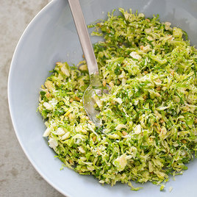
Brussels Sprout Salad

Why this recipe works:

Instead of roasted Brussels sprouts, we wanted a light, bright, raw preparation that was just as delicious. Shredding the Brussels sprouts super-thin is key, and letting them sit in the dressing for at least 30 minutes softens them fully and seasons them deeply. To flavor the salad, we chose a simple lemon vinaigrette, rounded out with shallot and mustard. Crunchy nuts and creamy cheese are the finishing touches.

Serves 8

Slice the sprouts as thin as possible. Shred the Pecorino Romano on the large holes of a box grater.

Ingredients

3 tablespoons lemon juice
2 tablespoons Dijon mustard
1 small shallot, minced
1 garlic clove, minced
Salt and pepper
6 tablespoons extra-virgin olive oil
2 pounds Brussels sprouts, trimmed, halved, and sliced very thin
3 ounces Pecorino Romano cheese, shredded (1 cup)
1/2 cup pine nuts, toasted

Instructions

1. Whisk lemon juice, mustard, shallot, garlic, and ½ teaspoon salt together in large bowl. Slowly whisk in oil until incorporated. Toss Brussels sprouts with vinaigrette and let sit for at least 30 minutes or up to 2 hours.

2. Fold in Pecorino and pine nuts. Season with salt and pepper to taste. Serve.

How to Slice Brussels Sprouts

You can use the slicing disk of your food processor or slice the sprouts with a chef’s knife. Follow these steps to do the latter safely and quickly.

1. TRIM: Trim the stem end of each sprout and then cut each sprout in half through the cut end.

2. SLICE: With the flat surface on the cutting board, thinly slice each half.

