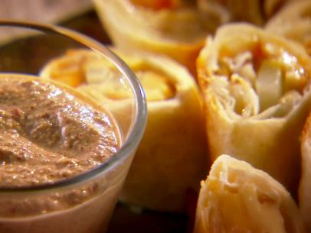
Pear/Gruyere Rollups
Ingredients
1/4 cup pecans
4 dried arbol chiles
1 clove garlic, unpeeled
Salt and freshly ground black pepper
4 flour tortillas, warmed
8 ounces smoked gruyere cheese, or any other smoked cheese, sliced into 1/2-inch logs
1 pear, such as Bartlett, cut into 1/4- inch slices
3 tablespoons honey
Vegetable oil, for brushing
Directions
Preheat a medium heavy skillet. Add the pecans, chiles and garlic, toasting on all sides until fragrant, about 3 minutes. Remove from the heat and let cool slightly. Remove the outer peel from the garlic and remove the stems from the chiles. Transfer the pecans, garlic, chiles and1/3 cup water to a blender and blend until smooth. Season with salt and freshly ground black pepper.
Preheat the oven to 400 degrees F.
Place the tortillas on a work surface and top with 4 slices of cheese, 4 slices of pear and then drizzle with about 2 teaspoons of honey per tortilla.
Fold in the sides of the tortilla over the filling and roll up to fully enclose. Secure with 2 toothpicks to prevent it from opening while baking and brush with vegetable oil.
Place the rolls on a greased baking sheet and bake until tortillas are crunchy, about 35 minutes. Let the rolls cool enough to handle, about 5 minutes. Cut into thirds and serve warm or at room temperature with the pecan-chile salsa.

