Unit 6 | Assignment - What's the Weather Like?

Python API Challenge - Ricardo Mendoza

Observations

1. As we move closer to the equatorial line (latitude = 0) the maximum temperature tend to increase, as shown on chart below. On the opposite side, heading to north (positive latitude) the temperature become negative (so cold!)

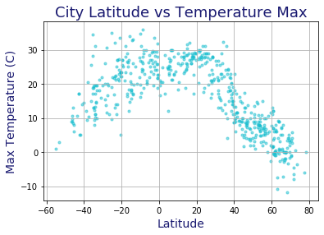

1. The wind speed is relatively low, although it increases as we move to the north (positive latitude). So cold and windy in the north!

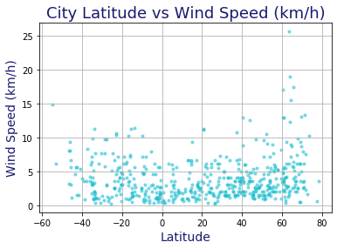

1. There is no straight relationship between the latitude and the humidity and cloudiness as the charts below shown

