**ASSIGNMENT #1(b) – Preparing a Linux server for Oracle installation**

**Ramesh Danuwar**ISQA 4300/8306-860  
Fall 2019

• **getentpasswd|grep “\home”**

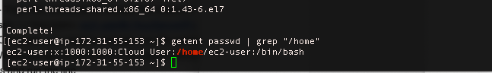

• **getentgroup|grep [1-9][0-9][0-9][0-9]**



**• lsblk**

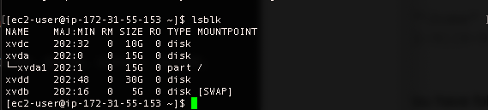

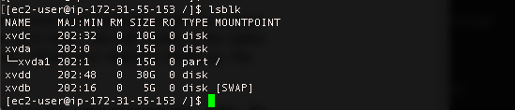

**• ls-l**

