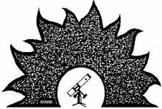
times
Phoenix Astronomical Society
www.pasaz.org
February 2022
Volume 73 Issue 6
P H O E N I X A S T R O N O M I C A L S O C I E T Y — E S T A B L I S H E D 1 9 4 8 Alex Woronow to Speak at PAS Meeting Feb 3
By Alex Woronow
The Stellina Telescope—The future of ama teur astronomy has arrived
A new generation of amateur tele scopes is upon us: Enter the Stellina! The automation of the Stellina telescope sur passes any previous or other current tele scopes in a plethora of dimensions, from an entree into DSO astronomy to a capable image platform.
Set it down wherever you want; the Stellina is light, compact, and portable. Insert a battery, turn it on, and it obtains its latitude and longitude, points upward, fo cuses, takes a sky image, and plate solves to orient itself to the sky—all hands-off. Select a target, and it slews to it, centers the target and checks the focus, and then begins imaging without the aid of addon software. The stacked image updates real-time after onboard subframe QC, calibration, and stacking and transmits its stretched image to connected smartphones and tablets—up to 20 of them simultaneously—again with out the assistance of an attached computer and software. The Stellina provides a WiFi network. The master smart device selects the targets, composes the fov and other administrative tasks. I’ve connected a por table monitor to mirror one of the connect ed devices, making this rig ideal for
the Stellina can save the “raw” subs in FITS format for processing later, or it can create a 16bit TIFF of its stacked result without interrupting the image updates to connected devices.
It’s exciting to watch the first 10-sec ond sub appear, maybe with a faint ghost of the target and a few stars. The Stellina tracks the target and adjusts its image dero tator; the second, third, and fourth subs roll in, and the target begins to show its shape and stars brighten. A few more subs, and target and star colors become clearer; de tails being to appear within the nebula or galaxy. It’s an engaging and exciting expe rience studying the current image and antic ipating the next update.
This presentation
will cover the above fea
tures and show some
early images I’ve cap
tured with this remark
ably advanced amateur
instrument.
Dr. Alex Woronow:
I received an A.B. de
gree in Astronomy from
Berkeley, an M.S. in ge
ology from U. Houston,
and my Ph.D. from Har
vard. My dissertation fo
cused on the statistics of cratering on Mars back in the Mariner 7 spacecraft days. After several years on the research faculty at U. Arizona’s Planetary Sciences Dept., I joined the geosciences faculty at U. Hous ton. I have held many NASA research grants and written numerous papers on planetary-surface processes and statistical methods applicable to planetary geology. My final work years were at Exxon’s re search lab, developing and deploying a novel Bayesian risk-assessment technique for hydrocarbon exploration. My astro-im age processing interest focuses on extract ing maximum information (detail) from the images utilizing artificial intelligence and statistical tools, and more traditional ap proaches.
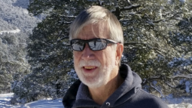
star-party/out-reach sharing. In addition,
Alex Woronow provided this photo of himself.
By Terri Finch, Assistant Editor
Feb 3 PAS Meetingmeeting:
Meeting doors open at 7pm. The meet
Please join PAS in welcoming Alex Woronow to the Feb 3rd PAS Meeting. This meeting will be conducted virtually via Zoom and this is the link to access the
https://us02web.zoom.us/j/82279362985?p wd=OElHcnVaWlJrOVMycFZJcTRaZEJl UT09
ing will begin at 7:30pm. We hope to see you there! Bring your Family and Friends to this fantastic meeting!
PAStimes 2 Phoenix Astronomical Society Contact Info February 2022
President | Stu Brackney | 480-221-5711 | President@pasaz.org
Past President | Mike Marron | 480-488-3031 | PastPresident@pasaz.otg
Vice President | Paul Facuna | 602-246-1554 | VicePresident@pasaz.org
Webmaster | Pete Turner |  | Webmaster@pasaz.org
Secretary | Alex Vrenios | 602 789-6556 | Secretary@pasaz.org
Treasurer | Eric Steinberg |  | Treasurer@pasaz.org
Event Manager | Terri Finch | 602-561-5398 | Events@pasaz.org
Newsletter Editor | Don K. Boyd |  | Editor@pasaz.org
PAS Host | Bob Ewing |  | PASHost@pasaz.org
Member at Large | Jenny Neujoy | 602-787-6818
Member at Large/Equipment Manager | Bruce Wurst | 602-909-8024 | Brulipps@yahoo.com

Phoenix Astronomical Society 3241 E Shea Blvd #249 Phoenix AZ 85028-3365
Past PAS Recorded Presentations
By Terri Finch, Event Manager
Did you miss a PAS Meeting and wish you could see it? You can get to the link of Past Recorded PAS Meetings with Guest Speakers any time by going to the left hand navigation tool on the PASaz.org website and clicking on “PAS Monthly Meetings.” From there a drop down item will appear
and please click on “Videos of Speaker Presentations.” You will then find record ings of Past PAS Meetings for your view ing pleasure. The collection is in oldest to newest order. Please work your way to the bottom of the collection to find the most recently recorded PAS Guest Speaker Pre sentation.
As long as PAS can record the PAS Meetings, PAS will continue to add more recordings to this page. Here is the direct link to the recorded PAS Meetings collec tion: https://www.pasaz.org/pas-monthly meetings/videos-of-speaker-presentations.
Enjoy!
Spring 2022 PAS GUEST SPEAKERS
By Terri Finch, Event Manager
Events@pasaz.org
Due to the Covid-19 pandemic, PAS Meet ings are being held via Zoom over the internet. The Zoom link has been added to the calendar listing for that night’s meeting and in the News letter in the article about the next PAS Meeting. Please visit the PAS calendar at PASaz.org to find out more about these upcoming Meetings and Guest Speakers. If a Meeting will happen
In-Person, the Calendar Listing will give you that info. For a complete list of Guest Speakers, visit: https://docs.google.com/document/d/1OO UpaYNvw3p7JCRXCKSjDcbsK60DnvWOoifb qPrNp8/edit?usp=sharing
Do you have an idea for a guest speaker? Email Paul Facuna VicePresident@pasaz.org the details and contact info for that possible Guest Speaker.
Here are the next scheduled guest speakers at PAS:
V = Virtual Meeting through Zoom
P = In Person at PVCC Main Campus Mar 3: TBA
Apr 7: Mike Mackowski, Topic: National Space Society
May 5: Ted Blank, Topic: Mars Ingenuity Helicopter
What’s Up For February? By Don K. Boyd, PAStimes Editor
Name Date Rise Set Mercury 02-15-22 05:49 16:05 Venus 02/15/22 04:38 15:10 Mars 02-15-22 05:05 14:54 Jupiter 02-15-22 07:56 19:54 Saturn 02-15-22 06:48 17:22 Uranus 02-15-22 10:38 12:06 Neptune 02-15-21 08:27 20:08 Pluto 02-15-22 05:47 15:45 All Times Arizona Time
Bold means the object is “visible” in the evening
PAS is incorporated in the state of Arizona as a non-profit, scientific and education al 501(c)(3) organization. Our newsletter PAStimes is published monthly from Septem ber to May and distributed via the Internet. All Issues are available for download on our website www.pasaz.org . Ads for astronomy equipment are provided as a courtesy to sellers and buyers, and do not constitute any endorsement by PAS. All Photos by Don Boyd unless otherwise credited. All articles and photos are copyright their authors or PAStimes.
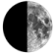
February 15, 2022 Sunrise: 07:12
Sunset: 18:14
Q1: February 8
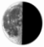
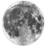Full: February 16 Q3: February 23
New: March 2
February 2022 PAStimes 3 "Science City" at Haleakala at 10,023 Feet
By Mark Johnston, PAS Member & Solar System Ambassador
On October 23rd I had the opportunity to observe from the restricted "Science City" area of Haleakala at 10,023 feet. I was a guest of the Haleakala Amateur Astronomers. Until the Moon rose, we had Bortle 1 skies and fabulous seeing - best I've ever had. I had the opportunity to use a Celestron C9.25 SCT and a 110mm F8 refractor. It was strictly visual. Jupiter's detail was sensational! I took several photos from the summit and an iPhone photo of M27 through the refractor using my night vision after the Moon rose. A great experience and they've invited me back - another reason to plan a trip back to Maui!
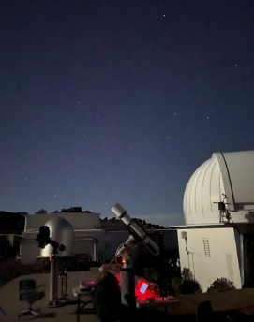
The day before, I had the opportunity to meet for lunch with Andy Lunt, founder and CEO of Lunt Solar Systems. Andy explained some of the behind-the-scenes history of his company which was fascinating, and I'm now signed up to be a beta tester for new solar products.
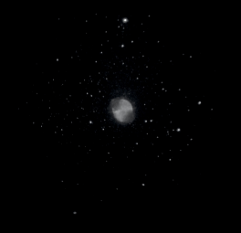
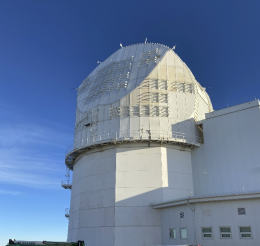
The new solar observatory. These five photos are taken and provided
by Mark Johnston.
This is the observing pad we used.
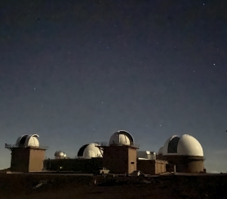
The new solar observatory. These five photos are taken and provided by
Mark Johnston.
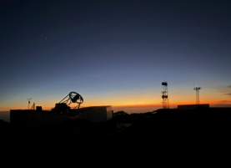Here is my iphone pic of M27 through the 110mm refractor.
Here is an unidentified cluster of observatories.
This is the two meter Los Cumbres scope.
PAStimes 4 February 2022 Pinnacle Peak Park Oct 30
Mark Johnston, Solar System Ambassador Oct 30th I put on an EAA star party for the City of Scottsdale at Pinnacle Peak park. We had a full house (30 people) and for once the weather, temperatures, and all my hardware and software cooperated per
fectly!
I showed live images of M31, M45, M33, M57, M27, NGC7000, NGC457, NGC7293, NGC869, M15, Jupiter, and Saturn. Shown here are a couple of iphone photos of the TV during the event (the
Helix nebula and the North America/Pelican nebulas).
Stu Brackney adds: Not…nice, VERY VERY nice OMG you hit a grand slam as they say this time of year.
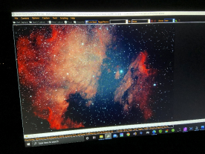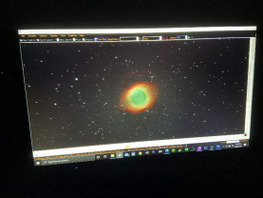Helix Nebula taken by Mark. North American Nebula taken by Mark Johnston.
NGC 6960: The Witch's Broom Nebula
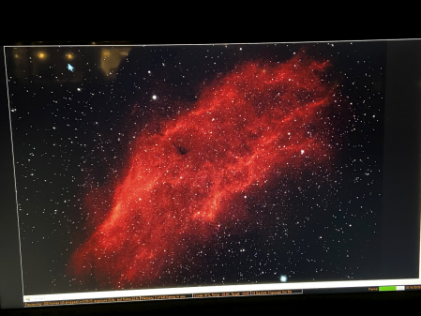
This is the Witch’s
Broom nebula on Mark's
EAA screen from the
Nov 26, 2021 event he
did at Pinnacle Peak Park
The original review of
this event is in the Janu
ary 2021 Newsletter on
page 5. NGC 6960, also
known as the Western
Veil Nebula, the Witch's
Broom Nebula, and
Sharpless 103, is the
remnant from a superno
va which occurred about
10,000 years ago. It is
the counterpart to the
Eastern Veil Nebula,
NGC 6992. Its amazing
filamentary structure is
thought to be due to
compression of expand
ing shells of gas as they
meet the resistance of the
interstellar medium.
February 2022 PAStimes 5 Desert Foothills Star Party Oct 21
By Terri Finch, Event Manager
It was a warm day of about 90 degrees that led to a chilly evening of about 63 degrees at pack up time. It started with the loading of my SUV with the Doctor (for those of you who haven’t met The Doctor yet… my telescope is named Doctor Who). Storm Moon (my daughter - we are a team) and I loaded and took off to the Desert Foothills Event location to do a private star party for about 200+ attendees from a company out of town. We met up with our awesome contact at the event, Joanie, who showed us where to set up. We were set up about 20 minutes before the start of the event.
The event was very fun. Storm and I were not the only enter tainment for this event. There was a dude breaking open geodes, there was music by the Sahnas Brothers (very beautiful music), Brandon, a sound technician for the band, was very interested in seeing more in the night sky than the rest of the attendees,
and for the guests, there was hors d'oeuvre, then a main meal, then dessert, and it was a very well planned three hour event.
This is an awesome location if anyone is looking to hold a larger event. There’s plenty of parking and in the case of non-cooperative weather, there is a large barn that can accommodate a very big group of people.
The evening progressed with Storm and I showing Venus until Venus dipped too far into the trees. Then we showed Saturn and Jupiter. I switched back and forth be tween the two during the evening since they were near each other and the people wanted to see both of them while there. I also showed the Moon which was one day past full and the craters on the edge were spectacular from this location. At first the Moon was behind a bush, so I waited for it to get high enough to enjoy without any obstruction by the bush. Brandon came over and we showed him the E.T. Open
there for some great views. It’s a dark location, however, and there were lights. It’s also very dusty and uneven ground to stand on. Of the 200+ who attended this event, I’d say about 75 visited the telescope with repeat visits to see all the objects the night sky had to offer. It was an amazing event and I hope to do it again sometime. Everyone was so wonderful to work with. Joanie even let me move their rather bright “Star Gazing” sign away from the telescope but within sight of the telescope.
Many thanks to Joe Costello with Onstage Entertainment Group for hiring PAS to be at this event. Looking forward to more events like this one.
If you wish to hire PAS to provide astronomers and telescopes at your event, please reach out to me, Terri, Event Manager at Events@pasaz.org or 602-561-5398. Please leave a message so I can get back to you.
Cluster and Alberio.
The crowd seemed to appreciate the telescope being
This was the set up with a white table cloth provided by the venue. It was a very fun event. Photo by Terri Finch.
Why Write a Review of an Event?
By Terri, Assistant Newsletter Editor, Events@pasaz.org
When PAS does an event, whether hosting or participating, I usually send out a request, by email, for those who attended, to write a review for the newsletter. Why? Because, PAS would like to keep a histori cal record of the events attended. Your newsletter review (of any length) enhances reviews written by other PAS Members or “thank you’s” from a school, or scout group. So, take a moment and write a re view of any astronomical event, you have attended, especially if you felt really good about the event. Let other people know, and help maintain our history.
The other reason I ask for reviews is that having me as the only writer of reviews of events, can get kinda dull for the reader. I don't usually put humor into my reviews
(but Darlene does), and I may forget some details that the reader may wish to know about, so I ask that others give me their reviews so that we can make a really good picture of how the event went.
We include things like weather, seeing and transparency, as well as activities if it’s not just a Star Party. Talk about who attend ed the event, tell us about the parts you really liked and give the reader something different to read with your personal touch. So if you have a moment to review an event, get the it to me by the deadline so it can be incorporated into the Newsletter with the other reviews about that same event.
One other reason we might want your input is if you did an event that was ex tremely awesome, and you want people to
know about it so they attend the event with you next time, such as a really spectacular viewing session at Antenna’s site, then your review is the only way they will find out about this event and what a great time was had by the attendees. So, send those reviews to me. They can be as short as a few sentences.
As of the April 2014 Awards Ceremo ny, reviews that are added to the newsletter are considered Public Outreach & you can get an award for including your review in the newsletter. The top 3 PAS Members to write reviews for the Newsletter will be included in the NSN Awards. Reviews can be Reviews of an event, a phone app or computer program having to do with As tronomy or an Article written for the news letter about anything else astronomy related. Send them to me today!
PAStimes 6 February 2022 EAA at Pinnacle Peak Park Oct 1st
By Mark Johnston, Solar System Ambassador & PAS Member On Friday October 1, I did an EAA star party for the City of Scottsdale at Pinnacle Peak Park. We enjoyed relatively rare clear skies and had a full house. I showed M8, M20, M16, M31, the Wizard nebula, the Owl cluster, Caroline's Rose, M33, M16, the Helix nebula, M13, Jupiter and Saturn.
Afterwards, Kris helped me pack up and we went to Needle Rock to join Ani who was observing and imaging with friends. Kris and I set up our scopes and I imaged the Heart and Soul Nebulas with my C9.25/Hyperstar scope. Here's the Soul nebula from that night (IC1848).
By Aniruddh Nayak
Awesome shot again Mark!!
It was nice seeing you all again after my brief hiatus! I was happy to be able to get my system up and running without bungling much!
I thought I had gotten the Veil nebula, but I think I got the Bat Nebula NGC6995.
Here's my final image.
RASA 11
IDAS NBZ Nebula Booster Filter
Subs: 24x120s
Lights only
ZWO294MC Pro
Processed in Affinity Pro
By Kris Mlak
Nice shot, Ani, looks great!
I will bow out of the newsletter - my attempts at post-process ing were futile.
Maybe next time!
Kris
By Kris Mlak
Hello, Terri.
If it's not too late, I would like to contribute the following image for the newsletter. This is my first serious attempt at astro photography (M1- Crab Nebula).
I am grateful to be under the tutelage of Mark Johnston who has been instrumental in my journey and for processing this image. Cheers to you both!
Kris Mlak,
Terri, Assistant Editor writes:
I wish to thank all three of the fine astrophotographers for sharing their awesome images with everyone through our club newsletter.
The Crab Nebula (catalogue designations M1, NGC 1952, Taurus A) is a supernova remnant and pulsar wind nebula in the constellation of Tau rus. Astrophoto by Kris Mlak.
The Heart and Soul Nebulae are a pair of nebulae in Elysian Shore. The Heart Nebula is lit by the Melotte 15 cluster at its core and stretches for over 30 light years. The Soul Nebula, about 330 LY away, is less diffused than its neighbor. Together, both nebulae are considered a gateway that leads to the For midine Rift. Astrophoto by Mark Johnston.
The Veil Nebula is a cloud of heated and ionized gas and dust in the constellation Cygnus. Astrophoto by Ani Nayak.
February 2022 PAStimes 7 Place your Astronomy Equipment Ad in this Newsletter
Do you have some astronomy-related items you’d like to sell? Prepare an ad and send it my way so that Don and I can help you sell it through the club newsletter. PAS members get this service for free. Items you may wish to sell: Books, Star Charts, Telescopes, Eyepiec es, Finder Scopes, and more. As long as it is astronomy-related, I will happily add it to the newsletter. Please include all items you wish to sell, and what is included with those items. Price them, and provide contact info for the way you wish to be notified, such as email or phone number. I await your submissions to Starstuff@gmail.com.
Ads for items for sale listed in PAStimes Newsletter are written by the seller. PAS is not responsible for the ads and does not guarantee the quality of the items for sale. PAS reminds everyone, you purchase at your own risk, so do your research beforehand. Ads in PAStimes run for one month and may be renewed on a month-to-month basis, space permitting, as long as the request to run the ad again is submitted by deadline (10th of month). Ads in PAStimes are FREE for PAS members. Non-members are asked to make a small donation to PAS. Non-members may email Terri, Assistant Editor at Starstuff@gmail.com to place their ad and get details on where to send a donation, via check or money order, made out to Phoenix Astronomical Society.
The deadline for the March issue will be Feb 10th. Some of these items can also be seen with photos on the PASaz.org website here: https://www.pasaz.org/items-for-sale
For Sale: Three Astronomy Items
* William brand. Zenith star refractor 73mm f5.9 PFL APO white body /gold trim rack and pinion 2.5'' focuser, 430 focal length $500. Used 3 times.....new condition.
* Explore Scientific 2'' 2X focal extender, 2 X 2001747 $200. Used once.....new condition in box.
* iOptron Az mount Pro level and go Alt-Azimuth with the heavy duty 2' tubular heavy duty tripod legs. Includes metal carry case. Very good condition. Asking $880.
Contact Roger twinklescope@yahoo.com 602 466 5141
For Sale: A Lot of Astronomy Equipment
* Asking $1800.00 Takahaski scope
* $250.00 Takahaski Finder Scope #552
* $400.00 Takahaski Extender-Q 1.6x
* $120.00 Takahaski Tube holders of which there are two and a small one
* Starlight 2” Feather Touch Focuser $344.00
* Celestron #94175 Reducer $110.00
* TeleVue 2” Mirror Diagonal DPC- 2002 $120.00
* Meade #918A Diagonal Prism $25.00
* Meade Series 4000 8-24mm Zoom Eyepiece $66.00
* Meade #918A Diagonal Prism $24.00
* Meade Ultra-Wide angle 8.8 $40.00
* Celestron # 93506 1 ¼ Japan $60.00
* Meade #8x50 Finder scope #544 Blue Japan $34.00
* Mack 111 Hyperion Zoom 8-24m $266.00
* Orion 9x50 Right-Angle Image finder $54.00
* ScopeTronix MaxView 40mm Eyepiece $34.00
* Orion Black Right-Angle Correct Image $30.00
* Vixen LV 15mm Lanthanum EyePiece 08626 $36.00
* Celestron Mount with Pelican Case. Also has a Pier made of 1/4" heavy case pipe. The plate is 1/2 inch. Asking $1800.00 for all three.
Contact Marge at lovins50@aol.com to set up a visit to see the items you are interested in. Pick up location will be near McDonald Drive & Granite Reef Rd in Scottsdale.
See ad with photos at this link: https://www.dropbox.com/sh/wwyyi1pfkb11jn9/AABMsoxs-_cvpcagtEhqNnVSa?dl=0
FOR SALE: Meade RCX-400 14-inch telescope. Condition is “like new”. Prices listed are the original purchase price – asking price is at end of this Ad:
* Enhanced diagonal 2-inch Series 5000 ($180)
* Meade 24mm wide angle eyepiece ($225.00)
* Meade Model 1220 Field De-Rotator ($600)
* SBIG ST-7XME CCD Dual Sensor USB Camera with case $2000)
* Meade manual and other pertinent manuals/software.
Equipment can be seen and picked up from a location in North Scottsdale, Arizona. Prefer not to ship. Local Pickup please. I will be glad to answer any questions. Total Asking Price for all items listed above is $5,000.00 plus any shipping/packing costs if required. Contact: Richard rjkarizona@cox.net

