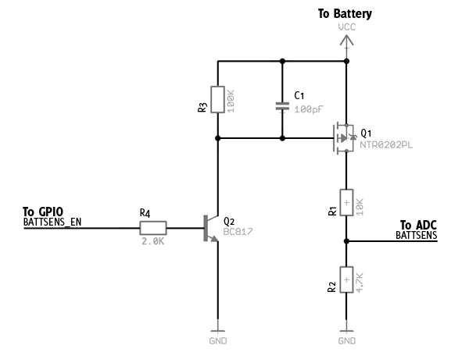

Pros:  
Helps preserve battery life (Control of voltage divider)  
Relatively good price  
Cons:  
Potentially not needing GPIO

http://www.microbuilder.eu/Tutorials/Fundamentals/MeasuringBatteryVoltage.aspx

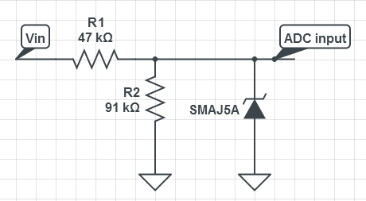

Instead of Zener diode, use Vishay QSBT40 TVS Diode Array(24V outputs)  
Resistors for scaling, voltage protection, linear regulator

\*Shunt cap for non-voltage divider  
\*Linear reg/variable reg: current rush, power to stop it  
\*R1=98.8k, R2=26k  
\*Zener Diode  
\*P=0.0279W