Rory Flemming

BIOENG 1586 Spring 2017

Homework: BCI

**PART 1: Continuous Decoder**

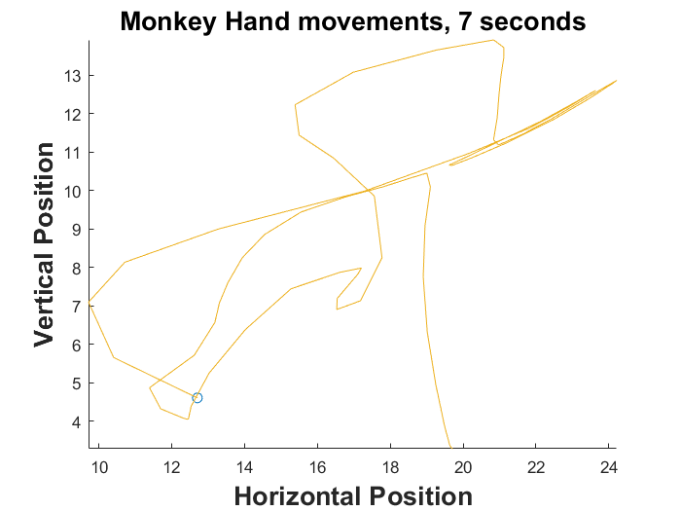In this task, the monkey is continuously moving his hand to hit targets as they appear on the screen. To the left, we see a sample of 7 seconds of this monkey’s hand position. The movements are smooth, yet apparently chaotic as they follow targets.

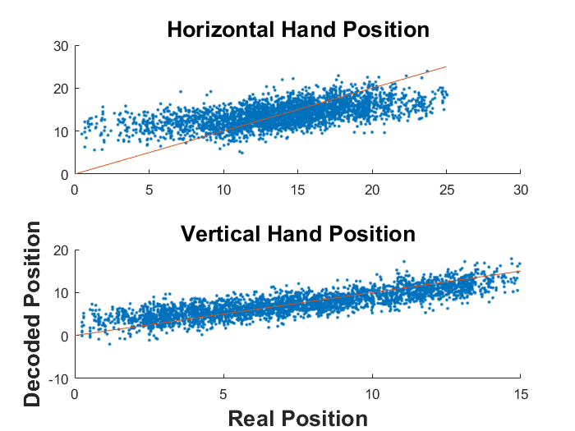To create a continuous decoder, we will use a simple linear filter. Essentially, we will be predicting the hand position by the neural data using linear regression.

To the right, we compare the predictions of the decoder with the actual locations provided in the training data. It appears that our decoder predicts the vertical position well, but does not do such a great job at the horizontal direction. The mean-squared error of the decoder is 8.60. This will be more meaningful as we compare it to the error of other attempts.

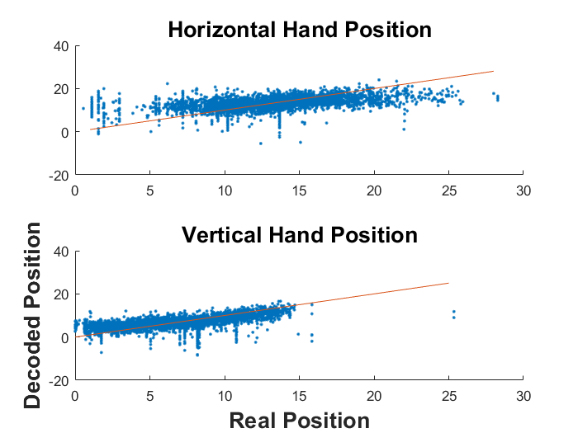Next, we will test whether the decoder built off this data is generalizable beyond its training set. We have another set of data stored away for testing.

To the left is a comparison between the reconstruction of the test data and the actual test data. The fits appear to be slightly worse (MSE = 13.1). We see that the linear filter decodes a variety of positions for what is actually the same position.

These fits are made from the neural data binned 70ms before the position. It is possible that a different bin may be more informative of the hand position. When we check bins with lags of -70, 0, 70, 140, and 210ms made from the test data on the test data, we get MSEs of 10.6, 10.4, 10.1, 9.87, and 9.85, respectively. This suggests that the 210ms delayed time bin may be most informative.

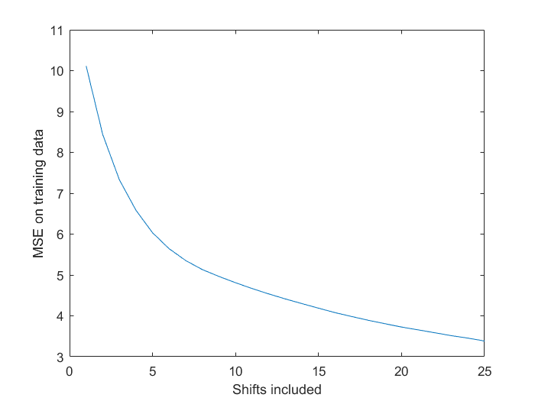We can also include more than one time bin into the regression. If we collect more data that is informative of the prediction, we should produce better predictions. However, if we collect too much data, and get neural activity that is not informative of the movement of the hand position at a given time, our predictions will suffer. Therefore, if we include N time bins, we would expect MSE to decrease as N increases up to a minimum, then MSE would begin to increase. However, when I wrote the code, I was testing on the same data I trained on. In this case, you would expect the MSE to continue to decrease. If I had tested on different data than I trained on, the U-shape MSE curve would have been apparent.

**PART 2: Discrete Decoder: Naïve Bayes Classifier**

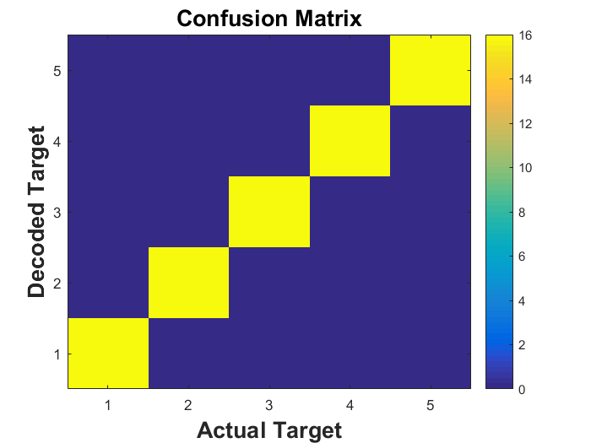We see that our naïve bayes classifier is totally accurate on decoding the correct target from the spike data. If the data was even noisier, it may not be so accurate, however, and it may be necessary to upgrade to a bayes classifier without the naïve, independence assumption.

