Rory Flemming

BIOENG 1586 Spring 2017

Homework: Neural and Behavioral Analysis

**PART 1: Behavioral Analysis**

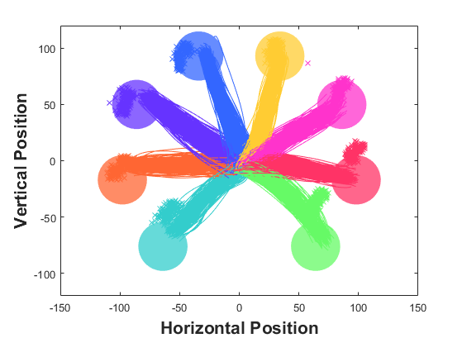

To the left, we have a visualization of the monkey’s behavioral data on the center-out reach task. We observe that the hand trajectories (lines) to each target are smooth, and follow the same trajectory with some variance. The monkey’s average eye location for a trial (x’s) are approximately on or above the target locations. This suggests that the monkey makes a saccade to the target at the beginning of its reach movement.

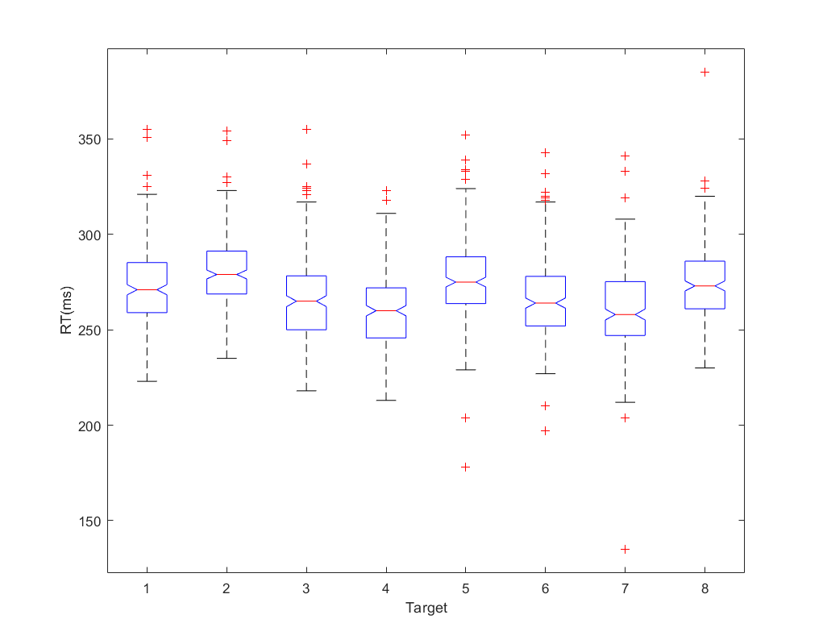

The monkey’s mean reaction time over the course of the experiment is 288 +/- 22 ms (mean +/- std). To determine whether the monkey’s RT depends on reach direction, a 1-way analysis of variance was performed. It appears that the monkey’s RT does depend on direction (F(7,1840) = 31.25, P < 3.8e-41). Box-and-whisker plots of the RT distributions are shown to the right. Targets 3, 4, 6, and 7 are rightward targets while 1, 2, 5, and 8 are leftward targets. It appears that the RTs for the rightward targets would be faster, though it would be necessary to do post-hoc t-tests to know for sure. I did not.

The monitor has a refresh rate, which affects the time at which targets are displayed. This creates a lag, a difference between the target appearing on the screen and the time which the command is sent. This may have significance when we begin looking at the neural data. This lag is approximately uniformly distributed with a mean of 18.9ms and 5ms standard deviation.

**PART 2: Neural Analysis**

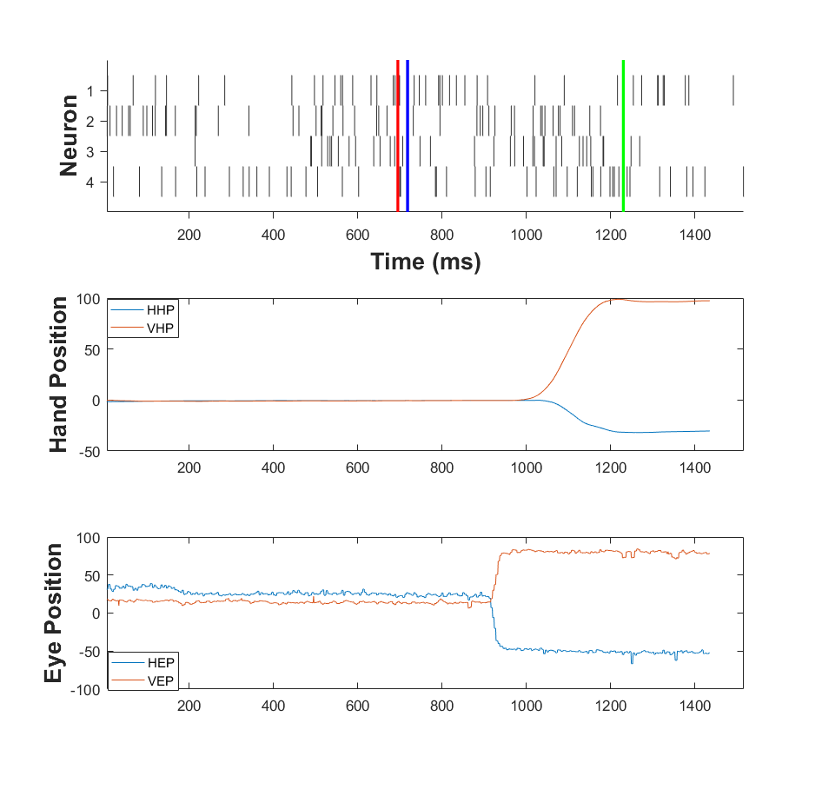To the left, we see a raster of four neurons, the hand, and eye position during a single trial. The eye trace appears to be noisier. This could be due to the coils, or the fact that the eyes actually move small amounts at all times to maintain images on the retina. Still, it could be larger instabilities in maintaining fixation. The red line is that time at which the cue is instructed to appear, the blue line is the time at which the cue appears on the screen, and the green line is the time at which the target is acquired.

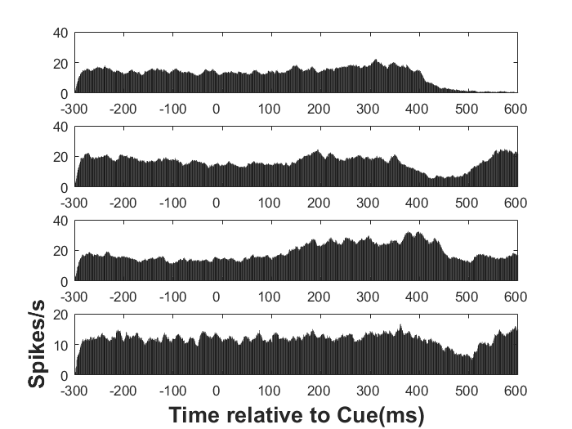

To the right are peristimulus time histograms (PSTHs). These histograms show firing rates before and around the stimulus onset. Unfortunately, error in my code or data seems to have made it such that I do not actually capture the correct epoch for the activity. Presumably, if these neurons were sensitive to the cue or the behavioral responses to them, we would see changes in activity pre- vs post-cue onset. These PSTHs are generated from activity on trials for one target, the top right target (pink).

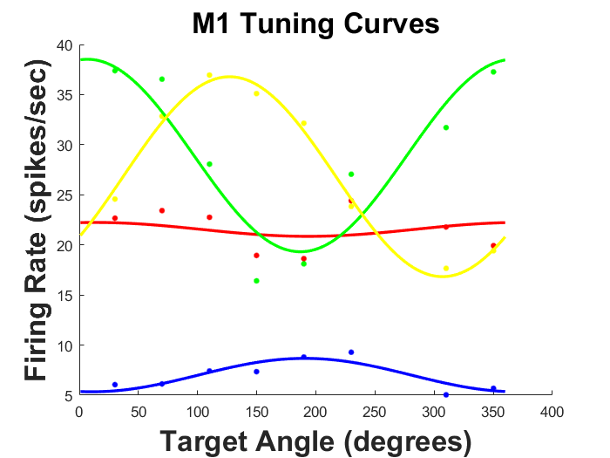

The last step for this exercise is to plot the tuning curves for each neuron. The tuning curve shows the firing rate as a function of target location. These tuning curves are well-fit by cosines. Using these cosine fits, we can determine the neurons’ preferred directions, which are the target direction in which the neurons have a maximal firing rate. The preferred directions of these neurons are 191 (blue), 13 (red), 7 (green), and 125 (yellow) degrees.