|  |  |
| --- | --- |
| Network Automata and Emergent Phenomena | |
| Principal Investigator: name and email  Richard Foard, [Richard.foard@gtri.gatech.edu](mailto:Richard.foard@gtri.gatech.edu) | Additional Key Personnel  (none) |
| Date:  May 29, 2018 | Proposed Funding  $15,000 |

|  |  |
| --- | --- |
| Please check all that apply and upload supporting documentation with this SoW in the Help Request. | |
| ☐ **Human Subject Research** Approval from Institutional Review Board (IRB) is required.   Visit [www.researchintegrity.gatech.edu](http://www.researchintegrity.gatech.edu) and attach copy of IRB approval notification. | ☐ **Use of Drones/Unmanned Air Vehicles** Approval from GTRI Flight Team is required.   Contact [GTRIUAVFlightOps@gtri.gatech.edu](mailto:GTRIUAVFlightOps@gtri.gatech.edu), and attach document of agreed upon actions. |
| ☐ **Vertebrate Animals** Approval from Institutional Animal Care & Use Committee (IACUC) is required.   Visit [www.researchintegrity.gatech.edu](http://www.researchintegrity.gatech.edu) and attach copy of IACUC approval notification. | ☐ **Biological or Physical Agents** Approval from Institutional Biosafety Committee (IBC) is required.  Visit [www.researchintegrity.gatech.edu](http://www.researchintegrity.gatech.edu) and attach copy of IBC approval notification. |
| ☐ **Lab or Chemical Hazard** Guidance and potentially approval from Environmental Health & Safety is required. Contact Debbie Wolfe-Lopez at 404-385-2964 for further guidance.   Provide approval notification, positive affirmation of training/certification, or other artifacts as applicable. | ☐ **Laser, Radiation, or Machine Shop Hazard** Guidance and potentially approval from Environmental Health & Safety is required.   Contact Nazia Zakir at 404-894-3605 or [ors@ors.gatech.edu](mailto:ors@ors.gatech.edu) for guidance and provide applicable approvals. |
| ☐ **Export of Information, Non-US Citizens, or Non-GTRI Participants** Non-GTRI faculty/staff, Non-US Persons, or third-party researchers are employed or will have access to project material.  Contact GTRI’s export-control coordinators at [export@gtri.gatech.edu](mailto:export@gtri.gatech.edu) for guidance and include applicable documents. | ☐ **Classified Research** Provide positive affirmation that you have read the policy for conducting classified IRAD projects and have in place the requisite procedures (e.g., security classification guide, review team, etc.) set forth within that document process.  Follow procedures in <https://webwise.gtri.gatech.edu/inside-gtri/corporate-initiatives/irad/classified-irad-guidance-document> |
| ☐ **Possible** **Conflict of Interest or Project is Potentially Related to Personal Activities External to GT** If you have external activities, provide positive affirmation that you have reported those activities intend to follow the requirements. |  |

# Project Executive Summary

Proposed is an exploration of the universe of complex graphs produced by basic network automata – abstract machines that start with a simple, two-color graph and repeatedly apply a generation rule to make color and topology changes based on the state of each node and its neighbors. A small subset of the possible rules produce graphs with complex, emergent properties. Some of these can be of interest outside the realm of theoretical mathematics. Stephen Wolfram, for example, has produced graphic outputs that replicate complex designs found in living organisms, and has done so using geometric automata even simpler than those proposed here. *[1]*

The investigator suspects that this work could yield insight leading to the creation of machine/rule combinations useful in modeling social and other natural processes. If successful, the ultimate result could be a toolset of richly expressive, computationally cheap alternatives to traditional analytical models. Such models could find application in areas such as simulated information diffusion, propagation of influence on belief systems, movement patterns of groups under stress or attack, formation of political allegiances, and the like. Because network structures are ubiquitous in human and natural affairs, the potential range of applicability is very broad.

The technical approach will focus on a single, simple machine that operates on graphs with invariant out-degree 2, using a rule that guides incremental color and topology changes. A rule’s effect on a node is determined by the node’s “triad state” – its own color-state and those of its two neighbors.

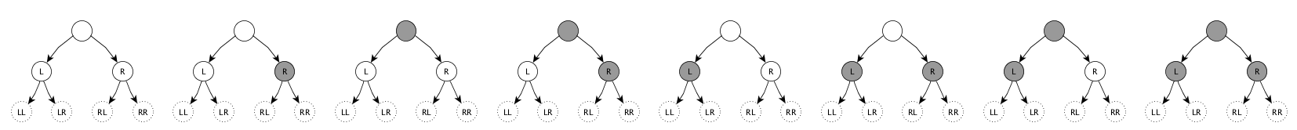

*The 8 states that a node “triad” may exist in, each with the 6 nodes (L, LL, LR, R, RL, RR)*

*to which the center node’s left or right edges may be redirected by the rule-part for its triad’s state.*

A rule specifies a composite action for each of a node triad’s 8 possible states. For each possible state, an action specifies (a) one of six replacement destinations for the center node’s left edge, (b) one of six replacements for its right edge, and (c) one of two new color states (black or white) for the node. There are, consequently, (6 × 6 × 2)8 possible rules, or 722,204,136,308,736. Rules can be thought of as points in a discrete, irregular, 8-dimensional rule-space. Many of the possible rules are vacuous or trivial in their operation, and can be dismissed from consideration *a priori*.

 

*Example: A 16-node graph before (left) and after 16 iterations of rule 565337038632294 (colors omitted)*

This research will identify and analyze rules of interest by:

* Creating an automated “machine runner” capable of running batches of rules,
* Devising strategies for sampling and searching the vast space of possible rules,
* Developing a process for recognizing rules of potential interest based on simulation runs, and
* Analyzing, in detail, rules that show promise for applied use or for further investigation.

# Heilmeier Catechism[1]

## What are you trying to do?

Our goal is to devise simple, rich tools for use in modeling social and other natural processes. A successful outcome will illuminate a path to higher-fidelity simulations useful in understanding phenomena in which large numbers of independent actors create outcomes that cannot be forecast using conventional analytical techniques.

## How is it done today, and what are the limits of current practice?

The variety of techniques used to model natural phenomena spans all types of discrete and continuous methods. Nearly all techniques entail careful design of approximating mechanisms, however, and can fail to capture the rich and often counterintuitive behavior of “found,” emergent processes. A paradigm based on *searching for* rather than *designing* certain model components could produce results not otherwise achievable.

## What’s new in your approach and why do you think it will be successful?

Cellular automata have received research attention for decades, but those that operate on graph/network substrates have only rarely been studied *[2]*. The expressive power and broad applicability of network models lends credence to the suspicion that a sufficiently exhaustive search of previously unexamined automata will turn up those with useful, emergent properties.

## Who cares?

Any agency seeking insight into processes involving large numbers of actors or components with complex and relationships could benefit by adding an expressive, alternative modeling tool to its repertoire.

## If you’re successful, what difference will it make?

At this stage, it is not possible to draw a straight line from the proposed research to results that provide clear value in sponsored work. The more likely outcome is a clearer sense of whether additional investigation will lead to such value, and insight into directions that subsequent efforts should take.

## What are the risks and the payoffs?

The foremost risk is that of achieving results that are interesting at an abstract, theoretical level but give no indication that further work will lead to practical value. An ideal payoff would be the production of evidence that further work can yield computationally inexpensive simulation models that differentiate a sponsor’s capabilities from those of her competitors or adversaries.

## What are the midterm and final ‘exams’ to check for success?

At midterm, prospects of success would be evidenced by the existence of one or more utility measures – tests that could be applied to an automaton’s output to determine if it warrants being singled out for deeper study by non-automated means. A final “A+” will be in order if a machine is identified that can play a demonstrably useful role in simulating some aspect of a natural process.

# Project Plan for the Proposed Effort

Effort will be spent at a uniform rate equaling approximately half-time for the (single) investigator. Tasks will overlap considerably, but a nominal schedule is:

* 3 weeks (effort, 6 elapsed)
  + Design and implement rule-based simulation software.
  + Design and implement search tools.
  + Identify criteria for selecting automata for study.
* 4 weeks (8 elapsed)
  + Choose candidate rules using search tools and criteria.
  + Run simulations varying rules, parameters, and initial conditions
  + accumulate result base.
  + Filter results using selection criteria.
  + Perform focused analysis of results, rules of interest.
* 1 week (2 elapsed)
  + Analyze, document, present
  + Propose follow-on research if indicated.

# Additional Discussion

(N/A)

# References

1. Wolfram, Stephen, 2002. *A New Kind of Science.*
2. Martínez, G.J., McIntosh, H.V. and Mora, J.C.S.T., 2006. Gliders in rule 110. *International Journal of Unconventional Computing*, *2*(1), p.1.

**DCAA Audit Information**

1. Project Title.

Network Automata and Emergent Phenomena

1. Primary Communities of Interest (COIs) and Subarea.

Primary area: Other

Secondary area: Modeling and Simulation Technology

Targeted DoD Organization. DARPA – Defense Advanced Research Projects Agency

1. Anticipated TRL at Project Completion. (TRL = 2)

|  |
| --- |
| 1 - Basic principles observed and reported.  2 - Technology concept and/or application formulated.  3 - Analytical and experimental critical function and/or characteristic proof of concept.  4 - Component and/or breadboard validation in laboratory environment.  5 - Component and/or breadboard validation in relevant environment.  6 - System/subsystem model or prototype demonstration in a relevant environment.  7 - System prototype demonstration in an operational environment.  8 - Actual system completed and qualified through test and demonstration. |

1. Project Summary. A wide variety of simple network automata will be simulated with the goal of identifying those yielding emergent results. Criteria and utility tests will be devised and used to choose a subset of machines that can be studied to inform subsequent research into improved modeling tools for complex natural processes.
2. Keywords.

Automata, Emergence, Network, Graph, Modeling, Simulation

1. Project Description.
   * What problem are you trying to solve?

Our aim is to increase the utility and fidelity of simulation models used in the study of complex social and natural processes by introducing a novel technical approach.

* + What is new about your approach?

Our method of generating behavior relies on a the emergent behavior of certain network automata. The abstract machines we will employ have not yet seen widespread interest and study.

* + If you succeed, what difference will it make?

Our success will increase the fidelity of simulation models used in the study of a wide range of natural processes. Simulations involving many interacting parts or actors will produce more valuable results.

* + What will it provide in terms of new capabilities for the DoD?

A successful outcome could underpin valuable extensions to simulation models. The incorporation of emergent processes can support tools that generate behaviors more faithful to social and other natural processes than existing analytical methods can, resulting in higher-fidelity simulations and better overall results.

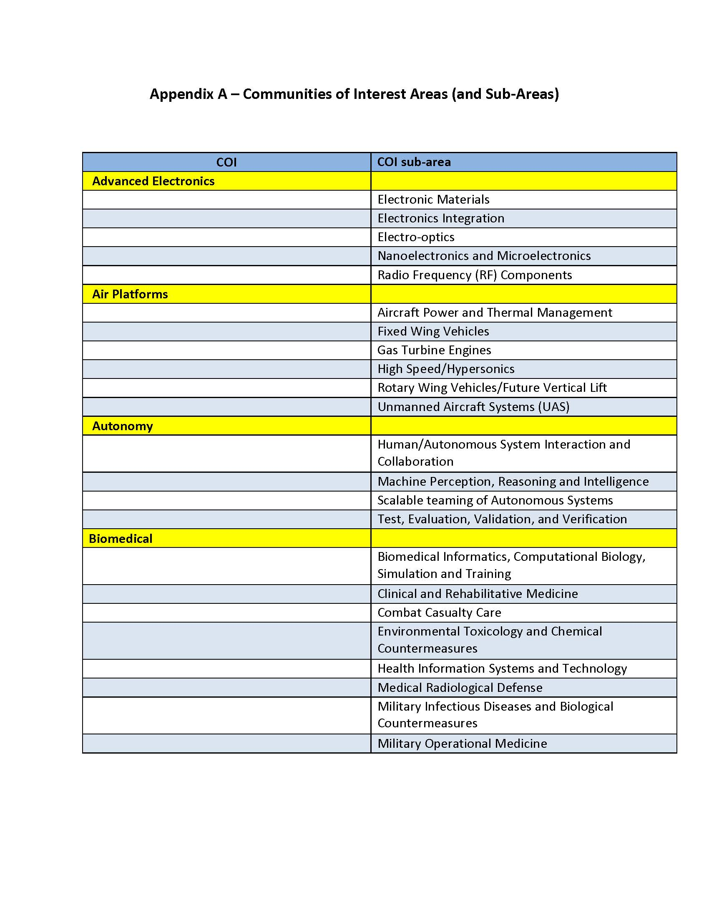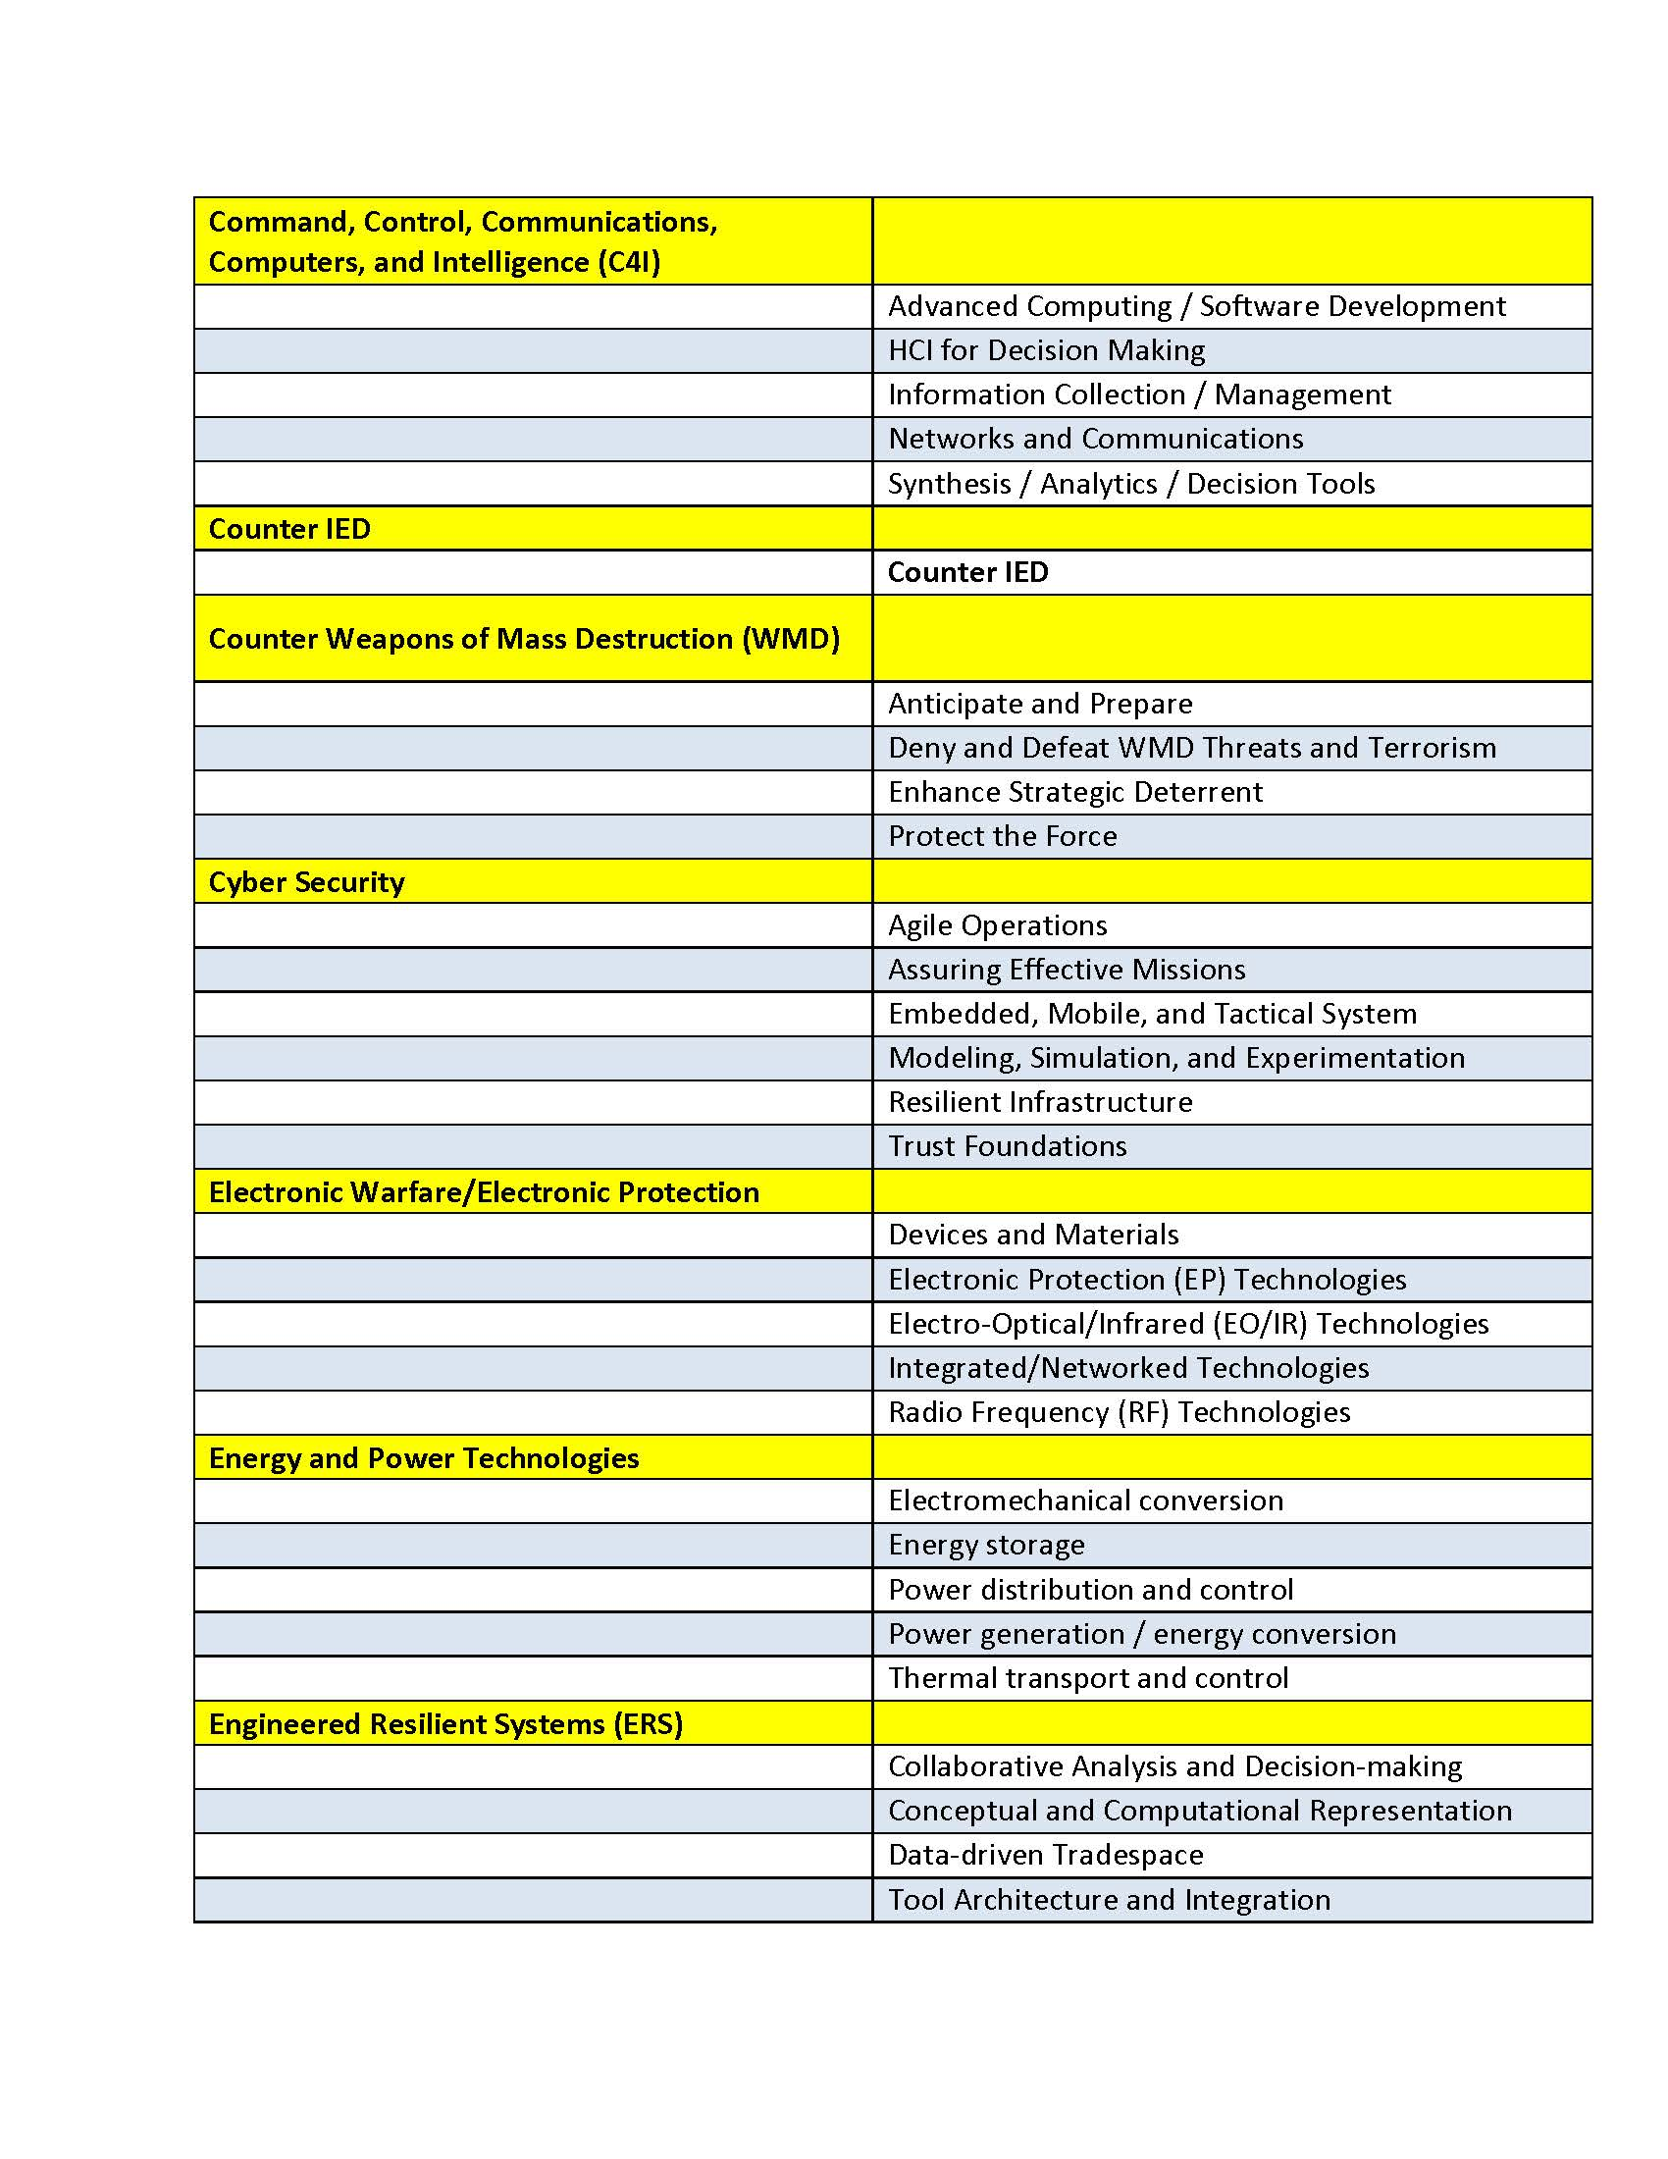**Appendix A - continued**

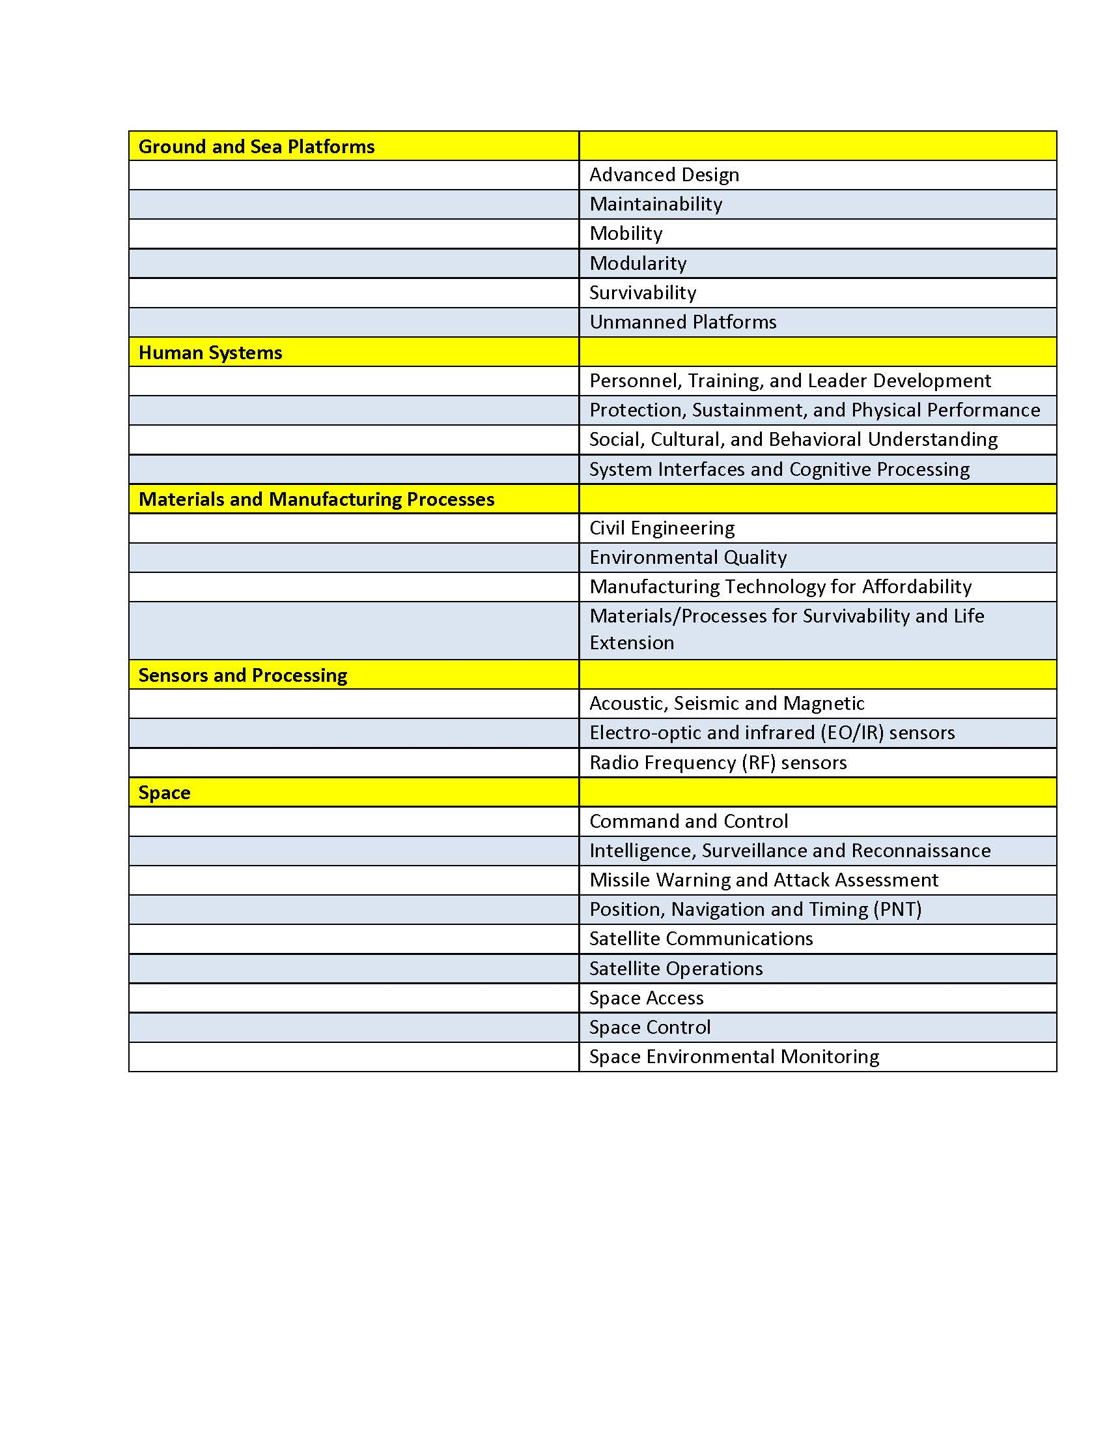

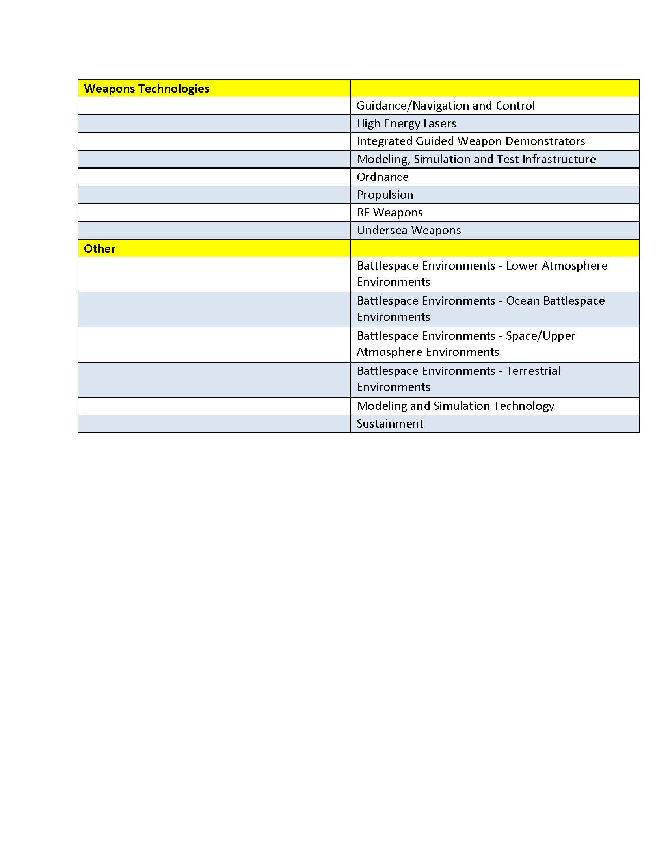

**Appendix B:**

**List of Potentially Targeted DoD Organizations**

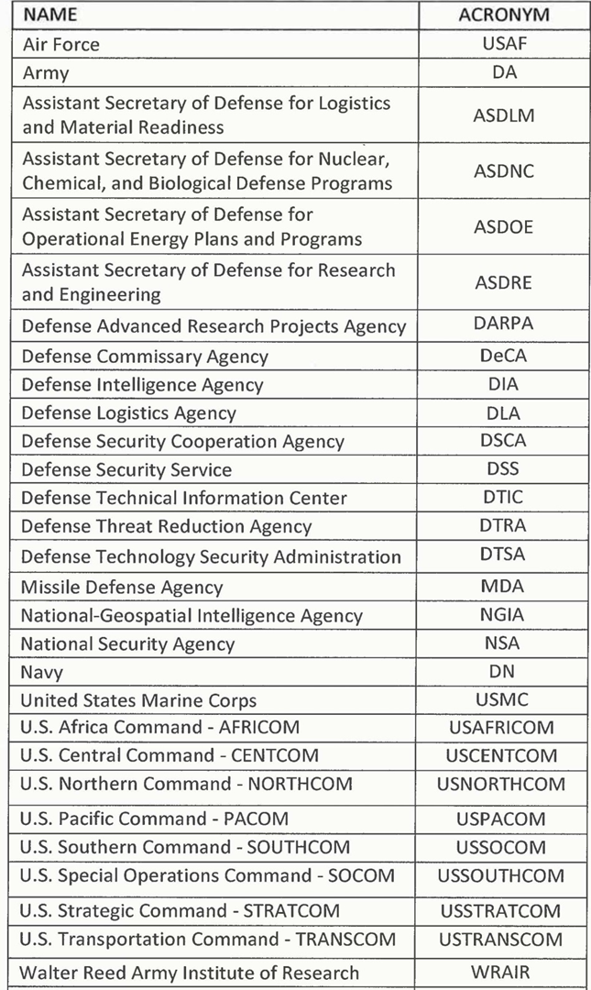

1. see <https://en.wikipedia.org/wiki/George_H._Heilmeier>