Untitled

Alasdair Warwick

10/06/2021

Table of Contents

R Markdown 1

Including Plots 2

Tables 2

Flextable - Table 1 2

Flextable - Table 2 3

# R Markdown

<https://rmarkdown.rstudio.com/articles_docx.html> - set up template word document

This is an R Markdown document. Markdown is a simple formatting syntax for authoring HTML, PDF, and MS Word documents. For more details on using R Markdown see <http://rmarkdown.rstudio.com>.

Cross-references:

* See Table 1
* See plot 1.

When you click the **Knit** button a document will be generated that includes both content as well as the output of any embedded R code chunks within the document. You can embed an R code chunk like this:

summary(cars)

## speed dist   
## Min. : 4.0 Min. : 2.00   
## 1st Qu.:12.0 1st Qu.: 26.00   
## Median :15.0 Median : 36.00   
## Mean :15.4 Mean : 42.98   
## 3rd Qu.:19.0 3rd Qu.: 56.00   
## Max. :25.0 Max. :120.00

# Including Plots

You can also embed plots, for example:

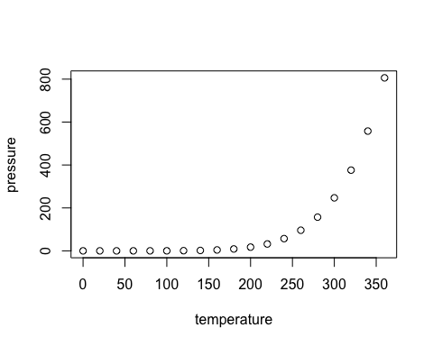

Figure 1: my figure caption

Note that the echo = FALSE parameter was added to the code chunk to prevent printing of the R code that generated the plot.

# Tables

## Flextable - Table 1

iris %>%   
 head() %>%   
 qflextable() %>%   
 set_caption(caption = "My flextable caption",  
 autonum = run_autonum(seq_id = "tab", bkm = "tab1"))

Table 1: My flextable caption

| Sepal.Length | Sepal.Width | Petal.Length | Petal.Width | Species |
| --- | --- | --- | --- | --- |
| 5.1 | 3.5 | 1.4 | 0.2 | setosa |
| 4.9 | 3.0 | 1.4 | 0.2 | setosa |
| 4.7 | 3.2 | 1.3 | 0.2 | setosa |
| 4.6 | 3.1 | 1.5 | 0.2 | setosa |
| 5.0 | 3.6 | 1.4 | 0.2 | setosa |
| 5.4 | 3.9 | 1.7 | 0.4 | setosa |

## Flextable - Table 2

iris %>%   
 .[1:2, 3:4] %>%   
 qflextable() %>%   
 set_caption(caption = "My flextable caption 2",  
 autonum = run_autonum(seq_id = "tab", bkm = "tab2"))

Table 2: My flextable caption 2

| Petal.Length | Petal.Width |
| --- | --- |
| 1.4 | 0.2 |
| 1.4 | 0.2 |

### Heading 3

Heading 4

Heading 5