Untitled
Alasdair Warwick
10/06/2021
Table of Contents
R Markdown 1
Including Plots 2
Tables 2
Flextable - Table 1 2
Flextable - Table 2 3

R Markdown
https://rmarkdown.rstudio.com/articles_docx.html - set up template word document
This is an R Markdown document. Markdown is a simple formatting syntax for authoring HTML, PDF, and MS Word documents. For more details on using R Markdown see http://rmarkdown.rstudio.com.
Cross-references:
- See Table 1
- See plot 1.
When you click the Knit button a document will be generated that includes both content as well as the output of any embedded R code chunks within the document. You can embed an R code chunk like this:
summary(cars)
## speed dist
## Min. : 4.0 Min. : 2.00
## 1st Qu.:12.0 1st Qu.: 26.00
## Median :15.0 Median : 36.00
## Mean :15.4 Mean : 42.98
## 3rd Qu.:19.0 3rd Qu.: 56.00
## Max. :25.0 Max. :120.00

Including Plots
You can also embed plots, for example:

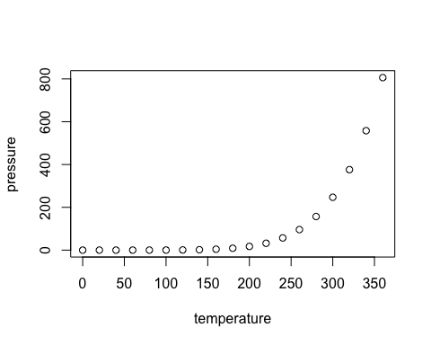
Figure 1: my figure caption
Note that the echo = FALSE parameter was added to the code chunk to prevent printing of the R code that generated the plot.

Tables

Flextable - Table 1
iris %>%
head() %>%
qflextable() %>%
set_caption(caption = "My flextable caption",
autonum = run_autonum(seq_id = "tab", bkm = "tab1"))
Table 1: My flextable caption
Sepal.Length | Sepal.Width | Petal.Length | Petal.Width | Species
5.1 | 3.5 | 1.4 | 0.2 | setosa
4.9 | 3.0 | 1.4 | 0.2 | setosa
4.7 | 3.2 | 1.3 | 0.2 | setosa
4.6 | 3.1 | 1.5 | 0.2 | setosa
5.0 | 3.6 | 1.4 | 0.2 | setosa
5.4 | 3.9 | 1.7 | 0.4 | setosa

Flextable - Table 2
iris %>%
.[1:2, 3:4] %>%
qflextable() %>%
set_caption(caption = "My flextable caption 2",
autonum = run_autonum(seq_id = "tab", bkm = "tab2"))
Table 2: My flextable caption 2
Petal.Length | Petal.Width
1.4 | 0.2
1.4 | 0.2

Heading 3
Heading 4
Heading 5

