**394.1 Advanced Corporate Finance - Valuation**

**Homework Assignment 1 – due on Tuesday October 1**

**Please submit one Word or PDF document per group, and indicate group members’ names on the first page.**

**This assignment has a total of 100 points.**

Questions 1 – 4 make use of the following information:

Small Corp. is investigating a possible new project, project X, which would affect the firm’s cash flows as follows (all cash flows in table are risk-free):



**Question 1 (10 points):**

Respond to parts *a* through *d*.

1. What are the incremental cash flows associated with Small Corp.’s undertaking project X? Are these inflows or outflows?

**Year 0: 30 (outflow)**

**Year 1: 15 (outflow)**

**Year 2: 13 (inflow)**

**Year 3: 25 (inflow)**

**Year 4: 6 (inflow)**

Year 5: 10 (inflow)

1. What is the *PV* of project X under a flat term structure of 7 percent, compounded annually, irrespective of maturity?

**$29.45**

1. Under these assumptions, what is the hurdle rate? Without further calculation, determine whether the *IRR* for project X is higher or lower than the hurdle rate. (*Hint:* Use part *b*.)

**6.53%, IRR lower than hurdle rate of 7%.**

1. Why might a flat term structure be unrealistic?

**Riskiness and uncertainty of cash flow might change over time.**

|  |  |  |  |  |  |  |
| --- | --- | --- | --- | --- | --- | --- |
|  | 0 | 1 | 2 | 3 | 4 | 5 |
| without X | 135 | 160 | 180 | 175 | 190 | 195 |
| with X | 105 | 145 | 193 | 200 | 196 | 205 |
| **incremental CF** | **-30** | **-15** | **13** | **25** | **6** | **10** |
|  |  |  |  |  |  |  |
| **NPV** | **($0.55)** |  |  |  |  |  |
| **IRR** | **6.53%** |  |  |  |  |  |
| **PV** | **$29.45** |  |  |  |  |  |

**Question 2 (10 points):**

Describe the equivalent tracking portfolio for project X, giving long and short positions and amounts, under a flat term structure of 7 percent, compounded annually. Conceptually, why are we interested in tracking project X’s cash flows with a portfolio of marketable securities?

**T = 1, short $15 worth of zero-coupon bond**

**T = 2, long $13 worth of zero-coupon bond**

**T = 3, long $25 worth of zero-coupon bond**

**T = 4, long $6 worth of zero-coupon bond**

**T = 5, long $10 worth of zero-coupon bond**

**Tracking portfolio is the market-based approach of calculating the fair value of a project. In the case that term structure is not flat, one would be able to assign the right riskiness, thus the market discount rate, to cashflows.**

**Question 3 (10 points):**

Let *Bt* = price per $100 of face value of a zero-coupon bond maturing at year *t*. Then, if *B1* = $95.00, *B2* = $89.50, *B3* = $83.70, *B4* = $78.00, and *B5* = $75.00, implying that the term structure of interest rates in no longer flat:

1. Determine zero-coupon rates for years 1 through 5 to the nearest .01 percent.

|  |  |  |  |  |  |
| --- | --- | --- | --- | --- | --- |
| **0** | **1** | **2** | **3** | **4** | **5** |
|  | **95** | **89.5** | **83.7** | **78** | **75** |
|  | **5.26%** | **5.70%** | **6.11%** | **6.41%** | **5.92%** |

1. Let’s reconsider the tracking portfolio under the new term structure. What is the market value of this tracking portfolio at date 0?

|  |  |  |  |  |  |  |
| --- | --- | --- | --- | --- | --- | --- |
| Year | 0 | 1 | 2 | 3 | 4 | 5 |
|  |  | 95 | 89.5 | 83.7 | 78 | 75 |
| rate |  | 5.26% | 5.70% | 6.11% | 6.41% | 5.92% |
| incremental CF | $ (30.00) | $ (15) | $ 13 | $ 25 | $ 6 | $ 10 |
| PV, incremental CF | $ (30.00) | ($14.25) | $11.63 | $20.92 | $4.68 | $7.50 |
| **PV** | **$ 30.49** |  |  |  |  |  |

1. What is the *NPV* of project X under the new term structure?

**$0.49**

1. How are your answers to parts *b* and c related?

**They are the same, as the tracking portfolio replicates cashflows from project X.**

**Question 4 (10 points):**

Consider the cash flows associated with undertaking project X.

1. Is this an early or late cash flow stream?

**LATE; It starts off with negative flows, then provides positive cash flows later.**

1. Based on the term structure of interest rates in Question 3, what is the hurdle rate? What does such a hurdle rate represent?

**6.12%, the average term structure for the cashflow of project X**

1. Calculate the *IRR* for project X.

**6.53%**

1. Based on the hurdle rate calculated and a comparison with the *IRR*, should Small Corp. undertake the project?

**Yes; Because it is a late cash flow stream, and IRR > Hurdle, they should take on the project.**

1. If the sign of each cash flow were reversed, how would the hurdle rate and project *IRR* change? How would Small Corp.’s decision change? Why?

**Hurdle rate: 6.12%**

**IRR: 6.53%**

**Would decide not to take on the project since NPV <0**

It would become an early cash flow stream, the hurdle rate would be unchanged and the IRR would be unchanged. Therefore, the company would reject the project, as for early cash flow projects, IRR needs to be less than the Hurdle Rate.

**Question 5**:

True or False: Indicate whether each claim below is true or false. Give a brief explanation for your answer:

* 1. Investors can diversify market (i.e. systematic) risk by holding the shares of a large number of companies, say, of every company in the stock market, in their portfolios **(5 points)**.

**FALSE: diversification only reduces idiosyncratic risks. Systematic risk cannot be diversified away.**

* 1. In evaluating a research and development (R&D) project, your CFO says: I heard that our head of R&D is planning to leave the company and retire as soon as his personal investments in the stock market are worth one million dollars. The success of our R&D effort critically depends on his involvement in the process. So the uncertainty about whether he will retire or not should affect the cost of capital we use to discount this project’s expected cash flows **(5 points)**.

**FALSE – whether R&D head’s stock portfolio hits one million dollar is a systematic risk that the company has no control over. (not sure)**

False; always take on projects that increase firm’s market value; no other considerations should be taken

Aside: If you agree with the CFO, do you think the cost of capital should be adjusted downward or upward to reflect the retirement risk **(5 point)**?

Upwards; not sure

* 1. When deciding which firms to include in our comparison set for obtaining an estimate of project beta, we should focus on those firms with low leverage. Due to low leverage, these firms will have low equity betas, hence our beta estimate will be low, reducing the cost of capital and increasing the NPV that we calculate via the risk-adjusted discounting method **(5 points)**.

**FALSE - should include firms with riskiness similar to that of our project.**

Question 6:

Which of the following scenarios are possible under CAPM? Briefly explain why or why not **(5 points each)**.

* 1. Portfolio Expected Return Betax

A 25% 1.2

B 20% 1.4

Rm = 30%

Rf = 55%

**No – Everyone would just hold risk-free asset instead of market portfolio**

Not possible; Setting up a system of equations, we get rf = .55, and rm = .3, which gives a negative rp, which is impossible.

b. Portfolio Expected Return Standard Deviation

A 35% 30%

B 25% 40%

**Yes – A portfolio with a higher expected return and lower standard deviation is possible**

c. Portfolio Expected Return Standard Deviation

Risk-free 6% 0

Market 12% 28%

A 14% 26%

**No – With a beta of 1.33, portfolio A should have a standard deviation at least 37.24%**

d. Portfolio Beta Standard Deviation

Market 1 20%

A 0.6 35%

**Yes – implied covariance between A and market is 0.024, which is possible**

**Question 7 (10 points)**

Consider the following pieces of information:

* Risk-free rate = 2%
* Market portfolio: Expected return = 7%, Volatility (return standard deviation) = 20%
* Stock A: Expected return = 7%, Volatility = 30%, Market beta = 1.2

Show that you can build a portfolio whose Sharpe ratio exceeds the Sharpe ratio of the market.

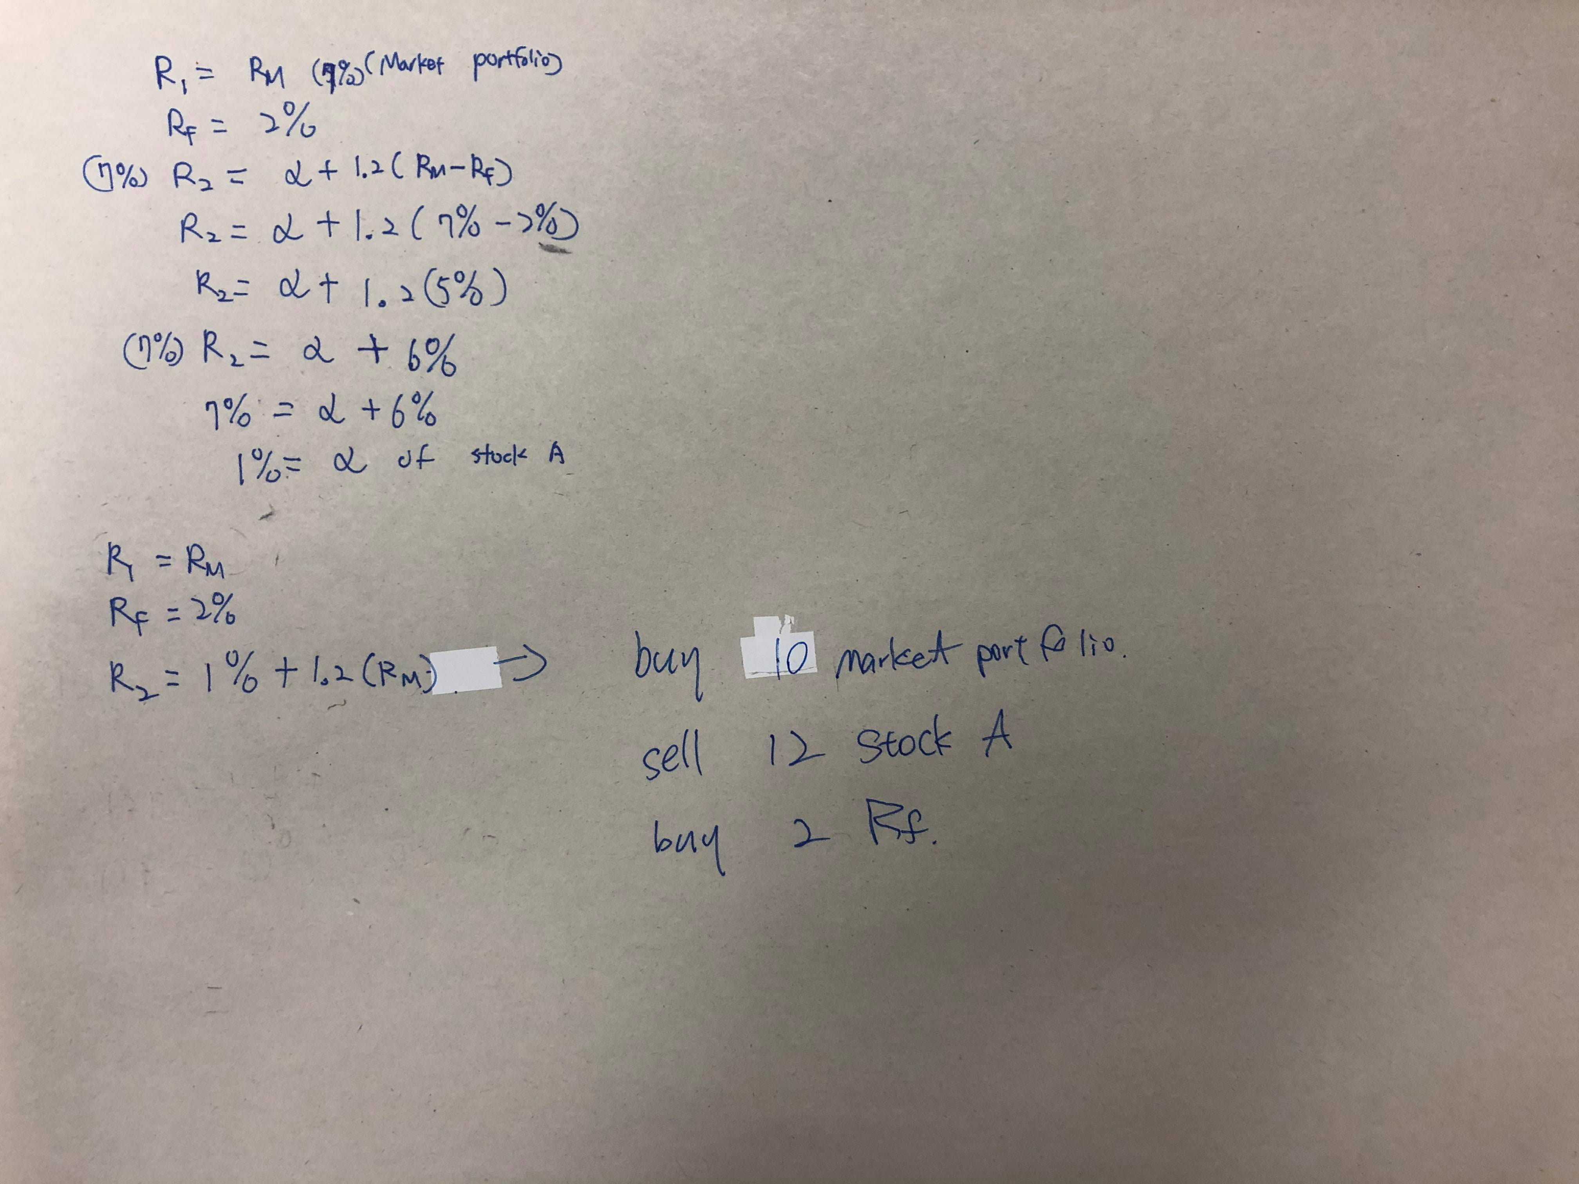With the expected return of 7%, CAPM does not hold true for stock A. Thus, there poses a opportunity for arbitrage. In theory, stock A has an alpha of 1%, and we can exploit an arbitrage opportunity by Short 12 market, buy 10 market and buy 2 risk free buying 10 market, short selling 12 stock A, and buying 2 Risk Free. In this case, we generate a portfolio with positive return and zero volatility. Thus, the Sharpe Ratio is infinite.

**Question 8 (10 points):** Exercise 6.11 on Page 211 of G&T

For Factor 1:

$$\left[\begin{aligned}x_{a}+x_{b}+x_{c}=1 \\ {2x}_{a}+{3x}_{b}+{3x}_{c}=1 \\ {2x}_{a}+{1x}_{b}+{0x}_{c}=0\end{aligned}\right.$$

Using matrix row reduction, we get $x_{a}=2, x_{b}= -4, x_{c}=3$

For Factor 2:

$$\left[\begin{aligned}x_{a}+x_{b}+x_{c}=1 \\ {2x}_{a}+{3x}_{b}+{3x}_{c}=0 \\ {2x}_{a}+{1x}_{b}+{0x}_{c}=1\end{aligned}\right.$$

Using matrix row reduction, we get $x_{a}=3, x_{b}= -5, x_{c}=3$

.