**Ryan Harty**

**Derrick Hung**

**Hannah Warren**

**Assignment 1: Dividend Initiations, Stock Splits and Stock Returns**

**Portfolio 1: Stocks who initiated a dividend in the last 12 months**

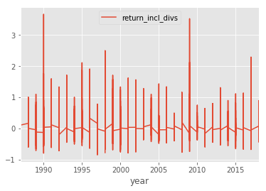

Looking at the image above, we get an idea of the total annual returns might be for the prospective portfolio consisting only of stocks who initiated a dividend in the last 12 months, however, the picture isn’t quite clear. Annual returns were used for plotting in order to create a clearer plot.

For Portfolio 1, the most significantly different 2 values are the Sharpe ratio, the alpha, and the betas. There is a 50% increase in the Sharpe ratio when going from an equally-weighted portfolio to a value-weighted portfolio. This indicates that investors with the value weighted portfolio can expect a higher rate of excess return for each unit increase in risk taken. This is backed up by the higher alpha value for the Value-weighted portfolio.

Looking at the Sharpe ratio for the split time periods, we see that both value weighted and equally weighted portfolios experienced an increase in their Sharpe ratio, indicating that compared to 20 years ago, investors today can expect more excess returns.

**Portfolio 2: Stocks who announced a split in the last 12 months**

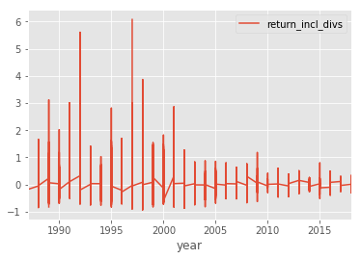

The image above is again a graph of the annual total returns.

For this portfolio, the Sharpe ratio of the value-weighted portfolio is again significantly higher than the Sharpe ratio for the Equally-weighted portfolio, and this is again backed by the alphas. However, for portfolio 2, the Equally-weighted portfolio has a negative value, indicating that for every increase in risk taken, the investor can expect a decrease in excess return.

For looking at the Sharpe ratio for the split period, both the value weighted and the equally weighted portfolios experienced an increase in their Sharpe ratio, however, the Value-weighted portfolio maintained the higher Sharpe ratio.

**Portfolio 3: Stocks who either announced a split or initiated a dividend in the last 12 months**

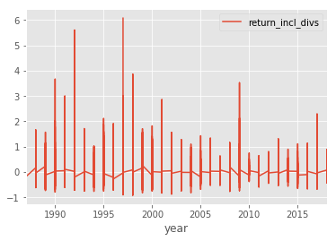

The above graph is the annual returns per year.

Both the Equal-weighted and Value-weighted portfolios had negative alphas, indicating a low expected excess return for each unit increase of risk taken. The most interesting value was the standard devations. Compared to other portfolios, the Equally-weighted portfolio had the highest standard deviation, whereas the Value-weighted portfolio had the lowest by a significant margin. This indicates that the value-weighted portfolio did not have much variation compared to other portfolios.

Looking at the Sharpe ratios for the 2 different time frames, we see where the Value-weighted portfolio initially had a negative Sharpe ratio, indicating that 20 years ago, the Value-weighted portfolio had a market return that was lower than the risk-free rate. For the second time period however, the Value-weighted portfolio has one of the higher Sharp ratios.

**A Brief Summary of our Numeric Findings:**

|  |  |  |  |  |  |
| --- | --- | --- | --- | --- | --- |
| Portfolio | Avg returns | sd | sharpe | alphas | betas |
| EQUAL div | 0.0110738071457 | 0.0467270805978 | 0. 1823889905 | 0.00191733680 | 1.0902 |
| VALUE div | 0.0165946791941 | 0.0533244129432 | 0.2633573692 | 0.00845394342 | .7956 |
| EQUAL spl | 0.00936572212916 | 0.0516938730458 | 0.0953740579 | -0.0046665769 | .9029 |
| VALUE spl | 0.0137589675909 | 0.0518043007975 | 0.2163462364 | 0.00620941693 | .8317 |
| EQUAL ds | 0.0079404190773 | 0.0565050613036 | 0.1318225863 | -0.0017001593 | 1.0275 |
| VALUE ds | 0.00495925117485 | 0.0191126154346 | 0.1259874191 | -0.0043797754 | 1.7234 |

|  |  |  |
| --- | --- | --- |
| Portfolio | Sharpe: 1987-2002 | Sharpe: 2003-2018 |
| EQUAL div | 0291452104671 | 0.179025471334 |
| VALUE div | 0.28567303527 | 0.241013952572 |
| EQUAL spl | 0.16624735453 | 0.195938920285 |
| VALUE spl | 0.19078049112 | 0.246903687700 |
| EQUAL ds | 0.07163355871 | 0.198455033196 |
| VALUE ds | -0.1678611292 | 0.245609360107 |