Final Project Report

Full Stack Job Portal with Strapi and Next.js using REST API and Postgres



Project Supervisor
Amjad Iqbal Khan

Submitted By

S24029898ED1

Raja Muhammad Haider Ali BC200414326

Software Projects & Research Section,
Department of Computer Sciences,
Virtual University of Pakistan


CERTIFICATE

This is to certify that Raja Muhammad Haider Ali (BC200414326) have worked on and completed their Software Project at Software & Research Projects Section, Department of Computer Sciences, Virtual University of Pakistan in partial fulfillment of the requirement for the degree of BS in Computer Sciences under my guidance and supervision.

In our opinion, it is satisfactory and up to the mark and therefore fulfills the requirements of BS in Computer Sciences.

Supervisor / Internal Examiner

<<Project Supervisor Name>>
Supervisor,
Software Projects & Research Section,
Department of Computer Sciences
Virtual University of Pakistan

___________________
(Signature)

External Examiner/Subject Specialist
<<External Supervisor Name>>

___________________
(Signature)

Accepted By:

_____________
(For office use)

EXORDIUM

In the name of Allah, the Compassionate, the Merciful.

Praise be to Allah, Lord of Creation,
The Compassionate, the Merciful,
King of Judgment-day!

You alone we worship, and to You alone we pray for help,
Guide us to the straight path

The path of those who You have favored,

Not of those who have incurred Your wrath,
Nor of those who have gone astray.

DEDICATION

I dedicate this project to my beloved family, whose constant support, prayers, and encouragement have been my greatest motivation. Their belief in my abilities and unwavering confidence in my journey have given me the strength to overcome challenges and strive for success. Without their love and care, this achievement would not have been possible.
I also extend my heartfelt gratitude to my friends and mentors, who have guided and inspired me throughout this journey. Their valuable advice, encouragement, and constructive feedback have been instrumental in shaping this project. This work reflects my dedication to growth, learning, and achieving excellence in every endeavor.
ACKNOWLEDGEMENT

First and foremost, I would like to express my deepest gratitude to Almighty Allah for granting me the strength, knowledge, and perseverance to complete this project successfully.
I am profoundly thankful to my instructors and mentors for their guidance, support, and encouragement throughout this journey. Their expertise and constructive feedback have been invaluable in shaping the direction of this project.
I would also like to extend my heartfelt appreciation to my family and friends, whose constant support, motivation, and encouragement have been a source of strength for me. Their belief in my abilities has inspired me to strive for excellence.
Finally, I acknowledge the resources, tools, and technologies that enabled me to turn this project into a reality, providing a foundation for my learning and development. Thank you to everyone who contributed directly or indirectly to the success of this endeavor.
PREFACE

This report is a culmination of my efforts to design, develop, and deliver a functional and user-friendly Full Stack Jobs Portal. The project has been an opportunity to apply the knowledge and skills I have acquired during my academic journey, combining theoretical concepts with practical implementation to solve real-world problems.
The primary objective of this project is to bridge the gap between job seekers and employers by providing an efficient platform for job searching, recruitment, and management. The development process involved extensive research, planning, and testing to ensure that the portal meets the needs of its users while adhering to industry standards.
Through this project, I have gained valuable insights into full-stack development, database management, and user experience design. I hope this report serves as a guide for understanding the project's objectives, challenges, and outcomes, and demonstrates my dedication to learning and creating impactful solutions.

TABLE OF CONTENTS

CHAPTER NO. 1
gathering & Analyzing info 10

1.1 Introduction

1.2 purpose

1.3 scope

1.4 definitions, acronyms and abbreviations

1.5 Project requirements

1.5.1 Functional Requirements

1.5.2 Non-Functional Requirements

1.6 use cases and usage scenarios
1.6.1 Use Case Diagrams

1.6.2 Usage Scenarios

1.7 Development Methodology
1.7.1 Chosen Methodology

1.7.2 Reasons for Chosen Methodology
1.7.2 Work Plan (Gantt Chart)
1.7.2 Project Schedule (Submission Calendar)

CHAPTER NO. 2
designing the project 27

2.1 Introduction

2.2 purpose

2.3 scope

2.4 definitions, acronyms and abbreviations

2.5 Architectural Representation (Architecture Diagram)

2.6 Dynamic Model: Sequence Diagrams

2.7 Object Model/Logical Model: Class Diagram

2.8 Database Model (Database Diagram)

2.9 Graphical User Interfaces

Chapter no.3
DEvelopment 44

3.1 Development plan (Architecture Diagram)

<<Dear Students, you have to take special care of page numbers, which are written against each Chapter and sub headings. You have to mention your own page numbers and correct one against each document heading. Make proper table of contents. Remember that if there are any new headings or you have included more headings in your documents then you also have to write these in table of contents and modify table of contents according to your documents material>>

<<Dear Students, before starting each chapter the following would be the title page for each chapter on a separate page>>

CHAPTER 1
Gathering & Analyzing Info

1.1 Introduction
The Full Stack Jobs Portal is a web-based application designed to streamline the recruitment process by connecting job seekers with potential employers. In today's fast-paced world, where digital platforms play a crucial role in professional networking, this project aims to provide an efficient and user-friendly solution for job searching, application management, and recruitment.
This portal is developed using modern web technologies, including Next.js for the frontend, Strapi for the backend, and Postgres for database management. The platform offers tailored experiences for different user roles, including administrators, content managers, companies, and applicants. With features like job posting, application tracking, user engagement analytics, and profile management, the Jobs Portal caters to the needs of all stakeholders involved in the recruitment process.
The primary objective of this project is to create a robust, scalable, and intuitive system that simplifies recruitment while maintaining high standards of performance and security. Through this project, I aim to bridge the gap between job seekers and employers, facilitating seamless communication and effective hiring practices.
1.2 Purpose
The purpose of the Full Stack Jobs Portal is to create a comprehensive platform that connects job seekers and employers, simplifying the recruitment and job application processes. This project aims to address the challenges faced by both parties, such as the inefficiency of traditional job-seeking methods and the difficulty employers experience in finding qualified candidates.
By leveraging modern web technologies, the portal provides tailored features for administrators, content managers, companies, and applicants, ensuring a seamless experience for all users. The platform is designed to facilitate efficient job posting, application tracking, profile management, and data-driven insights, ultimately bridging the gap between job seekers and employers while fostering professional growth and opportunities.
1.3 Scope

Full Stack Job Portal project aims to develop a robust web application using Next.js, Strapi (with Postgres), and REST API for job seekers, companies, and administrators. The key features and scope of this project are as follows:

1. User Roles and Authentication:
- Implement user authentication and authorization using Simple JWT.
- Differentiate between user roles: Admin, Content Editor/Manager, and Frontend Users (registered companies and job seekers).

2. Job Management:
- Registered companies can add, update, and manage job postings.
- Specify job details including company name, address, expected salary, job type, experience required, and application deadline.
- Jobs are categorized by type (Permanent, Contractual, Full Time, Part Time).

3. Job Search and Filtering:
- Users can search jobs based on keywords and location.
- Filter jobs by type, education, experience, and salary range using checkboxes.

4. Profile Management:
- Registered users can update their profiles, upload CVs, and view the list of applied jobs.
- Companies can view and manage their posted jobs and see the list of candidates who applied.

5. Content Management:
- Content Editors/Managers can review, approve, and publish jobs posted by companies.
- Manage media assets associated with jobs (images).
1.4 Definitions, Acronyms and Abbreviations
- Authentication: The process of verifying the identity of a user before granting access to the system.
- Authorization: The process of determining whether an authenticated user has permission to perform a specific action or access specific resources in the system.
- Job Application: A formal submission by an applicant expressing interest in a job posting, typically including a resume and other required documents.
- Job Dashboard: A user interface that allows applicants and administrators to view and manage job listings, applications, and other relevant data.
- Job Filters: A feature that allows users to refine job search results based on criteria such as job type, location, salary, etc.
- Job Categories: The classification of job postings based on their type, such as Full-time, Part-time, Remote, Contract, etc.

1.5 Project Requirements
1.5.1 Functional Requirements

1. Super Admin / Administrator

Sr. | Functional Requirements
FR1 | Admin can login.
FR2 | Admin can logout.
FR3 | Admin can manage users, managers and companies accounts.
FR4 | Admins can grant or revoke access permissions.
FR5 | Admin can view overall site statistics, including user activity and job trends.
FR6 | Admin can generate reports on job statistics.

2. Content Editor / Manager

Sr. | Functional Requirements
FR1 | Manager can register.
FR2 | Manager can login.
FR3 | Manager can logout.
FR4 | Manager can access job postings for moderation.
FR5 | Manager can approve job postings.
FR6 | Manager can upload images/media related to job postings.
FR7 | Manager can access and manage uploaded CVs by applicants.

3. Companies (Frontend Users)

Sr. | Functional Requirements
FR1 | Companies can register.
FR2 | Companies can login.
FR3 | Companies can logout.
FR4 | Companies can manage their profiles.
FR5 | Companies can create and publish job postings with required details
FR6 | Companies can upload images related to job postings.
FR7 | Companies can set expiry date for job postings to prevent applications after the deadline.
FR8 | Companies can view and filter applicants based on job postings.
FR9 | Companies can monitor user engagement with job postings.

4. Applicants (Frontend Users)

Sr. | Functional Requirements
FR1 | Applicants can register.
FR2 | Applicants can login.
FR3 | Applicants can logout.
FR4 | Applicants can manage their profiles.
FR5 | Applicants can view and search jobs based on keywords and location.
FR6 | Applicants can filter jobs based on type, education, experience, and salary range.
FR7 | Applicants can apply for jobs.
FR8 | Applicants can upload CVs while applying for job.

1.5.2 Non-Functional Requirements
Sr. | Non Functional Requirements
NFR1 | Implement JWT-based authentication for user login and access control.
NFR2 | Ensure role-based access to features and data.
NFR3 | Implement custom error handling for better user experience.
NFR4 | Provide meaningful error messages and appropriate status codes.
NFR5 | Optimize server-side rendering with Next.js for faster page loads.
NFR6 | Ensure efficient database queries and data caching.
NFR7 | Implement data encryption for sensitive user information.
NFR8 | Prevent unauthorized access and data breaches.
NFR9 | Deploy application on Railway and Vercel.
NFR10 | Integrate Cloudinary for secure and efficient file uploads (CVs, images).
NFR11 | Ensure proper configuration and management of uploaded files.

1.6 Use Cases and Usage Scenarios
1.6.1 Use Case Diagrams

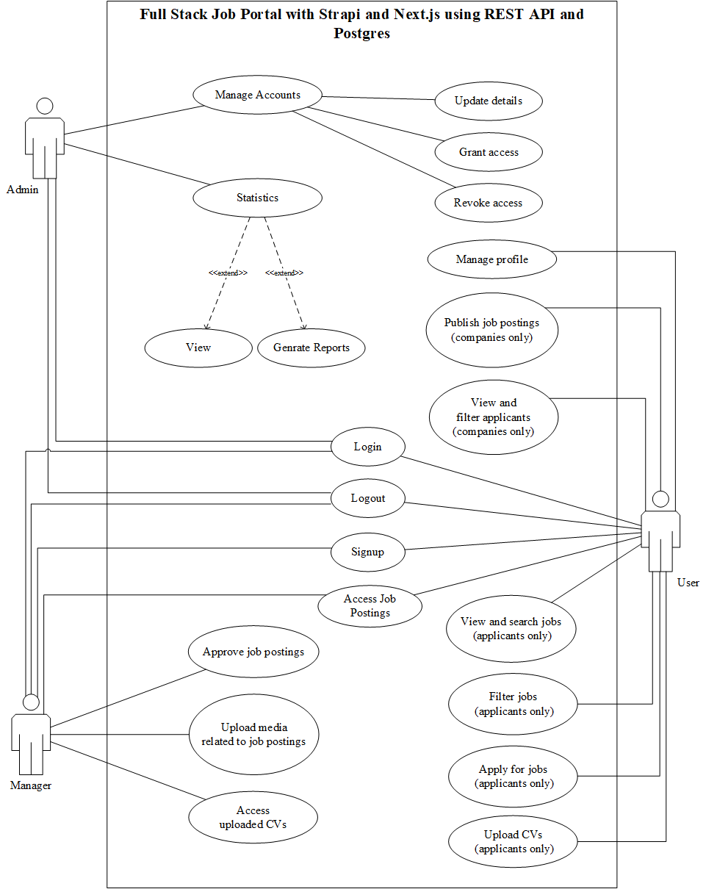

1.6.2 Usage Scenarios
1. Login
Use Case Title | Login
Use Case ID | 01
Actors | Admin, Manager, User
Description | Users can log into the system.
Actions | 1. User navigates to the login page.  2. User enters credentials.  3. User submits the login form.  4. System verifies credentials and grants access.
Alternative Paths | If credentials are incorrect, the user is prompted to re-enter them.
Pre/Post Conditions | Pre: User must have an account.  Post: User is logged in and redirected to the dashboard.
Exceptions | If the login fails, an error message is displayed.
Author | BC200414326

2. Logout
Use Case Title | Logout
Use Case ID | 02
Actors | Admin, Manager, User
Description | Users can log out of the system.
Actions | 1. User clicks on the logout button.  2. System logs out the user.  3. User is redirected to the login page.
Alternative Paths | None
Pre/Post Conditions | Pre: User must be logged in.  Post: User is logged out and session is ended.
Exceptions | If the logout process fails, an error message is displayed.
Author | BC200414326

3. Signup
Use Case Title | Signup
Use Case ID | 03
Actors | User (Applicants/Companies)
Description | New users can create an account.
Actions | 1. User navigates to the signup page.  2. Select role (Applicant/Company).  3. User enters required details.  4. User submits the signup form.  5. System creates a new account and redirects to the login page.
Alternative Paths | If any details are incorrect, the user is prompted to correct them.
Pre/Post Conditions | Pre: User must not have an existing account.  Post: New account is created and user is prompted to log in.
Exceptions | If the signup fails, an error message is displayed.
Author | BC200414326

4. Manage Accounts
Use Case Title | Manage Accounts
Use Case ID | 04
Actors | Admin
Description | Admin can manage users, managers, and companies accounts (update details, grant access, revoke access).
Actions | 1. Admin logs into the system.  2. Admin navigates to the “Manage Accounts” section.  3. Admin selects a user account.  4. Admin updates details, grants access, or revokes access.  5. Admin saves changes.
Alternative Paths | None
Pre/Post Conditions | Pre: Admin must be logged in.  Post: Account details are updated, access is granted or revoked as per the admin’s actions.
Exceptions | If the account update fails, an error message is displayed.
Author | BC200414326

5. Access Statistics
Use Case Title | Access Statistics
Use Case ID | 05
Actors | Admin
Description | Admin can view and generate statistical reports.
Actions | 1. Admin logs into the system.  2. Admin navigates to the “Statistics” section.  3. Admin views existing statistics.  4. Admin selects parameters for generating a report.  5. Admin generates and views the report.
Alternative Paths | None
Pre/Post Conditions | Pre: Admin must be logged in.  Post: Statistical reports are generated and viewed.
Exceptions | If the report generation fails, an error message is displayed.
Author | BC200414326

6. Access Job Postings
Use Case Title | Access Job Postings
Use Case ID | 06
Actors | User
Description | Users can access and view job postings.
Actions | 1. User logs into the system.  2. User navigates to the job postings section.  3. User views the list of available job postings.
Alternative Paths | None
Pre/Post Conditions | Pre: User must be logged in.  Post: Job postings are displayed to the user.
Exceptions | If job postings cannot be retrieved, an error message is displayed.
Author | BC200414326

7. View and Search Jobs
Use Case Title | View and Search Jobs
Use Case ID | 07
Actors | User
Description | Users can view and search for jobs.
Actions | 1. User logs into the system.  2. User navigates to the job search page.  3. User enters search criteria.  4. User views search results.
Alternative Paths | None
Pre/Post Conditions | Pre: User must be logged in.  Post: Job search results are displayed.
Exceptions | If the search fails, an error message is displayed.
Author | BC200414326

8. Filter Jobs
Use Case Title | Filter Jobs
Use Case ID | 08
Actors | User
Description | Users can apply filters to job searches.
Actions | 1. User logs into the system.  2. User navigates to the job search page.  3. User applies filters to narrow down search results.  4. User views filtered results.
Alternative Paths | None
Pre/Post Conditions | Pre: User must be logged in.  Post: Filtered job search results are displayed.
Exceptions | If the filter application fails, an error message is displayed.
Author | BC200414326

9. Apply for Jobs
Use Case Title | Apply for Jobs
Use Case ID | 09
Actors | User
Description | Users can apply for jobs.
Actions | 1. User logs into the system.  2. User navigates to a job posting.  3. User clicks on the apply button.  4. User submits application details.  5. System confirms the application.
Alternative Paths | None
Pre/Post Conditions | Pre: User must be logged in and have a completed profile.  Post: Job application is submitted.
Exceptions | If the application submission fails, an error message is displayed.
Author | BC200414326

10. Upload CVs
Use Case Title | Upload CVs
Use Case ID | 10
Actors | User (Applicants)
Description | Users can upload their CVs.
Actions | 1. User logs into the system.  2. User opens specific job posting.  3. User uploads their CV while applying for job.  4. System stores the CV.
Alternative Paths | None
Pre/Post Conditions | Pre: User must be logged in.  Post: CV is uploaded and stored.
Exceptions | If the CV upload fails, an error message is displayed.
Author | BC200414326

11. Publish Job Postings
Use Case Title | Publish Job Postings
Use Case ID | 11
Actors | User (Companies)
Description | User (Companies) can publish job postings.
Actions | 1. Companies logs into the system.  2. Companies navigates to the job postings section.  3. Companies creates a new job posting.  4. Companies publishes the job posting.  5. Job posting is available to users.
Alternative Paths | None
Pre/Post Conditions | Pre: User (Companies) must be logged in.  Post: Job posting is published and visible to users.
Exceptions | If the job posting fails to publish, an error message is displayed.
Author | BC200414326

12. View and Filter Applicants
Use Case Title | View and Filter Applicants
Use Case ID | 12
Actors | User (Company)
Description | Companies can view and filter job applicants.
Actions | 1. User (Company) logs into the system.  2. User (Company) navigates to the applicants section.  3. User (Company) can apply filters to view specific applicants.  4. User (Company) views filtered list of applicants.
Alternative Paths | None
Pre/Post Conditions | Pre: User (Company) must be logged in.  Post: Filtered list of applicants is displayed.
Exceptions | If the filtering fails, an error message is displayed.
Author | BC200414326

13. Approve Job Postings
Use Case Title | Approve Job Postings
Use Case ID | 13
Actors | Manager
Description | Managers can approve job postings.
Actions | 1. Manager logs into the system.  2. Manager navigates to the job approval section.  3. Manager reviews job postings.  4. Manager approves or rejects job postings.
Alternative Paths | None
Pre/Post Conditions | Pre: Manager must be logged in.  Post: Job postings are approved or rejected.
Exceptions | If the approval process fails, an error message is displayed.
Author | BC200414326

14. Upload Media Related to Job Postings
Use Case Title | Upload Media Related to Job Postings
Use Case ID | 14
Actors | Manager, User (Company)
Description | Actors can upload media related to job postings.
Actions | 1. Manager, User (Company) logs into the system.  2. Manager, User (Company) navigates to a specific job posting.  3. Manager, User (Company) uploads media (images, videos, etc.).  4. System stores the uploaded media.
Alternative Paths | None
Pre/Post Conditions | Pre: Manager, User (Company) must be logged in.  Post: Media is uploaded and linked to the job posting.
Exceptions | If the media upload fails, an error message is displayed.
Author | BC200414326

15. Access Uploaded CVs
Use Case Title | Access Uploaded CVs
Use Case ID | 15
Actors | Manager, User (Company)
Description | Manager, User (Company) can access uploaded CVs of applicants.
Actions | 1. Manager, User (Company) logs into the system.  2. Manager, User (Company) navigates to the applicants section.  3. Manager, User (Company) views uploaded CVs of applicants.
Alternative Paths | None
Pre/Post Conditions | Pre: Manager must be logged in.  Post: Uploaded CVs are displayed for viewing.
Exceptions | If the CV access fails, an error message is displayed.
Author | BC200414326

1.7 Development Methodology
1.7.1 Chosen Methodology
For the successful execution of our software development project, we adopted the VU Process Model, which is a hybrid approach combining elements from both the Waterfall and Spiral models. This model was chosen to leverage the structured nature of the Waterfall model while incorporating the iterative, risk-driven features of the Spiral model, thereby enhancing both the discipline and flexibility of our development process.
Overview of VU Process Model
The VU Process Model integrates the sequential phases of the Waterfall model with the iterative cycles of the Spiral model. It is particularly well-suited for projects requiring a blend of structured development and iterative refinement to manage risks effectively.

1.7.2 Reasons for Chosen Methodology
- Structured Approach: The Waterfall phases ensure a clear, structured approach to development, which is essential for maintaining order and clarity in project execution.
- Risk Management: The iterative Spiral phases allow for continuous risk assessment and mitigation, reducing the likelihood of project failure due to unforeseen issues.
- Flexibility: The model allows for iterative refinements, making it adaptable to changing requirements and stakeholder feedback.
- Comprehensive Testing: By integrating the Waterfall approach's thorough testing phases, the model ensures the system's robustness and reliability.

1.7.2 Work Plan (Gantt Chart)
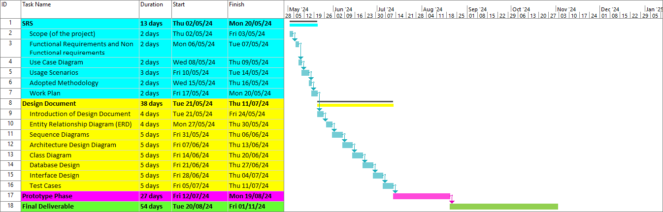

1.7.2 Project Schedule (Submission Calendar)

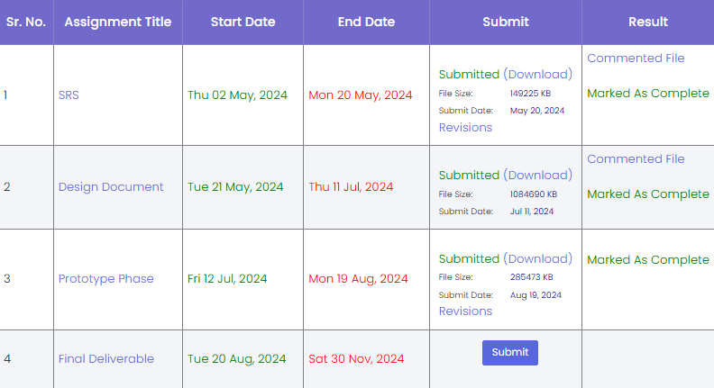

CHAPTER 2
Designing the Project

2.1 Introduction
This design document serves as a comprehensive blueprint for the software development project. It includes various diagrams and descriptions that outline the structure, relationships, and flow of the system components. The purpose of this document is to provide a clear and detailed understanding of the system’s architecture and design.
2.2 Purpose
The design document phase is crucial in the software development lifecycle due to following reasons:

- Clear Vision and Scope: It helps in defining the project's vision and scope, ensuring that there is a clear understanding of the project’s goals and deliverables.

- Detailed Planning: It allows for detailed planning of the system’s architecture and design, which aids in identifying potential risks and issues early in the development process.

- Reducing Misunderstandings: By providing visual representations and detailed descriptions, the document ensures that there is a clear and structured approach to the project, reducing misunderstandings and misinterpretations.

- Foundation for Development: It serves as a foundation for the development phase, guiding the development process according to the specified requirements and design.

- Reference Material: It acts as reference material throughout the development and maintenance phases, helping in troubleshooting and future enhancements.

- Quality Assurance: It provides a basis for creating test cases and ensuring that the system meets the specified requirements and design standards.

2.3 Scope
The scope of design document is to provide a comprehensive and structured blueprint for the development of the Full Stack Job Portal. It encompasses all essential elements of system design, including architecture, workflows, database structures, interface layouts, and test cases. The document serves as a detailed reference for developers, testers, and stakeholders to ensure alignment and clarity throughout the development process.
This document is specifically tailored to cover the following areas:
- System Overview: Defining the purpose and objectives of the job portal, including its user roles, functionalities, and overall goals.
- Design Components: Providing visual representations such as Entity Relationship Diagrams (ERD), Sequence Diagrams, Architecture Design, and Class Diagrams to explain system workflows and interactions.
- Database Design: Outlining the structure of the database using Postgres, ensuring efficient data storage, retrieval, and management.
- User Interface Design: Highlighting the design and functionality of critical interfaces such as login, signup, and job search pages.
- Functional Requirements: Documenting the specific functionalities for each user role (administrators, managers, companies, and applicants).
- Test Cases: Detailing scenarios and steps for testing to validate the functionality and reliability of the system.
The document's purpose is to act as a guide for the development team, reduce misunderstandings, and ensure that the project aligns with its goals. It will also serve as a foundation for future maintenance and enhancements of the platform.

2.4 Definitions, Acronyms and Abbreviations

• ERD (Entity Relationship Diagram): A graphical representation of the entities and their relationships within the database.
• REST API (Representational State Transfer Application Programming Interface): A software architecture style that uses standard HTTP methods to perform operations on resources (e.g., GET, POST, PUT, DELETE).
• Postgres (PostgreSQL): An open-source, object-relational database system used for data storage and management in the project.
• Admin/Administrator: A system user with the highest level of access, responsible for managing accounts, permissions, and monitoring system performance.
• Applicant/Job Seeker: A user who registers on the platform to search and apply for job opportunities.
• Job Postings: Listings created by companies to advertise open positions, including details like job description, qualifications, and deadlines.

2.5 Architectural Representation (Architecture Diagram)

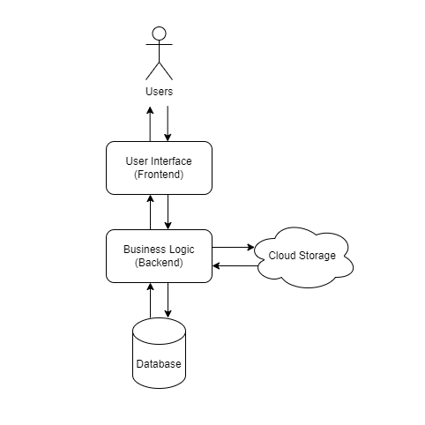

2.6 Dynamic Model: Sequence Diagrams

3.1 Login

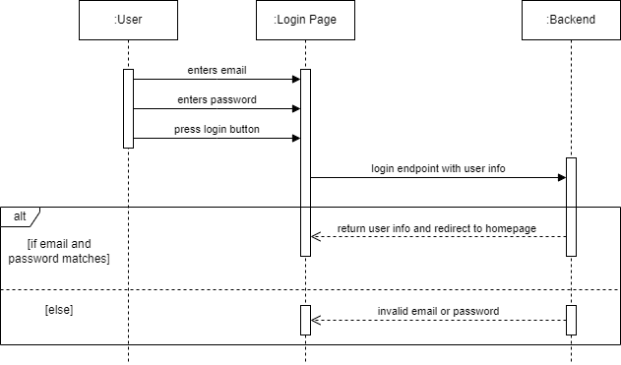

3.2 Logout

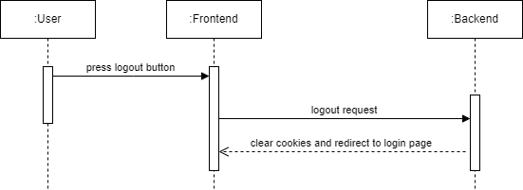

3.3 Signup

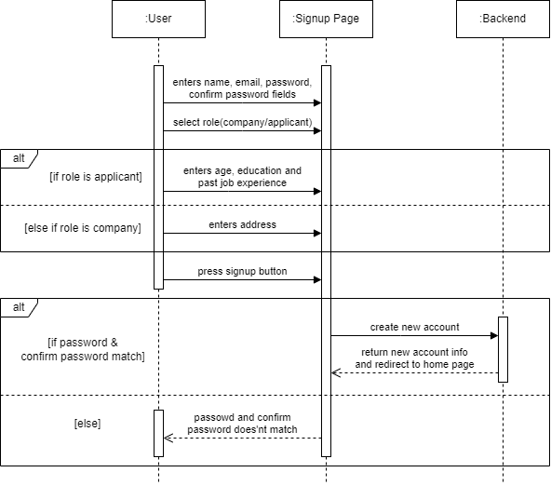

3.4 Manage Accounts

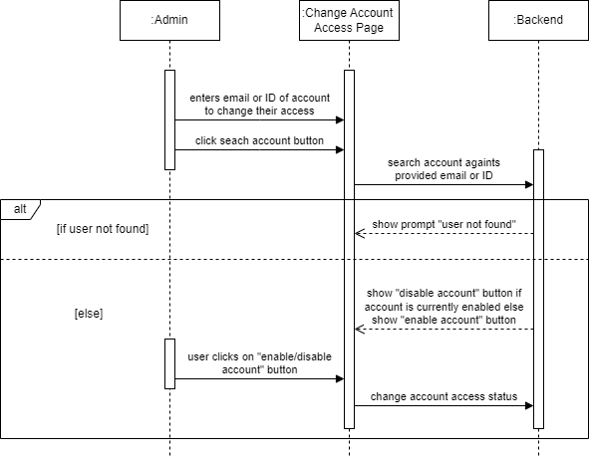

3.5 Access Statistics

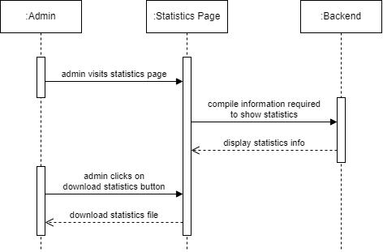

3.6 Access Job Postings

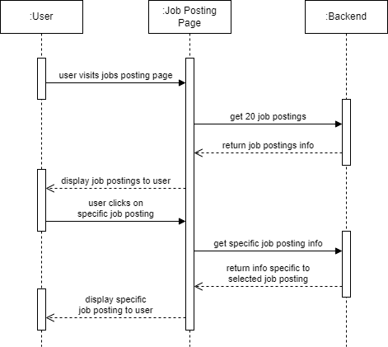

3.7 Search Jobs

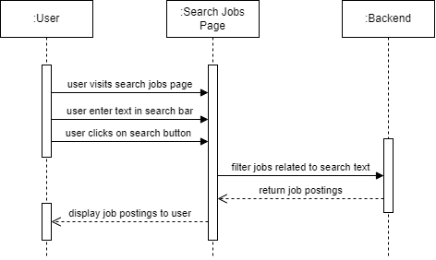

3.8 Filter Jobs

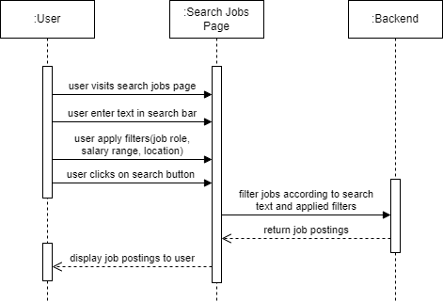

3.9 Apply for Jobs

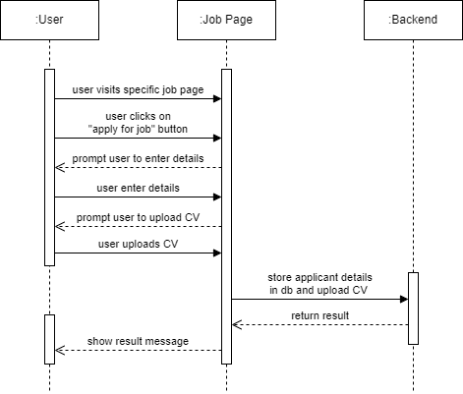

3.10 Upload CVs

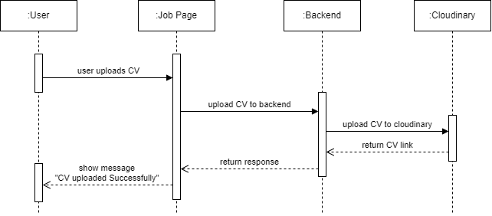

3.11 Publish Job Postings

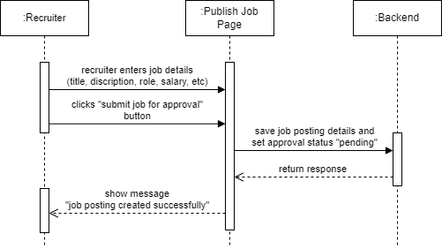

3.12 View and Filter Applicants

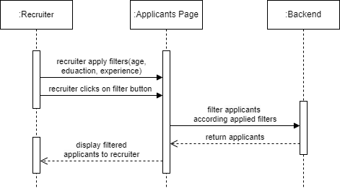

3.13 Approve Job Postings

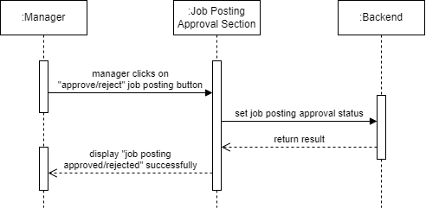

3.13 Select Applicant for Job

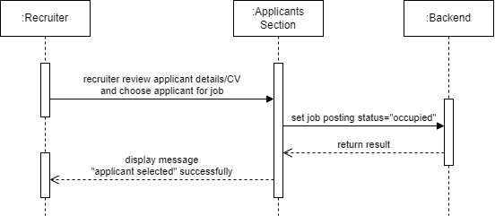

2.7 Object Model/Logical Model: Class Diagram

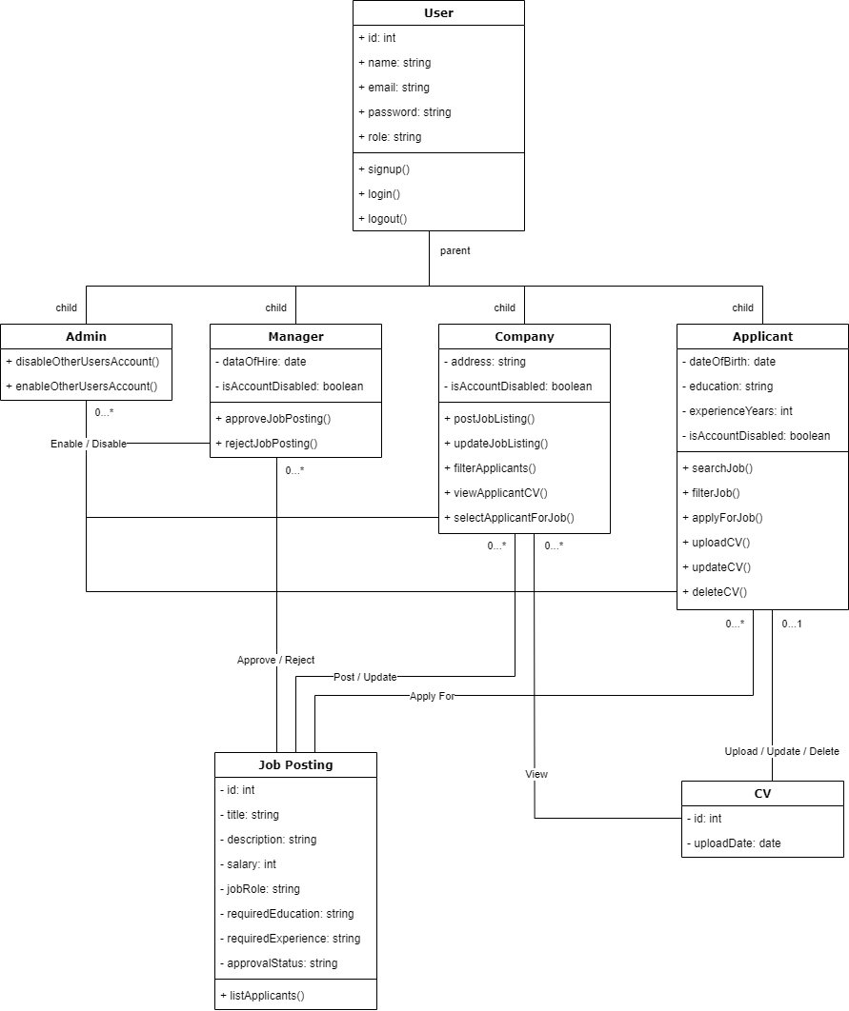

2.8 Database Model (Database Diagram)

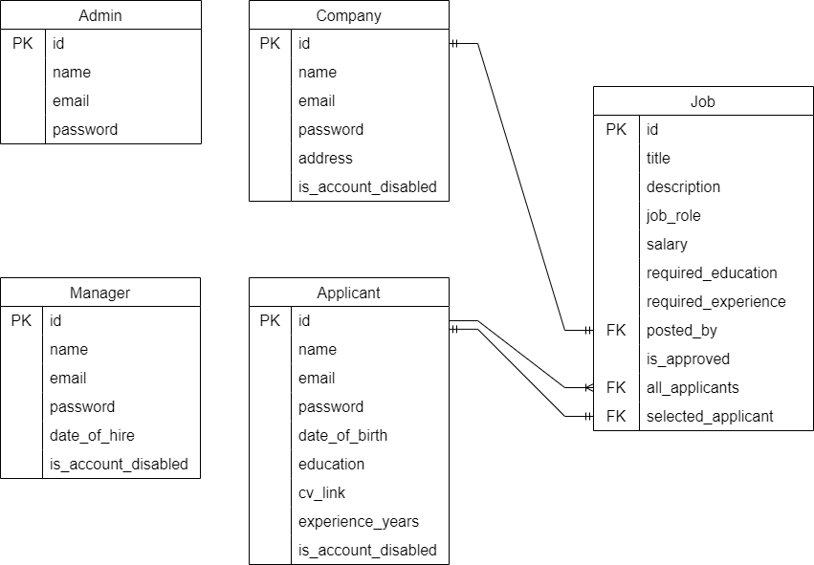

2.9 Graphical User Interfaces

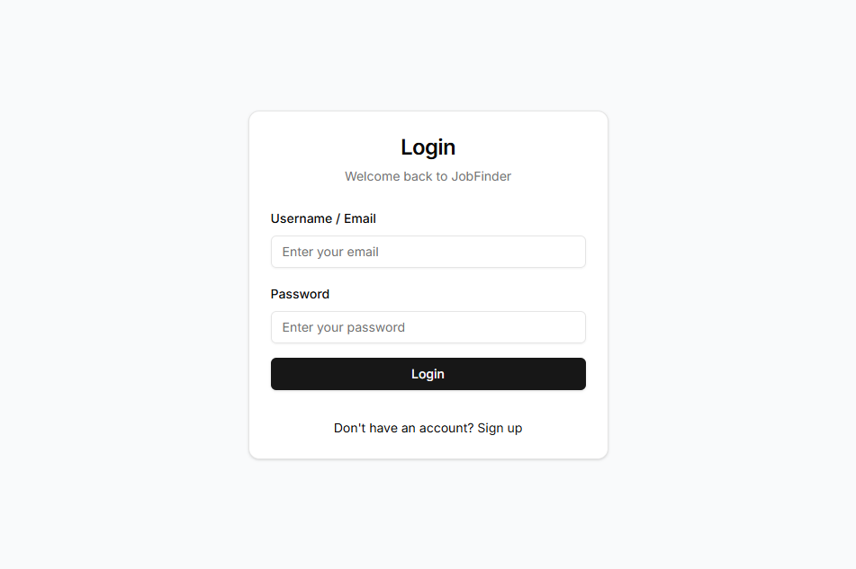
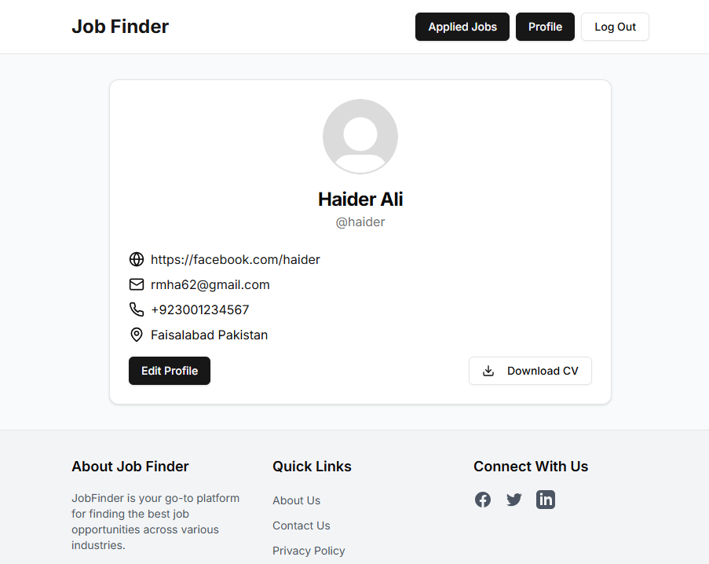

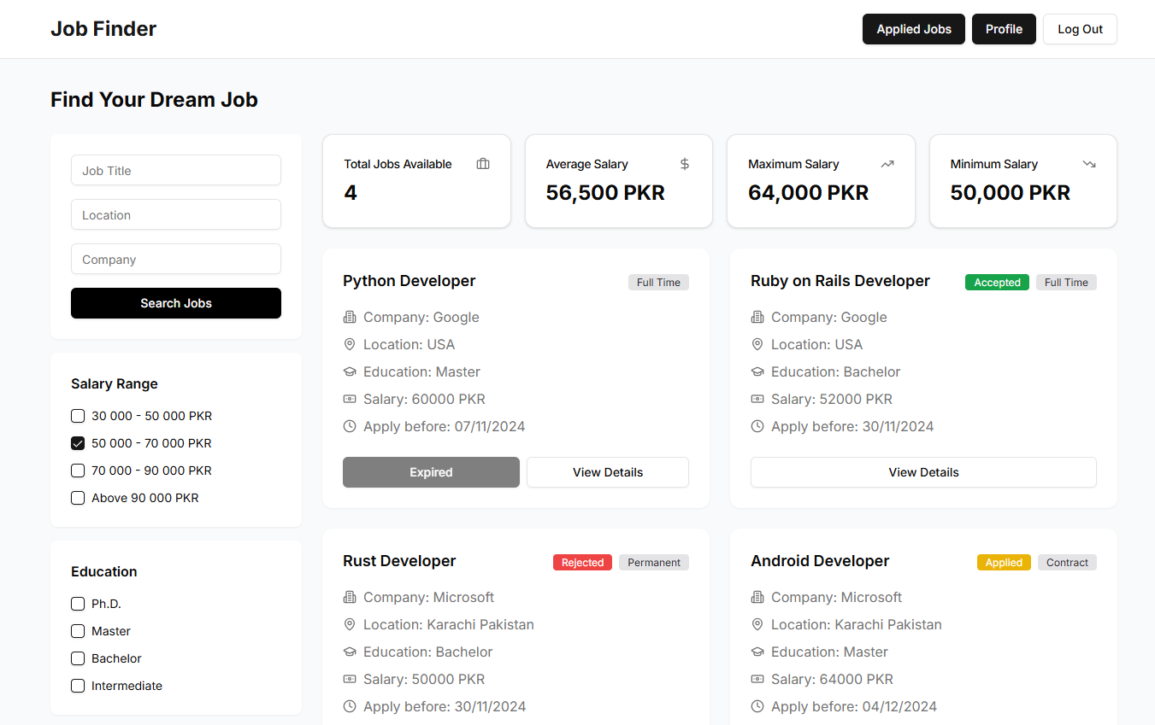

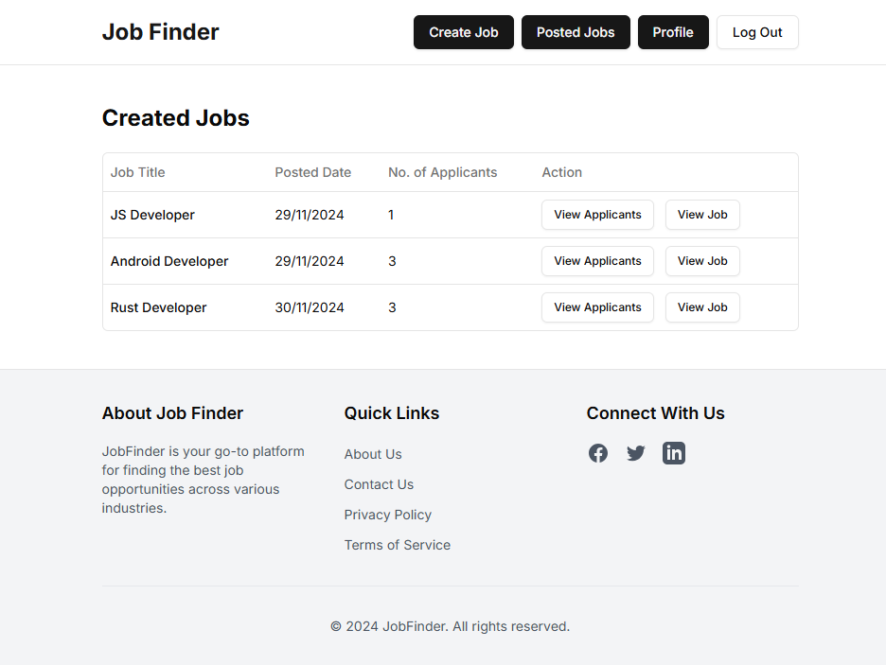

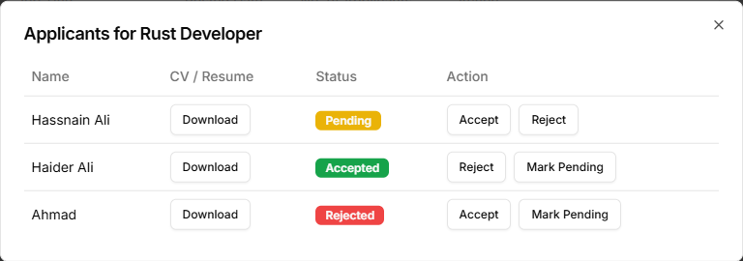

CHAPTER 3
Development

3.1 Development Plan (Architecture Diagram)

REFERENCES

• Sommerville, I. (2011). Software Engineering (9th Edition). Addison-Wesley.
- This book provided essential software engineering concepts for system design and methodology.
• Pressman, R. S. (2014). Software Engineering: A Practitioner's Approach (8th Edition). McGraw-Hill.
- Invaluable for structuring the development phases and design approach.
• Boehm, B. W. (1988). A Spiral Model of Software Development and Enhancement. ACM SIGSOFT Software Engineering Notes, 11(4), 14-24.
- Influenced the iterative approach used for risk management.
• PostgreSQL Global Development Group. (2024). PostgreSQL Documentation.
- Referenced for database management techniques and implementation.

APPENDIX

A.1 List of Acronyms
- API – Application Programming Interface
- ERD – Entity Relationship Diagram
- UI – User Interface
- DBMS – Database Management System

A.2 Glossary
- Applicant: A user who applies for jobs on the platform.
- Company: A business posting job openings.
- Admin: The system user with full access and management capabilities.

A.3 Database Schema
- Entities: User, Job Postings, Applications, CVs, and Statistics.

A.4 Risk Assessment
- Risk: Scope changes delaying the project.
- Mitigation: Using the Spiral Model for continuous feedback.

