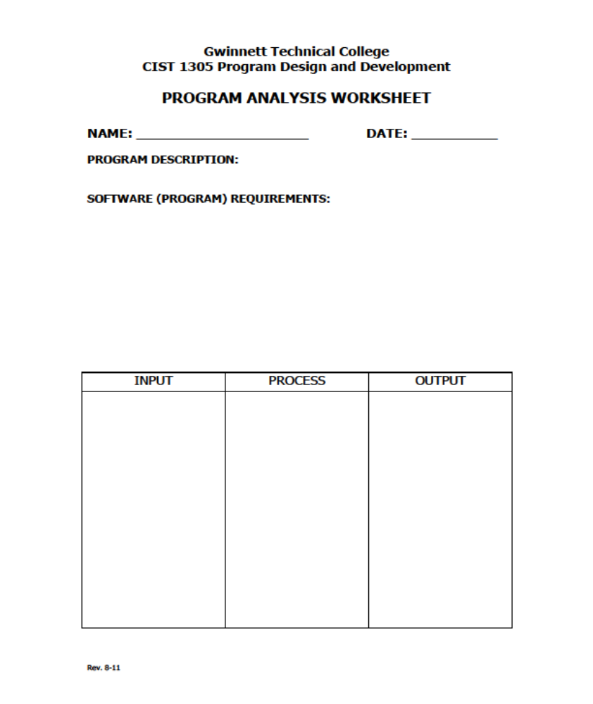
Group 2/6
02/19/2019
Savings Plan-Project 1
Display gross pay and net pay.
Display an allocated saving amount for clothes, school supplies, and savings bonds.
Display amount parents will match in savings.
dPayRate
dHrsWorked
dTotalHrs=Accumalate dHrsWorked over 5 weeks.
dGrossPay=dTotalHrs*dPayRate
dNetPay=dGrossPay-(dGrossPay* .14)
dClothesSavings=dNetPay *.10
dSuppliesSavings=dNetPay *.01
dSavingsBonds=(dNetPay-dSupliesSavings-dClothesSavings)*.25
dParentsBonds=dSavingsBond *.50
dGrossPay
dNetPay
dClothesSavings
dSuppliesSavings
dSavingsBonds
dParentsBonds

