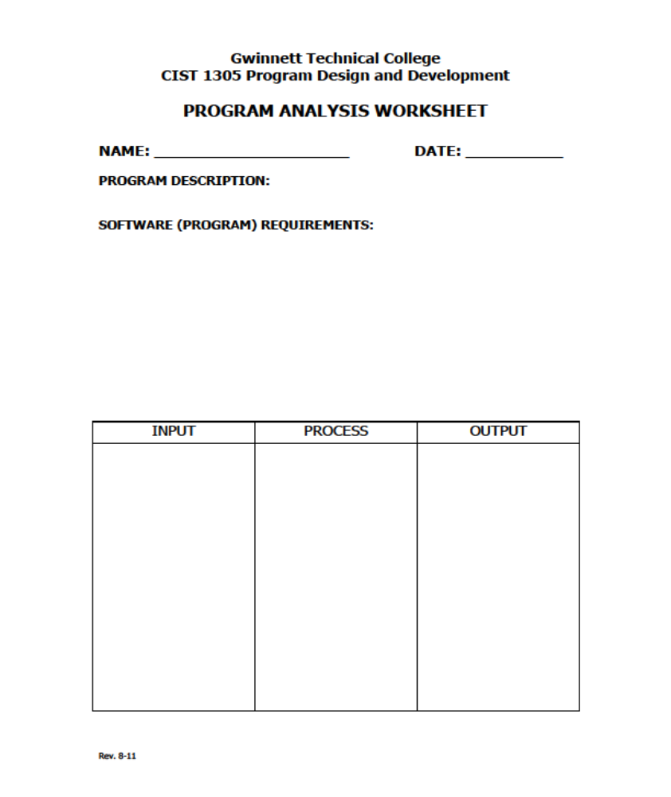
Renate Hamrick
02/18/2019
Student Lineup
Find out how many students
Collect student names while assigning to first or last position alphabetically.
iNumStudents
sName
Loop to assign alphabetically first and last student.
sFirstStudent
sLastStudent

