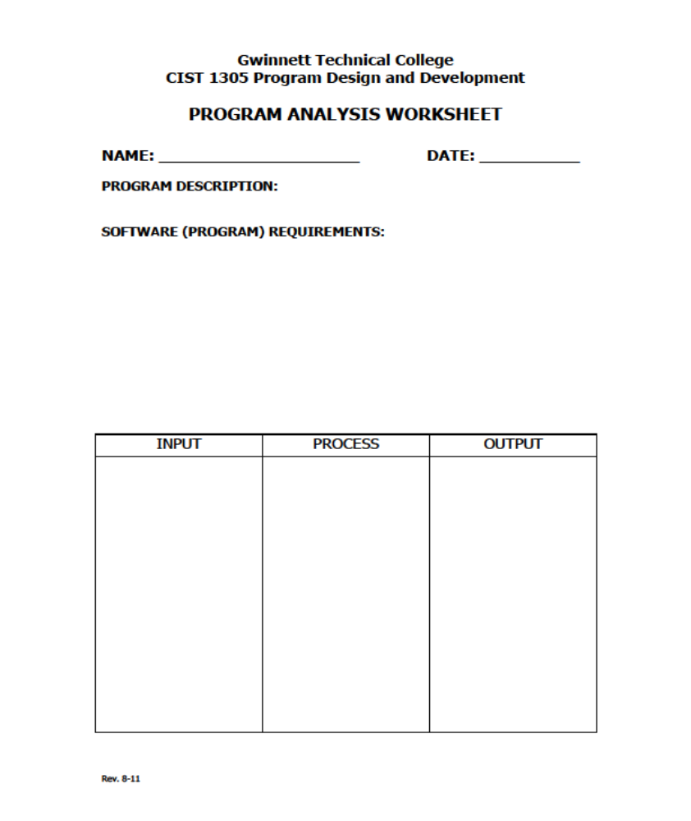
Renate Hamrick
4/15/2019
Checkers
Game of checkers.
Load board.
Load menu.
Move pieces.
Jump and eliminate opponent pieces.
Menu options
-Coordinates of piece to move
-Coordinates of spot to move to

Process for loading board

Process for loading pieces

Process for moving pieces

Menu
loadBoard
loadPieces

