French Revolution Conspiracies: Illuminati Rebirth, Justified Radicalism, and the Downfall of Religion
The French Revolution is popularly recorded by traditional educational texts, peer reviewed journals, and literature, in addition to being taught by the most basic of public education via elementary history classes. Because of this, its primary causes, perpetrators and outcomes are widely known, at least in the American education system. However, behind the scenes, there was a wave of fear sweeping France involving the overturning of religion, the renewed presence of the Illuminati in Germany and surrounding areas, and the believed use of revolution for world domination and manipulation. One must view the French Revolution as a painting done in pointillism, as every individual dot contributing to the revolution plays a different role, containing a wide range of magnitudes, to comprise the chaotic and conspiratorial canvas that is the French Revolution. In particular, my project will be looking at the conspiracy surrounding the Illuminati’s probable involvement in causing the French Revolution. The purpose of my project is to identify and explain the dots (we are going to call them nodes), measure their importance (through degree, average degree, modularity class, Eigenvector centrality, their clustering coefficient, etc. , identify the variance of weak and strong connections existing in their presence (mostly by the weight of the edges), and to identify the various roles of the multitude of networks involved. Members of this secret society, French officials, religious leaders, Freemasons, and alleged conspirators alike all are under the microscope for potentially instigating, causing, and affecting the wild revolution that forever changed the social and political structure of France. Due to this, I will be looking at the implications of religion, French leadership at this point in history, relations to surrounding European countries, and the context of the panic that ensued to cause these outlandish claims at the time. Regardless of thoughts or beliefs surrounding the presence of this secret, aloof society in modern day happenings, it is important to consider the viable historical evidence of its involvement at this point in history. As pointed out by R. of TopSecretWriters.com, “This isn’t the Illuminati of strange and outrageous conspiracy theories that you may read about online today, but a real, active secret society well documented by historians through member journals and documents throughout the period of the French Revolution(R. , 2011, p. 1).”
First, I am going to identify the initial conspiracy that sparked such vast research, claims, absurd rumors and undeniable truths. In my research, I am focusing on the conspiracy that the Illuminati, a secret society founded in Germany in the 18th century, operated covertly and discreetly through recruitment of influential leaders and abuse of religious sanctity to cause the French Revolution. To understand the roots of this conspiracy, it is important to identify the most influential node in this intricate network, Adam Weishaupt. He founded the Illuminati in 1776 while assuming his position as a professor of canon law at the University of Ingolstadt (Taylor, 2014, p. 293). Weishaupt was originally educated among Jesuits, but he soon became their worst enemy after the abolishment of their organization ((Robison & Forman, 1798, p. 46). After their dissolution, Weishaupt began working towards a new order and hinted to former Jesuits that they would recover and restore their influence (Robison & Forman, 1798, p. 47). However, most of the Jesuits he associated with declined his offer (except for two), sending Weishaupt on a mission against the Jesuits to form his new order, the Illuminati (or Illuminaten, as it was known in Germany (Robison & Forman, 1798, p. 47). Within a short amount of time, the organization grew to over two thousand members across Germany,including Bavaria, northern Germany, and Rhineland (Wilson, 1990, p. 164). Other influential nodes in this network of major influencers include two writers, who were relatively uninvolved in actual attempts to cause the revolution (conducted allegedly by Illuminati members) but are largely responsible for the conspiracy itself. These writers include John Robison and Abbé Augustin de Barruel who, unbeknownst of the other, both composed eerily similar accounts of the French Revolution in relation to a conspiracy about the downfall of religion and abuses of power (Taylor, 2014, p. 293). However, for purposes of my research and focusing on one consistent account, my findings will reflect the accounts of John Robison and his memoirs. In addition to these two, another writer, John Gifford, accused the Illuminati of reflecting their revolutionary turmoil on Germany, plunging them into “the same chaos of anarchy and disorder to which France has been a prey for the last ten years(Taylor, 2014, p. 295).” Regardless of the Illuminati’s proclaimed dedication to Enlightenment and moral ideals, many of their writings and expressed beliefs pointed to a desire for eradication of the state (Wilson, 1990, p. 164). Both writers claimed that Illuminati members, displeased with religious and government officials in Bavaria (largely due to getting shut down by Bavarian officials), had developed a plan for the “global subversion of church, state, and society; using an intricate system of seduction, secrecy, and hierarchy, members of the society intended to radicalize existent discontent with established systems of ecclesiastical and political government(Taylor, 2014, p. 293).” Many oppose this theory because the Illuminati was supposedly persecuted between 1785 and 1787 by the Elector of Bavaria, but by nature of being a secretive society, they allegedly survived undercover by infiltrating German reading societies, Masonic lodges, and eventually important French lodges (where their master plan unfolded) (Taylor, 2014, p. 293). The believability and validity of this theory was reiterated in a 1965 journal published by Robert Welch, founder of the John Birch Society, whom claimed the German Illuminati had evil roots in events such as Workmen’s Compensation Acts, Medicare under Lyndon Johnson, both World Wars, the Russian Revolution, the expansion of Communism, etc (Wilson, 1990, p. 163). While this may evoke feelings of skepticism regarding potentially outlandish UCT’s surrounding the Illuminati, Welch has a valid point regarding the French Revolution, as reasonable ideological connections were made to 19th century politics all the way up to the Nazi takeover (Wilson, 1990, p. 164). In alignment with the supposed Enlightened ideals reflected in Illuminati beliefs came the concept of enlightened bsolutism (Wilson, 1990, p. 164). This entailed faith in an absolute ruler and the potential for mass reform. By recruiting influential leaders and scholarly thinkers from Masonic lodges, the Illuminati evoked paranoia across Germany, resulting in their suppression by the Bavarian government (Wilson, 1990, p. 164). However, many believed attempts to shut down the Illuminati would only make them more powerful, raising suspicions about potential uprisings or revolutions led by them (Wilson, 1990, p. 164).
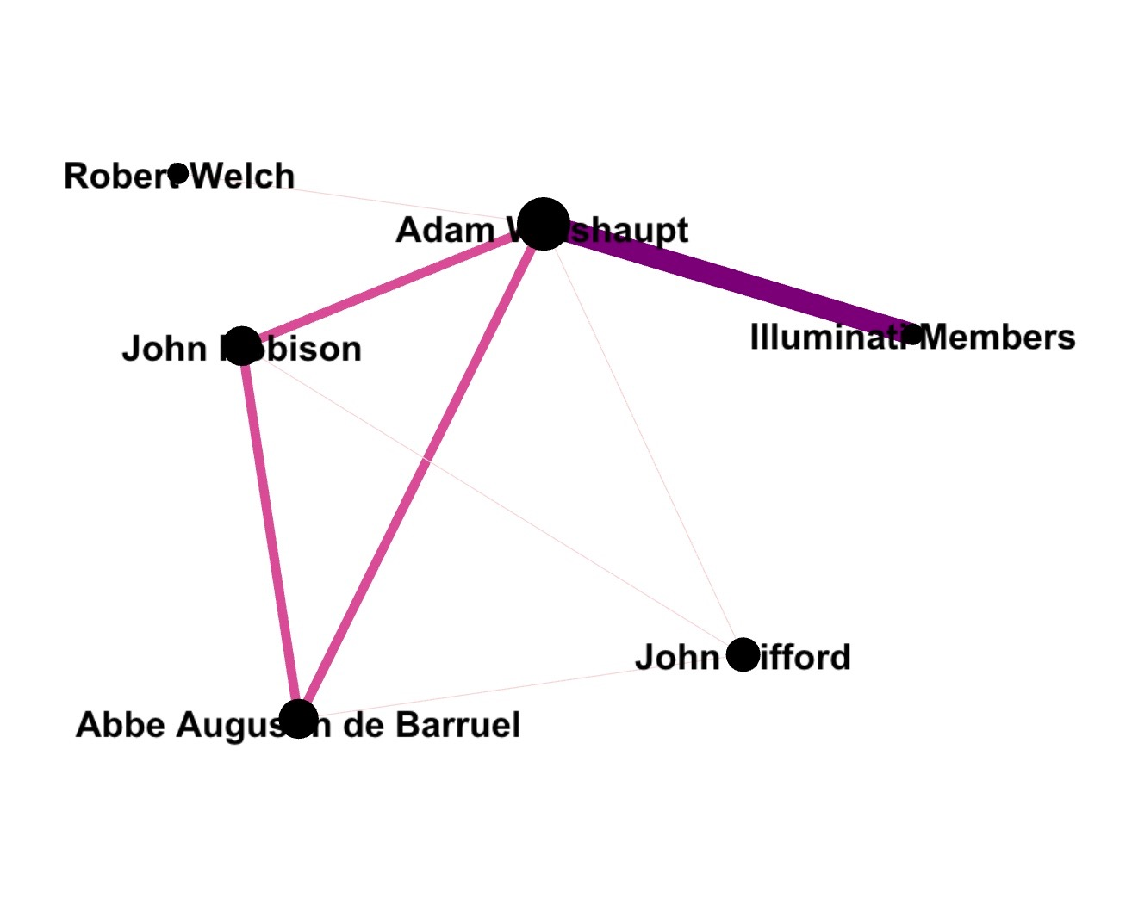

The connections mentioned in the previous paragraph can be shown by the above image which shows a small, yet intricate network. The nodes are sized according to Eigenvector centrality, in which Adam Weishaupt is the largest node. The edges are organized by weight, on a spectrum of colors. As you can see, Adam Weishaupt formed triadic closure along with John Robison and Abbe Barruel, as both writers did not know about each other but wrote about the same man, unveiling his society and digging deep into his practices. While this connection could be a technically weak bond/edge (as none were family, friends, or even acquaintances), the weight of these connections is strong pertaining to this conspiracy in itself. As far as John Robison, Abbe Barruel, John Gifford and Robert Welch, they form a clique of writers, essentially, as they all wrote on similar topics with almost identical purposes. Although the inclusion of a node entitled “Illuminati Members” may seem vague,I used a shorthand representation to focus on major actors in discovering the conspiracy. Additionally, this label could potentially represent homophily in their collection, as these members were bound by similar beliefs and backgrounds (more on that later).
Next, understanding the bigger picture of this conspiracy entails diving into the vast, intricate cluster of proclaimed Illuminati members (mentioned in Robison’s Proofs of a Conspiracy against all the Religions and Governments of Europe, Carried on in the Secret Meetings of Freemasons, Illuminati, and Reading Societies). While the large number of known members are an important piece of the conspiratorial, revolutionary puzzle, it is more useful to focus on members with the highest degrees, including, but not limited to, F.H. Bode, F.H Busche, Knigge, Marquis of Constanza and Bassus (Robison & Foreman, 1798, p. 93-96). Some factors contributing to this include these members’ associations with Freemasonry, as Bode, Busche, Marquis of Constanza, Knigge, and the Duke of Orleans were all known masons (Robison & Forman, 1798, p. 179).
The first node I’d like to focus on will be Johann Christoph Bode, known in texts as just Bode, who was arguably the most influential member in the Illuminati in regards to connecting German roots to French lodges pre-revolution. He is one of the largest reasons people associated the Illuminati with the French Revolution, as him and F.H. Busche visited France two years prior to the outbreak of the revolution to recruit Masons from the lodge “Anna Amalia” for Illuminati (Wilson, 1990, p. 165). Many of the members he approached were later head revolutionaries. In addition. Baron Knigge was an influential node, as he proposed the unity of the lodges of Frankfurt and Wetzlar to promote mutual “forbearance and intercourse (Robison & Forman, 1798, p. 45).” Along with Knigge, they used their Masonic connections and influence to recruit members across French lodges and “wormed” their way into the lodges to gain “entire command of the Fraternity(Robison & Forman, 1798, p. 180).” To improve this plan, the Marquis of Constanza stepped in to help Knigge, and formed a constitution with several participating lodges to form a plan called the Eclectic or Syncritic Masonry of the United Lodges of Germany (Robison & Forman, 1798, p. 45). However, upon hearing word of such recruitment and planning, the Elector of Bavaria took it upon himself to investigate and disapprove of these actions. He was especially suspicious of the Lodge Theodore, where allegedly its members had spoken of taking over the world (Robison & Forman, 1798, p. 48). Subsequently he forbid the secret meetings and assemblies taking place at the time, shutting down Masonic lodges (Robison & Forman, 1798, p. 48).
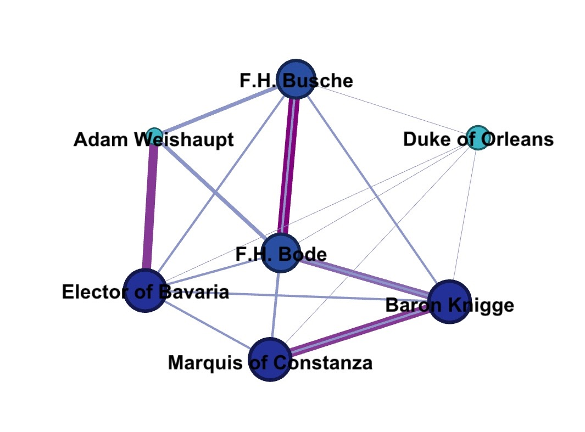
The above network shows the connections mentioned in the previous paragraph. The nodes are ranked by degree, with Adam Weishaupt and the Duke of Orleans having the lowest degrees. As opposed to the previous image, Adam Weishaupt is far less of an influential node, as the other members of the Illuminati with higher degrees worked closely with one another with little to no input from Weishaupt in the aforementioned scenarios. It is important to note that no nodes in this particular network serve as bridges; this reveals the close ties and interconnectedness of the involved persons.
As mentioned earlier, some of the largest concerns surrounding the potential disruption of religion and manipulation of religious officials in France at the time. The biggest node in this scenario was one of the most influential perpetrators of religious involvement with the Illuminati was the Duke of Orleans, who held the title of Grand Master of France, and was mentioned previously as a Freemason and associate of Bode, Busche, the Marquis of Constanza, and Baron Knigge. In Robison’s account, he describes Orleans as a “detested name”, as the Duke only used Illumination as a method to satisfy his selfish needs and “wicked heart” (Robison & Forman, 1798, p. 171). He was first brought into the order by Mirabeau, whom was essentially the antithesis to the Duke of Orleans, as he proudly exclaimed allegiance, honesty, and sacrifice to the order. However, it was thought that Mirabeau would happily use the Duke of Orleans when it “served him but would just as readily jump into bed with other parties (Muirden, 1989, p. 109).” In his position as Grand Master of France, Orleans essentially had access to all “Improved lodges (Robison & Forman, 1798, p. 174).” However, he was a pawn to the Illuminati, as they used him by lying, cheating, and ruining him despite his devotion (Robison & Forman, 1798, p. 172). At one point, Mirabeau, along with several Illuminati members including Sieyes, Pethion and a few unnamed members, attempted to seize Orleans’ fortune, influence and power to divide amongst themselves and other Illuminaten (Robison & Forman, 1798, p. 172). Although Orleans was aware of this plan, he still maintained a cheery and confident manner, most notably “during the contests between the Court and the Parliament of Paris, he courted popularity with an indecency and folly that nothing can explain but a mad and fiery ambition which blinded his eyes to all consequences (Robison & Forman, 1798, p. 172).” Orleans also had the potential to cause mass disruption in France at the time due to his financial status. Apparently, he was second only to King Louis XIV in land ownership across France, and had enough money to hire “‘idea men’ to oppose the crown (Muirden, 1989).” Now, in relation to religious corruption, another node comes into play. This highly revered man, known as Cardinal Dubois, was just as malicious as Orleans. As a Cardinal, he worked within the fabric of the Catholic church and attempted to strengthen the existing brotherhood for his benefit, by insuring their security, promising the ability to indulge upon freedom from Louis XIV and the oppression of the church (Robison & Forman, 1798, p. 17-18). Unfortunately, these attempts were halted by his death, but the Regent Orleans continued this sabotage to where religion across France was laughed at. Over time, Christianity became a nuisance to the French, and became a source of oppression rather than sanction (Robison & Forman, 1798, p. 18).
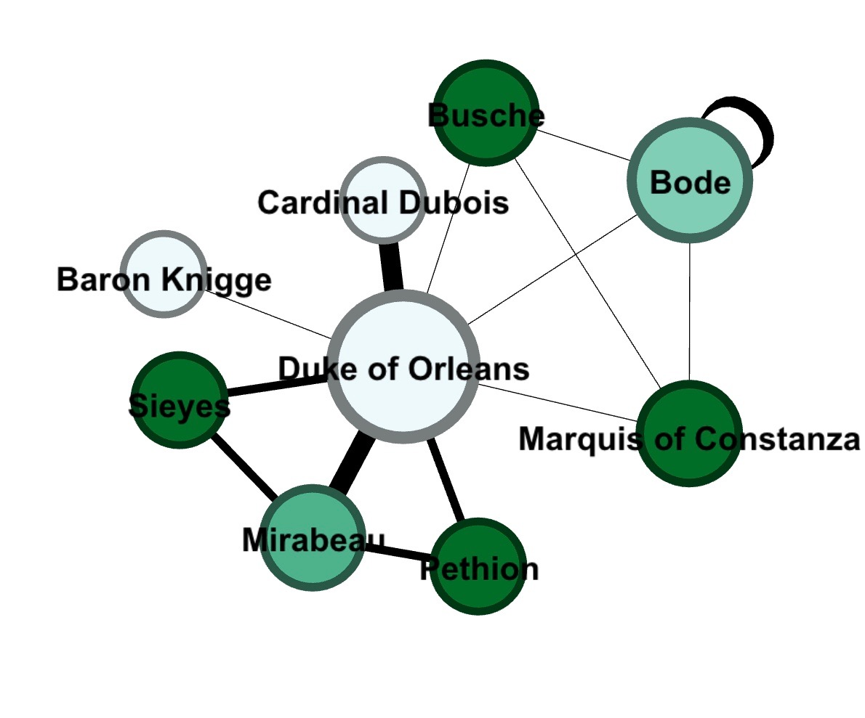

...what is that?

The above image shows the network surrounding the Duke of Orleans, who proved to be a major pawn in the Illuminati’s associations with the French Revolution. The nodes are sized accordingly due to degree centrality, in which the Duke of Orleans has an incredibly high degree due to his various connections, both weak and strong. It can be shown that the strongest edges are to Mirabeau and Cardinal Dubois, both important nodes in regards to the Duke of Orleans’ influence. As you can see, Orleans and Mirabeau’s camaraderie resulted in two instances of triadic closure, between Orleans, Sieyes, and Mirabeau and Orleans, Pethion, and Mirabeau.
As I mentioned earlier, the French Revolution can be seen as a puzzle with a multitude of parts that fit in different ways to form a complete picture. However, in relation to the Illuminati’s involvement in the revolution, this is no child’s puzzle, and the pieces (nodes) are complex, misshapen, and occasionally missing. Regardless of the complexity of the secret society, contributions to the puzzle are crucial nonetheless. These pieces, as brought forward by my research, largely through John Robison’s accounts in his writings Proofs of a Conspiracy against all the Religions and Governments of Europe, Carried on in the Secret Meetings of Freemasons, Illuminati, and Reading Societies), entail the behind the scenes working of the French Revolution via Freemasonry, religious officials and corrupt individuals in positions of leadership. The main vehicles of this sabotage included Adam Weishaupt, founder of the Illuminati, Johann Christian Bode, F.H. Busche, the Marquis of Constanza, the Duke of Orleans,Mirabeau, Cardinal Dubois, Baron Knigge, and the Elector of Bavaria. Through the images produced by Gephi, I attempted to break down the various connections present in the entire network of Illuminati members to show smaller-scale connections and variations in degree, Eigenvector centrality, etc. However, this extremely vast network is, to an extent, complicated by social network analysis due to varying accounts (one reason why I obtained almost all of my research from John Robison’s book) and historical accuracy. However, I found paying attention to Eigenvector Centrality to be most helpful, as the nodes with the strongest, most relevant connections appeared to be the main keys to connecting the Illuminati with French revolutionaries. In regards to the public’s attitude toward the probable causes of revolution, triadic closure plays in an important role, as the most basic of connections tended to cause a stir (i.e. when Bode and Busche visited French lodges two years prior to the outbreak of revolution, forming bonds with French Freemasons). Another example of this would be the Duke of Orleans, who, as the Grand Master of France, formed close ties to several Illuminati members via interactions with Mirabeau.
In conclusion, my project was a clustered attempt at analyzing and pointing out the connections between the Illuminati and potential causes of the French Revolution. Prior to my research, I admittedly would have classified this theory as a UCT given the modern implications of Illuminatism, especially in relation to popular culture myths. However, it is well documented that the Illuminati were a real, functioning society in the 18th century and on, whom formed to create a sense of brotherhood, fight against corrupt rule, and ponder over potential government ideals to combat the oppressive nature of European governments at that point in history. In my findings, I have concluded that it is completely plausible that this secret society was involved in the French Revolution, as their ideals of reform and enlightenment align with the reasons, causes and motivatons behind the revolution. Not to say that this puzzle has been or will ever be solved, but through understanding of the people involved, their place in French/German society at the time, affiliations with secret societies or government operations, and alleged intentions, a clear connection can be made. My final and complete network can be shown by the visualization below, as well as my Github repository (TBD).
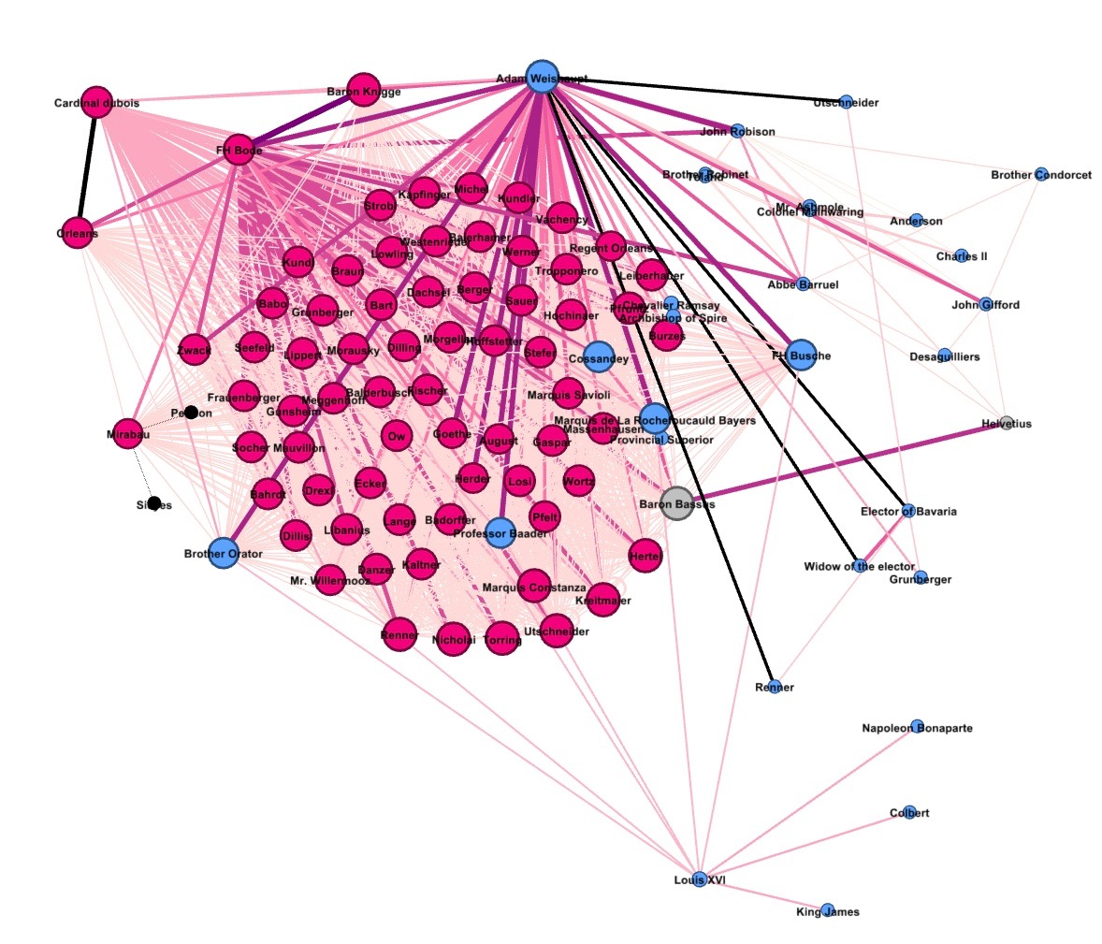
Works Cited
Muirden, G. (1989, Spring). Conspiracy Theory and the French Revolution. Journal of
Historical Review,9(1), 109-115. Retrieved December 10, 2016, from
http://www.ihr.org/jhr/v09/v09p109_muirden.html
R. (2011, January 31). The Illuminati and Causes of the French Revolution. Retrieved December
11, 2016, from
http://www.topsecretwriters.com/2011/01/the-illuminati-and-causes-of-the-french-revol
ution/
Robison, J., & Forman, G. (1798). Proofs of a conspiracy against all the religions and
governments of Europe: Carried on in the secret meetings of Free Masons, Illuminati,
and reading societies. New-York: Printed and sold by George Forman, no. 64,
Water-Street, between Coenties and the Old-Slip. (Original citation)
Taylor, M. (2014). British Conservatism, the Illuminati, and the Conspiracy Theory of the French
Revolution, 1797–1802. Eighteenth-Century Studies 47(3), 293-312. The Johns Hopkins
University Press. Retrieved December 12, 2016, from Project MUSE database.
Wilson, W. D. (1990). Weimar politics in the age of the french revolution: Goethe and the spectre
of illuminati conspiracy. Goethe Yearbook, 5, 163. Retrieved from
http://libproxy.lib.unc.edu/login?url=http://search.proquest.com/docview/1308020692?ac
countid=14244

