Predicting categories and indexing tags for biomedical literature

In this project we will try to train machine learning models that are useful for characterizing and indexing medical literature. We will work on documents that are freely available from the PubMed Central repository at the US National Library of Medicine, but our goal is to develop models that can be broadly applied to biomedical text.

Pubmed Central data can be obtained by running a search here:
https://www.ncbi.nlm.nih.gov/pmc
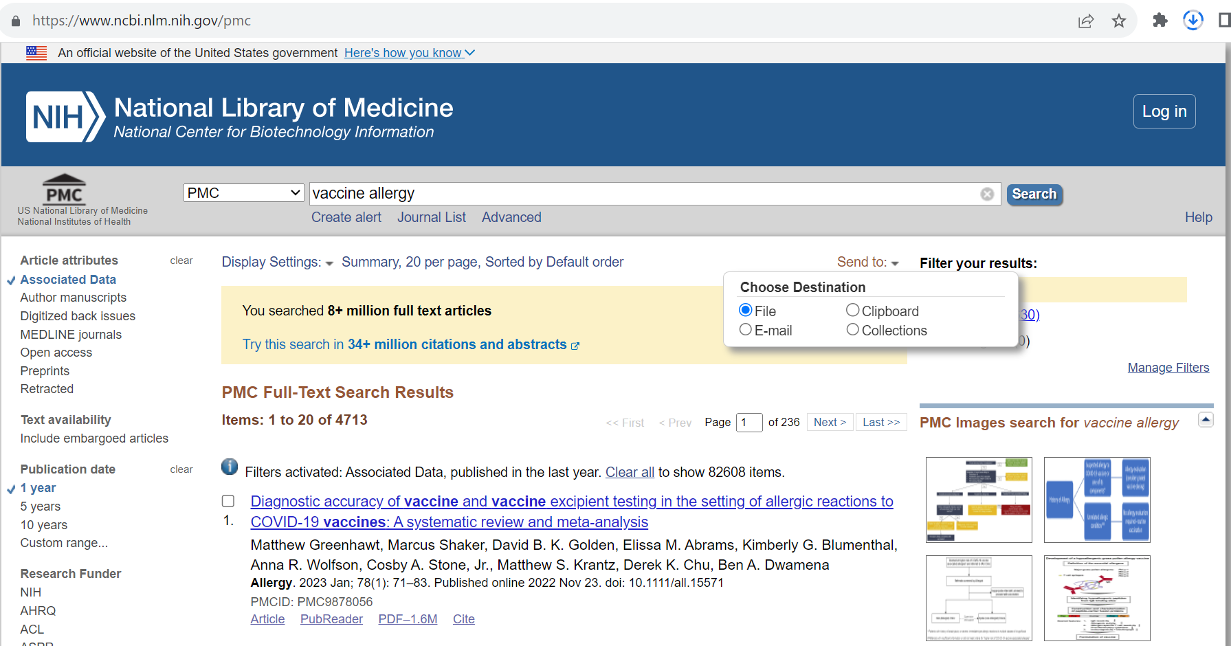

To retrieve a reasonably small dataset, I ran the query “vaccine allergy”, limiting the results to the past one year. Results we saved to an XML file by selecting “Send to”, “File”, then “XML”. The notebook “PMC_data_extraction.ipynb” pulls a tabular dataset from this file, where each row represents a paragraph of text and includes columns for the article ID (PMID), the paragraph number within the article (paragraph 0 is the title), and the ‘section path’ (a concatenation of all the section and subsection headings leading to that paragraph). Here are the first few rows:
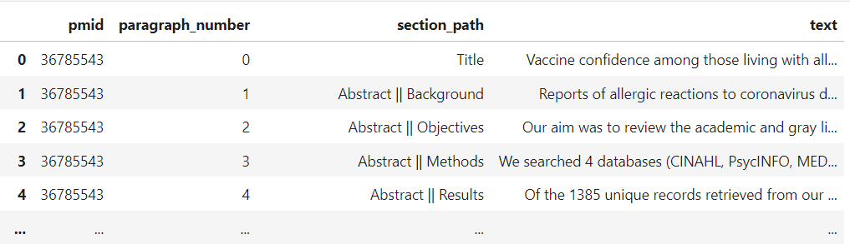

Project options

- Predict section from sentence
  - Sections: canonicalize these, maybe using regex?
    - Abstract
    - Introduction
    - Methods (aka “Materials and Methods”)
    - Results
    - Discussion
  - Subsections (e.g., ‘Results || Adverse Events’ )
    - use semantic clustering to find types of subsections

- Tag curation for MeSH terms
  - Retrieve MeSH terms by PMID
    - organize into tables, apply by joining
  - Predict MeSH terms from
    - Article
    - Abstract
    - Paragraphs
    - Sentences
  - Compare distributions between predicted and provided MeSH terms
  - Use of tags for model interpretability; demo of error terrain analysis

- Visualization: create interactive graphs
  - Parts of XML documents
  - Cross-referencing between articles
  - Taxonomy of MeSH terms

- Go big: use big data tools to extract large amounts of structured info from PubMed Central articles
  - Streaming parser; API?
  - Validate process using DTD; develop tests
  - Write results to database or spark
  - Explore things you can do with big data that you can’t do with smaller data-oriented
    - model performance
    - completeness of MeSH tree.

Models predicting subsections may be useful for identifying text that concerns topics like statistical methods or adverse events. We will want to figure out if a general adverse event model is useful, or whether it would be better to train a panel of models for different domains (surgery, medications, vaccines, etc.).

MeSH terms may provide a large number of useful labels for training biomedical text classifiers. This video describes how MeSH terms are defined, applied and used (notice how old it is):
‘Branching Out: The MeSH® Vocabulary’ https://www.nlm.nih.gov/bsd/disted/video/index.html

