Adaboost:

1. The output of the other learning algorithms ('weak learners') is combined into a weighted sum that represents the final output of the boosted classifier.
2. Subsequent weak learners are tweaked in favor of those instances misclassified by previous classifiers.
3. At each iteration of the training process, a weight wt is assigned to each sample in the training set equal to the current error E(Ft-1(xi)) on that sample.

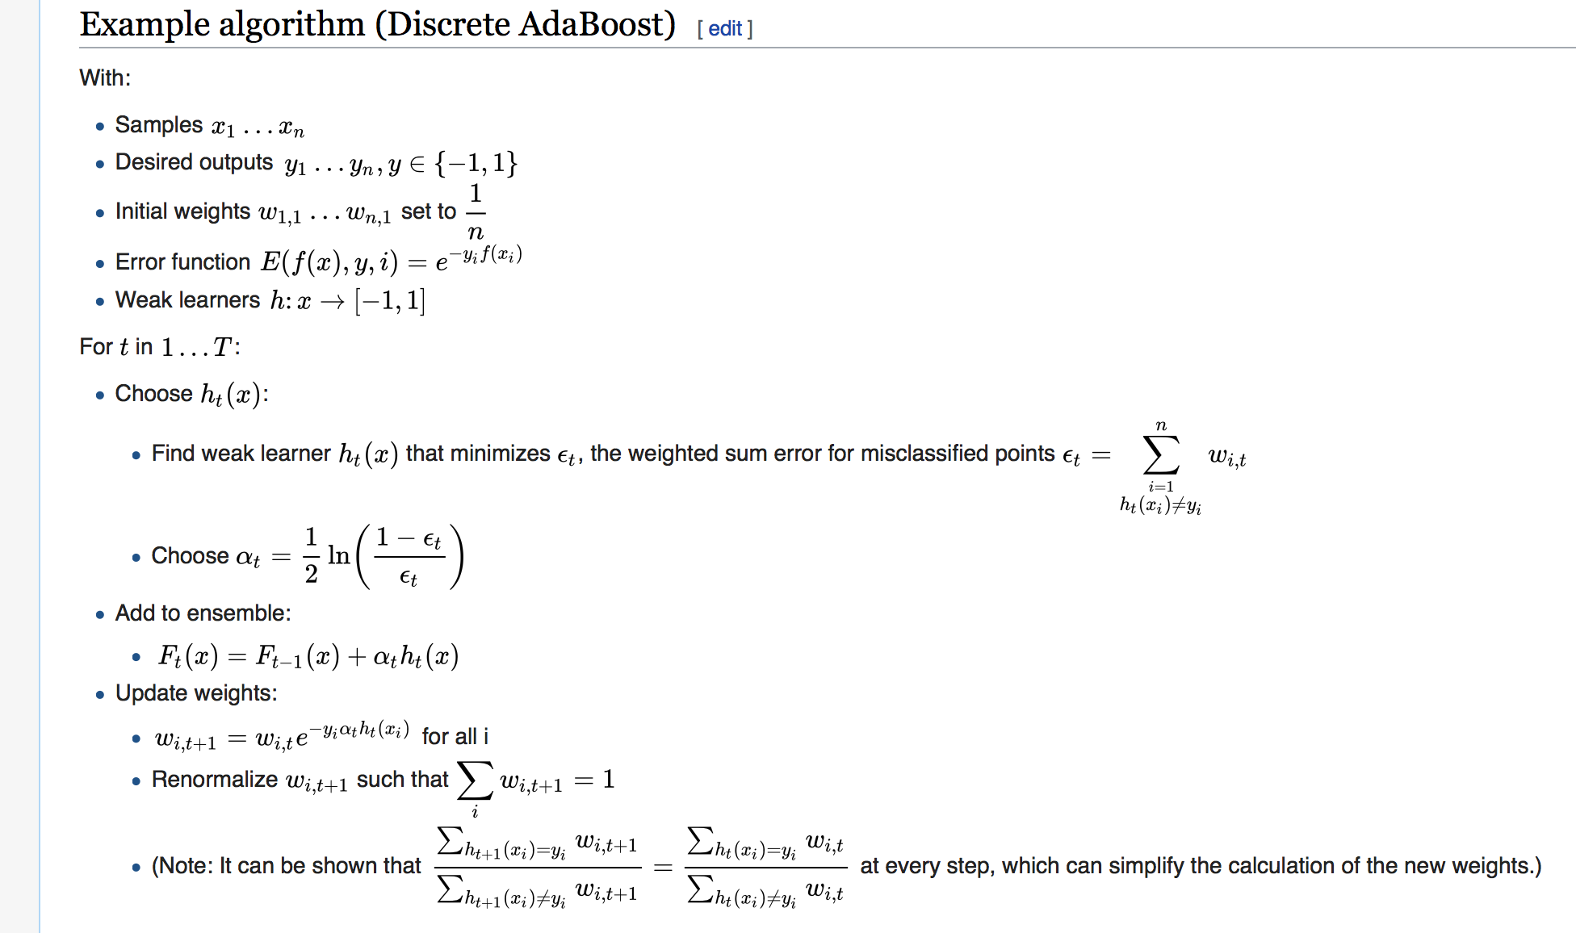

Bagging:

1. Given a training set D of size n, bagging generates m new training sets Di, each of size n’, by sampling from D uniformly with replacement.
2. This kind of sample is known as a [bootstrap](https://en.wikipedia.org/wiki/Bootstrap_(statistics)) sample. The *m* models are fitted using the above *m* bootstrap samples and combined by averaging the output (for regression) or voting (for classification).