Futures Mixing Desk: Design Brief
Oct 28, 2026 · @Robert

Summary
The Futures Mixing Desk is an interactive futures generator that turns five choices about the world in 2050 into a vivid, evidence-backed future, three tangible sub-futures, a customer story for each, and a How Might We for financial services.
It is stimulus for a series of futures workshops. Its job is to get mixed teams out of today's product thinking and into a shared, concrete picture of how people's working lives, and therefore their financial lives, could change. Every figure links to a published source, so the room argues about implications, not facts.
One-line purpose: make the future of work feel specific enough to design for, and connect it to the whole of a customer's financial life, not only their mortgage.

Background and context
The desk was built as input to a series of futures workshops on AI, the future of work and customers' financial lives. Earlier workshops in this space used static stimulus such as technology cards and a two-axis scenario matrix built around AI adoption and ecosystem openness.
Two shifts shaped this tool:
- From mortgages to financial life management. The organisation's direction is moving beyond single products. A mortgage is one part of how people manage income, saving, credit, protection, pensions and care across their lives. The desk frames every How Might We at that broader level.
- From one source to many. It started from BCG Henderson Institute's Beyond Tomorrow: Four Scenarios for the World of 2050 (April 2026). That report is now one input among about twenty, including IPPR, the World Economic Forum, ONS, the FCA, TUC, UK Finance, Experian and the Resolution Foundation, so no single consultancy view sets the frame.
The current version is a working prototype published as a private web page. It has been through four rounds of iteration on structure, visual style and the number of forces.

The problem and opportunity
Futures work often stalls in the space between big trends and real decisions. Teams can agree that AI will change work, but struggle to say what that means for a customer next to them in 2040, or what a bank should do about it.
The common failure modes the desk is designed to avoid:
- Too abstract. Megatrend decks describe the world, not a person's month. People nod along and change nothing.
- Anchored on today. Teams jump straight to features for current products, so ideas stay inside the mortgage journey they already own.
- One imposed future. A single scenario set handed over by a facilitator invites debate about whether it is right, not about what to do.
- Opinion dressed as fact. Unsourced claims derail sessions, and senior stakeholders discount the output.
The opportunity is a tool that lets people build a future themselves in under a minute, see it made concrete through real numbers and a human story, and leave with a question their organisation could act on.

Who it is for
The primary users are mixed teams in a futures workshop. The facilitator and the people who receive the workshop's output are close behind.
Audience | Who they are | What they need from the desk
Workshop participants (primary) | Product, design, strategy, data, risk and operations colleagues across lending, home, transport and wider financial services; varied comfort with futures thinking | A fast, low-effort way in; a future concrete enough to react to; permission to think beyond their current product
Facilitators | The person running the session, usually from strategy, service or experience design | Reliable stimulus that works in a room and on a screen; control over which futures each table explores; material that copies into Mural
Stakeholders and sponsors | Leaders who commission the work and act on its output | Confidence that the futures are grounded in credible sources; How Might Wes that link to strategy
Future teams reusing it | Teams running their own sessions after the series | A self-explanatory tool that needs little setup or briefing
Participants are not futurists and will not read instructions. The desk has to make sense in the first ten seconds, on a laptop or a phone.

Value it creates
The desk turns a vague topic into specific, shared, sourced material that a team can design from within a single session.
For participants
- A future they shaped themselves, which builds ownership and lowers the barrier to speculation.
- Concrete people to design for, such as a contract worker with three incomes or a couple whose mortgage ends at 71.
- A broader lens: each sub-future names the parts of financial life it touches, such as income, saving, credit, protection, pensions and care.
For facilitators
- Stimulus generated in seconds, with variety on demand through Surprise me and Draw other sub-futures.
- Different tables can explore different futures from the same tool, then compare.
- One-click text export for Mural or notes.
For the organisation
- A traceable chain from evidence to customer moment to How Might We, which makes workshop output easier to defend.
- A repeatable asset for the whole series and beyond, instead of one-off decks.
- Signals to watch: every sub-future starts from a figure visible today, which can feed horizon scanning.

Experience principles
- Play before reading. People make choices first and read second. No instructions screen; the first view already shows a generated example.
- Plain questions, few choices. Five questions in everyday language, three answers each. If a choice needs explaining, it is the wrong choice.
- Uncertainties are choices, certainties are givens. Things true in almost every UK future, such as an older population, are shown, not chosen.
- From world to person to question. Every output moves down the same ladder: a future, a tangible shift, a customer living it, a How Might We.
- Every number has a source. Figures carry a citation link. Stories are clearly labelled as illustrative composites.
- Provocation, not prediction. The tone invites debate. Nothing claims to be a forecast.
- Financial life, not product. How Might Wes span income, saving, credit, protection, pensions, payments and care.
- Calm, collectible, specific. The look is a set of specimen cards: distinct, a little playful, and uncluttered.

The experience
A single page moves people from choosing forces to holding a question they can work on, in about a minute.
- Arrive. The page opens with a generated example already showing, so it never looks empty. A short intro says what the desk does.
- Set the forces. Five plain questions, each with three tap-to-choose answers:
  - How much work does AI do? Helps out, Reshapes jobs, Runs routine work
  - Who benefits from the gains? A few, Some, Most people
  - How do people earn a living? One steady job, A mix, Many gigs
  - How stable is the world? Calm, Bumpy, Shocks
  - How hard do we act on climate? Delayed, Uneven, Climate-first
- Generate. One button produces the future. If someone changes an answer afterwards, the page says the result is out of date. Surprise me picks random answers for quick variety.
- Meet the future. A large specimen card shows a named future, such as The Patchwork Economy or The Storm Years, with a generated object, a short description, three sourced headline figures and what financial life looks like there.
- See the givens and the detail. A strip shows what holds in every future. A Life in this world panel turns each of the five answers into a sourced sentence.
- Explore three sub-futures. Cards show the three tangible shifts the answers drive hardest. Each has what is changing, a Now to 2040s timeline, the life areas it touches, a customer story and a financial services How Might We.
- Vary and capture. Draw other sub-futures swaps in a different strong trio for the same future. Copy for Mural exports the whole result as text.

Content model
The desk is a small library of written, sourced content combined by simple rules. No content is invented at run time.
Element | Count today | What each one holds | How it is chosen
Forces | 5 | A plain question, a one-line explainer, three named answers | Set by the user
Answer descriptions | 15 | One sentence describing that world, with a citation where a figure is used | Shown for each chosen answer
Givens | 2 | A certainty true in every future, with sources | Always shown
Futures | 8 | Name, colour and object, description, three sourced figures, financial life paragraph, reports it draws on, and a profile across the five forces | Nearest profile to the user's answers
Sub-futures | 15 | Title, what is changing, a three-step timeline with sources, life areas, a named customer story, a How Might We | Scored against the answers; top three with different drivers
Sources | 22 | Title and link for each report or dataset | Cited inline as numbered links
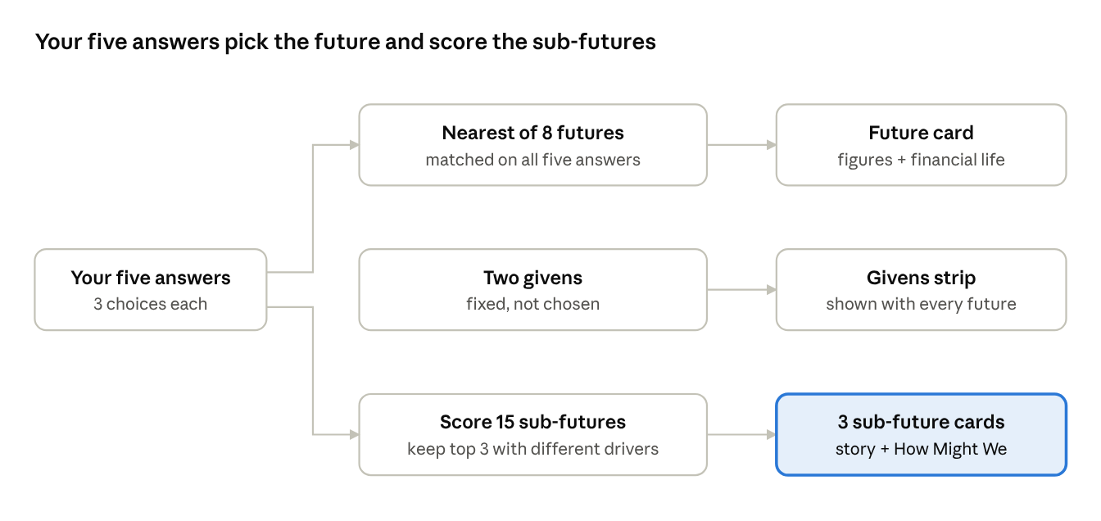
generation logic · answers to future and sub-futures
The same five answers do two jobs: they choose the nearest future and they score the sub-futures. The givens sit outside the choices.
The eight futures: The Leisure Dividend, Winner-Takes-Most, The Patchwork Economy, Fortress Economies, The Storm Years, The Resilience Decades, The Managed Transition, The Long Plateau.
Writing standards. Customer stories run to three or four sentences, name one person or household, and show at least two parts of their financial life. How Might Wes start with the phrase How might we, sit at the level of financial life rather than a single product, and are open enough to generate several ideas.

Visual and interaction direction
The look is a set of collectible specimen cards: each future is an object you can hold, compare and talk about. It draws on four reference images of gradient specimen cards, onboarding cards and calm serif questions.
- Specimen cards. White cards with a saturated gradient window, a notched corner tab and a mono code built from the user's answers, so every card is traceable.
- Generated objects. Each window holds a 3D-style object drawn from the answers in six materials: glass, pearl cluster, studded clay, ribbon, gold branch and metal puck. Each future has its own colour and material, so tables can refer to them by sight.
- Type. Bold wide caps for names, a mono face for data and labels, and a soft serif for descriptions and How Might Wes so the questions feel human.
- Calm controls. Tap-to-choose answers instead of sliders. No tick marks, leaders or track lines. Space and soft fills separate content, not rules.
- One clear action. A dark pill Generate button with a round arrow. Secondary actions are outlined.
- Ground and themes. A soft lavender ground in light mode and near-black in dark mode, with the gradient windows kept bright in both.
- Motion. A gentle float on objects and a short rise when results arrive, both switched off for people who prefer reduced motion.
- Responsive. Works from a projected laptop down to a 400 px phone; sub-future cards go from three columns to one.

Evidence and integrity standards
Credibility is the desk's licence to provoke, so the rules on evidence are strict and visible.
- Every figure is cited with a numbered link to its source, listed in full at the foot of the page.
- Global and UK figures are labelled. Scenario figures from BCG are global; UK figures describe today.
- Projections are named as projections, with the scenario or report they come from.
- Stories are composites. Each is labelled illustrative and built on the evidence beside it. No real customer data is used.
- Extrapolations are flagged. Where a sub-future extends a trend no report measures yet, such as AI agents managing personal money, the text says so.
- No single source sets the frame. Each future draws on two or more reports where possible.
- Known gaps. Some figures were taken from reputable secondary coverage because the primary PDF could not be opened, including parts of the BCG 2050 report. These should be checked against the primary documents before wider release.

Using it in workshops
The desk supports several facilitation patterns. All five are proposals; the facilitator picks one or two per session.
Mode | How it runs | Best for | Time
Each table builds a world | Each table sets its own answers, generates, and presents its future to the room | Opening energy, contrasting futures | 15–20 min
Assigned futures | The facilitator sets answers per table, for example one table per future, so the room covers the range | Balanced coverage across a series | 10 min setup
Live on screen | The facilitator drives the desk on a projector while the room votes on each answer | Large groups, plenaries | 10 min
Story to idea | Tables take one sub-future card, extend the customer story, then ideate on its How Might We | Moving from stimulus to concepts | 30–45 min
Stress test | Teams take an existing idea or strategy and check how it holds in three different futures | Strategy and portfolio reviews | 30 min
Suggested rhythm for a 90-minute session: generate and present (20 min), choose one sub-future per table (10 min), extend the story (15 min), ideate on the How Might We (30 min), share back (15 min).

Requirements, scope and constraints
Must have
- Five forces with three answers each, and a single Generate action.
- One future, the givens, the Life in this world detail and three sub-futures per generation.
- Inline citations and a full source list.
- Export of the whole result as text for Mural.
- Works on laptop, projector and phone, in light and dark mode, and with keyboard and screen reader.
Should have
- A facilitator view to lock answers for a table or share a specific future as a link.
- A printable or exportable card set for in-room use.
- More sub-futures, so repeated draws stay fresh across a series.
Out of scope for now
- Live AI generation of new futures or stories. All content is written and reviewed in advance so it stays sourced.
- Storing participants' work or personal data.
- Real customer data of any kind.
Constraints
- Runs as a single self-contained web page with no backend.
- Content must stay accurate as sources update; figures need a review date.
- The page is private until shared, so facilitators must share access before each session.

Success measures
Success means people engage within a minute, the room argues about implications rather than facts, and the series produces ideas beyond the mortgage journey.
Measure | How to capture it | Target
Time to first generated future | Observe at the first session | Under 60 seconds, no help needed
Futures explored per table | Facilitator count | 2 or more per session
Share of ideas outside mortgages | Tag each idea by financial life area after the session | Most ideas sit in at least one area beyond the home loan
Challenges to sources | Facilitator notes | Few or none; debate centres on implications
Participant rating | One-question poll at close: did the desk help you think about the future? | 4 out of 5 or above
Reuse | Sessions run by other teams after the series | At least one
Targets are starting suggestions for the series lead to confirm.

Risks and open questions
Risk | Why it matters | Mitigation
Read as a forecast | Participants or sponsors treat a future as the plan | Provocation framing on the page and in the facilitator brief
Repetition | With 15 sub-futures, later sessions see the same stories | Grow the library and rotate content between sessions
Stale figures | Sources update, and some came from secondary coverage | Check against primary documents and set a review date
Stereotyped stories | Composite customers can slip into clichés | Review stories for range of age, income, household and region
Visual over substance | Attractive objects distract from the content | Keep objects in the card windows only; the text carries the meaning
Access | The page is private until shared | Share with participants before each session
Open questions
- ☐ Should facilitators be able to lock or share a specific future by link?
- ☐ Do we need a printed card set alongside the screen version?
- ☐ Which other sources, such as internal customer research, should feed the stories?
- ☐ Who owns the content after the series ends, and how often is it reviewed?

Next steps
- ☐ Pilot the desk with a small mixed group and time the first generation
- ☐ Verify all figures against primary sources and add a review date
- ☐ Review the 15 customer stories for range and stereotypes
- ☐ Decide on a facilitator view and shareable future links
- ☐ Write a one-page facilitator guide covering the workshop modes
- ☐ Share the page with participants ahead of the first session

Sources
- Futures Mixing Desk prototype, which lists all 22 sources it cites
- BCG Henderson Institute, Beyond Tomorrow: Four Scenarios for the World of 2050
- IPPR, Transformed by AI
- World Economic Forum, Future of Jobs Report 2025

