BLOCKSIM

Dynamic Systems Simulator via Block Diagrams

INDEX

1. Introduction 2

2. Data input definition 2

3. Programming concepts 4

4. Results 5

# Introduction

BLOCKSIM is a simulator for dynamic systems that can be represented by block diagrams. This application allows the user to simulate any dynamic system that contains the following block types:

- Sinusoidal input with configureable amplitude;

- Constant;

- Sum;

- Multiplier;

- Gain;

- Inversion function;

- Integrator (using a modified trapezoidal function);

- Delay (memory).

# Data input definition

It is very important in software engineering to define a program structure that facilitates the data input and is also compatible to the algorithm to be developed.

The data input for this application is a text file that contains:

- as first line: maximum simulation time and integration step;

- and in the following lines: the description of each block in the system, its position and parameters, according to the table below:

|  |  |  |  |  |
| --- | --- | --- | --- | --- |
| Block | Parameter 1 | Paramter 2 | Parameter 3 | Parameter 4 |
| Input | applied node | applied node | INPUT | amplitude |
| Constant | applied node | applied node | CONST | constant value |
| Sum | start node | end node | SUM | quantity of factors to be summed |
| Multiplier | start node | end node | MULTIPLY | quantity of factors to be multiplied |
| Gain | start node | end node | GAIN | gain |
| Inversion | start node | end node | INV | 1 |
| Integrator | start node | end node | INTEGRATOR | type of integrator |
| Delay | start node | end node | DELAY | 1 |

This kind of data input was designed based on the well-known PSPICE/Cadence and EMTP/ATP simulators.

Example:

Consider the following MATLAB/SIMULINK circuit:

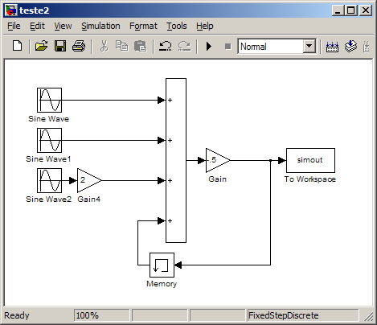

The input file to be used in BLOCKSIM is:

0.5 0.0001

0 0 INPUT 1

1 1 INPUT 2

2 2 INPUT 3

0 4 SUM 4

1 4 SUM 4

3 4 SUM 4

6 4 SUM 4

2 3 GAIN 2

5 5 OUTPUT 1

4 5 GAIN -0.5

5 6 DELAY 1

# Programming concepts

The algorithm developed to implement BLOCKSIM is based on three nodal matrices which describe the system based on block diagrams and auxiliary vectors. The implemented data input allows the creation of the nodal matrices because the system is described by nodal links between the elements (blocks). The matrices’ rows reflect the input nodes and the columns are the output nodes for each block.

The nodal matrices are defined as:

- typeelemmtx[start node][end node]: matrix that saves the type of the elements (blocks) that are part of the system. This matrix is scanned for each iteration to provide the type of elements attached to certain node.

- valuemtx[start node][end node]: matrix that saves the values of the elements’ properties when necessary. Note that the (i,i) elements of such matrix are related to the value of each i-node already processed or being processed.

- tobeprocessed[start node][end node]: matrix that defines the elements to be processed and also puts a mark on the elements that were already processed during that iteration.

Additional comments about the algorithm can be read in the source code.

# Results

Some sample models were created in MATLAB/Simulink to be tested in BLOCKSIM in order to compare the output of both softwares.

System A



System A is composed by three sinusoidal inputs, a sum and a gain. Note that this system is non-causal because of the feedback gain. Therefore, it was necessary to insert a delay block (memory block in Simulink) to avoid the algebraic loop. The results of the simulations using MATLAB/SIMULINK and BLOCKSIM are seen below:

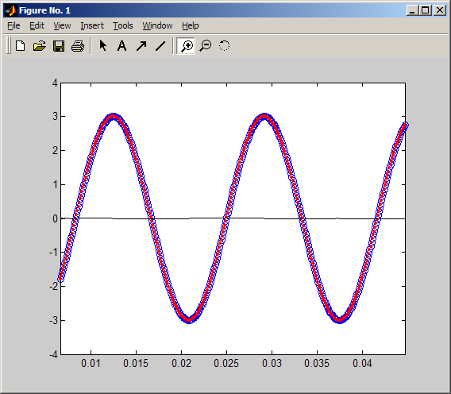

Comparison between the simulation results from BLOCKSIM (blue) and MATLAB/SIMULINK (red).

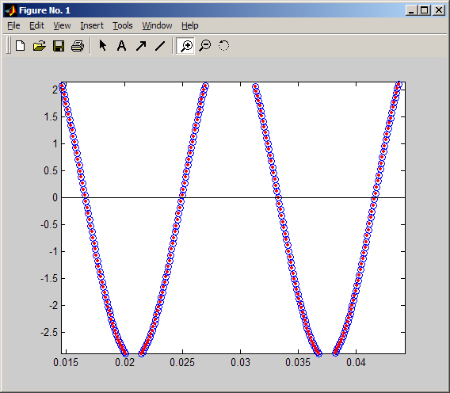

Comparison between the simulation results from BLOCKSIM (blue) and MATLAB/SIMULINK (red).

System B

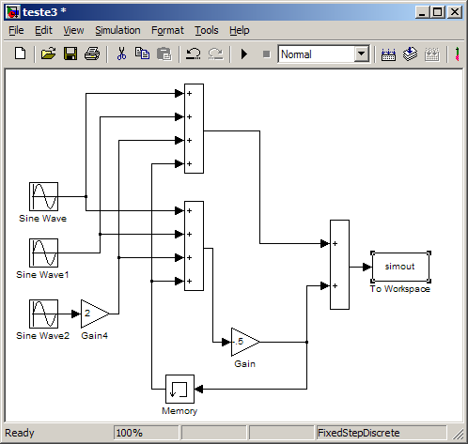

System B is composed by three sinusoidal inputs, three sums and one gain. Again, this system is non-causal because of the feedbacks to the sums. Therefore, it was necessary to insert a delay block (memory block in Simulink) to avoid the algebraic loops. The results of the simulations using MATLAB/SIMULINK and BLOCKSIM are seen below:

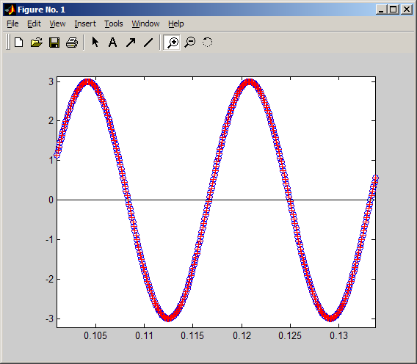

Comparison between the simulation results from BLOCKSIM (blue) and MATLAB/SIMULINK (red).

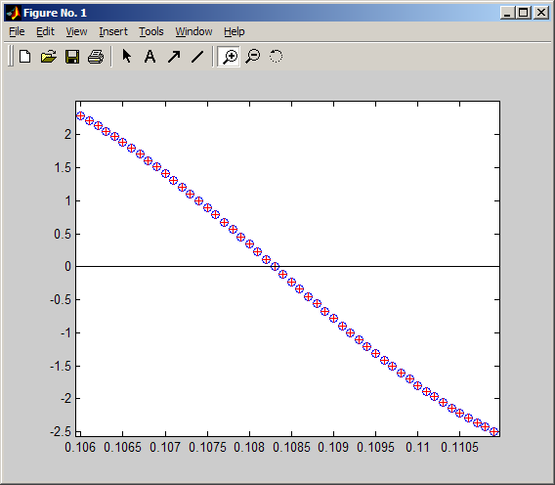

Comparison between the simulation results from BLOCKSIM (blue) and MATLAB/SIMULINK (red).

System C

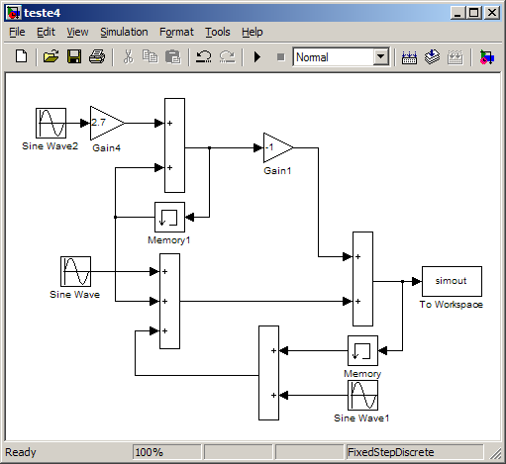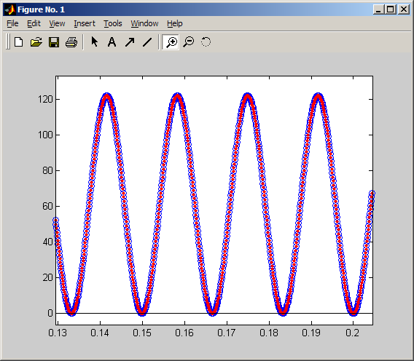

Comparison between the simulation results from BLOCKSIM (blue) and MATLAB/SIMULINK (red).

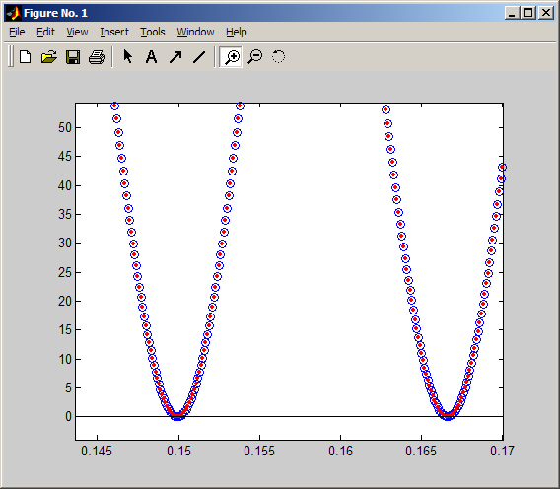

Comparison between the simulation results from BLOCKSIM (blue) and MATLAB/SIMULINK (red).

System D

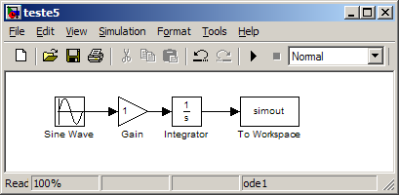

System D is composed by a sinusoidal input, one gain and one integrator.

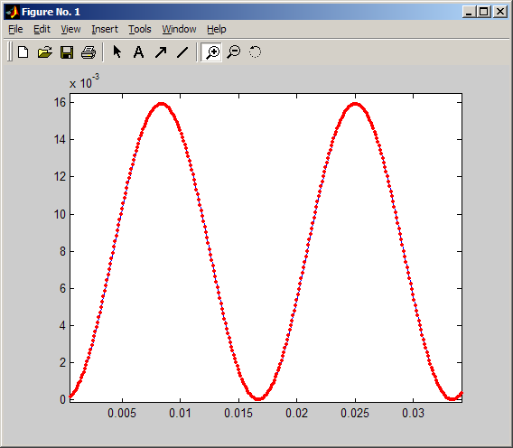

Comparison between the simulation results from BLOCKSIM (blue) and MATLAB/SIMULINK (red).

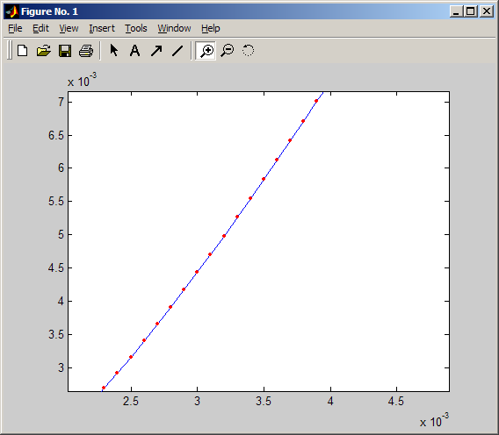

Comparison between the simulation results from BLOCKSIM (blue) and MATLAB/SIMULINK (red).

System E

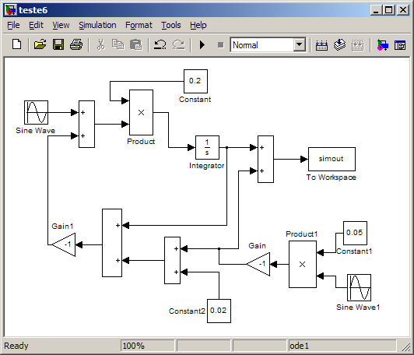

System E is a model utilized in electrical machinery stabilization studies.

- Integrator output:

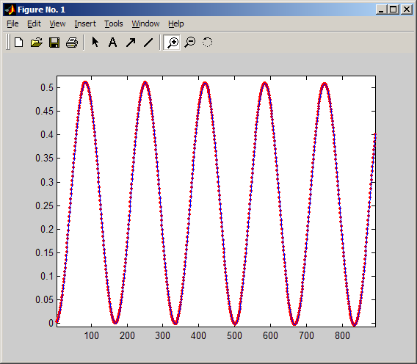

Comparison between the simulation results from BLOCKSIM (blue) and MATLAB/SIMULINK (red).

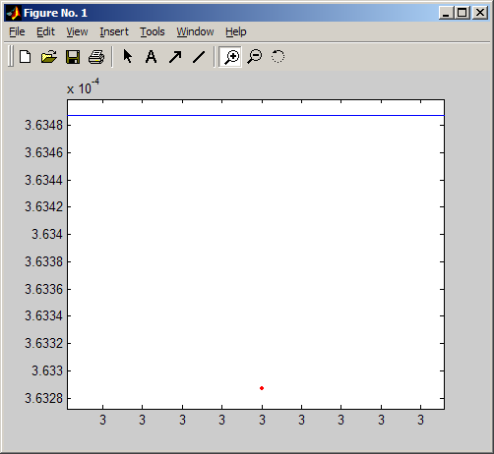

Comparison between the simulation results from BLOCKSIM (blue) and MATLAB/SIMULINK (red). Note that the error between the integration values is around 1x10-6.

- Output:

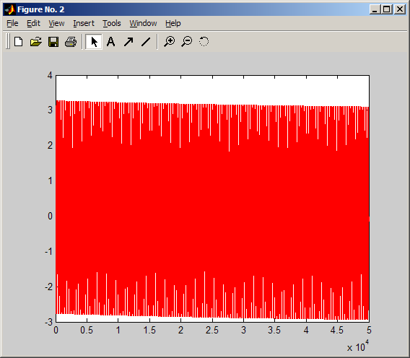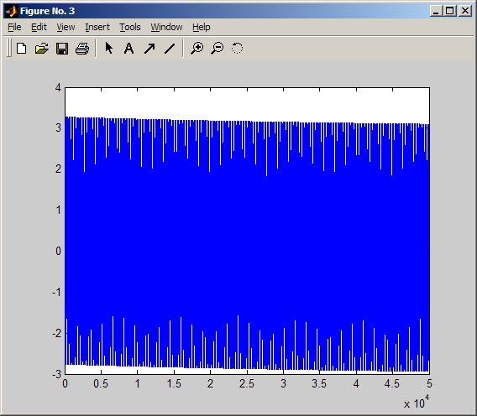

Comparison between the simulation results from BLOCKSIM (blue) and MATLAB/SIMULINK (red).

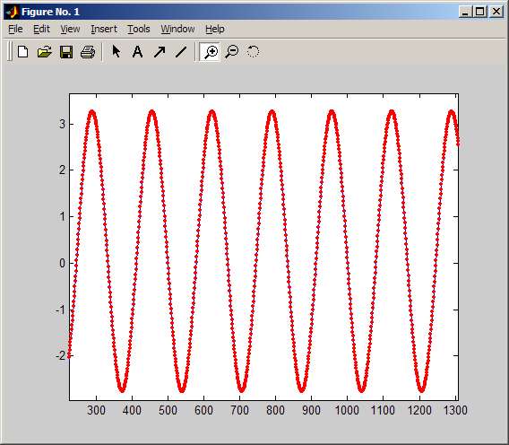

Comparison between the simulation results from BLOCKSIM (blue) and MATLAB/SIMULINK (red).