Ryan Mill

December 14, 2019

IP Address: <http://35.227.165.117:8080/ChampionFinal>

CS4950: Homework4

1. For my web application, the server will provide the JSON data based on conditions for characters in a game, important for user to discover character based on conditions on we browser.
2. <http://35.227.165.117:8080/ChampionFinal/>
3. <http://35.227.165.117:8080/ChampionFinal/role/Top>
4. Not completed

For this problem I created the application based on a @PathParam method where the conditions are the different roles and types for the characters. The user is able to search the characters based on different conditions. I learned how to do this through taking what I know from the weather1 assignment and using that as a template. I understood how to set up the database and JSON data but I had trouble setting up the different methods for testing.

3. For this step I developed the web service application going off of what I know from the weather1 assignment. Though all the values, strings, and methods had to be changed, I got the general idea from changing the web service application to fit my needs. I had the most trouble getting the tomcat server to work because I kept getting errors and having typos in my code.

4. 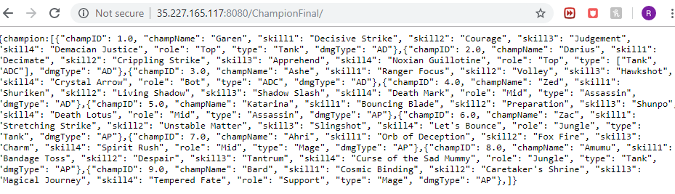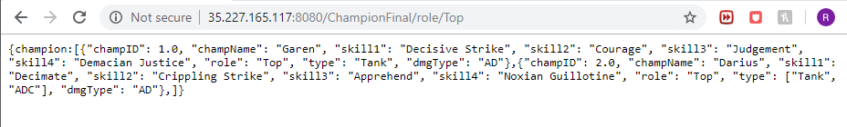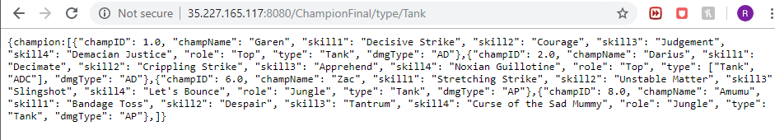

5. Web application was deployed to the ip address <http://35.227.165.117:8080/ChampionFinal/>