Ryan Mill
CS 4270
September 19, 2019
CS4270: Homework1

Part 1
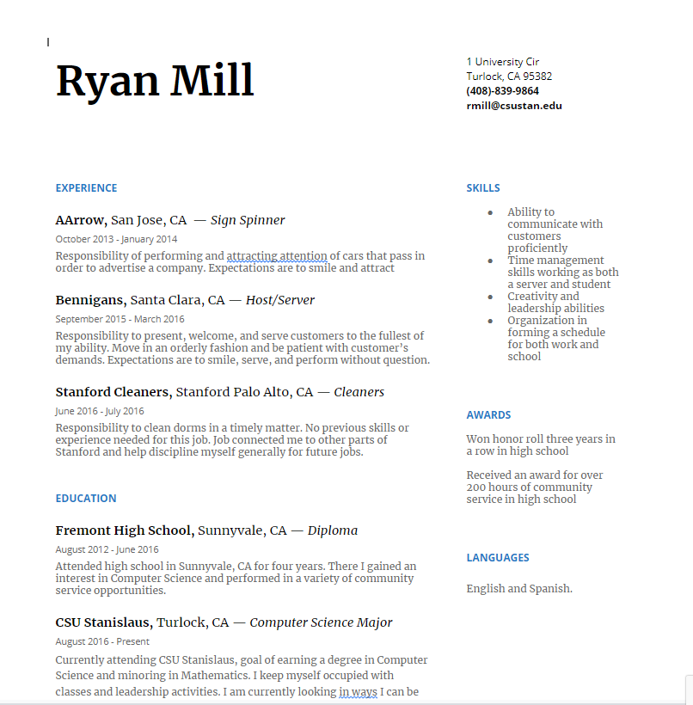

-I enhanced the template by simplifying the way users would browse my resume. I also tuned the resume to where the links jump the user to different parts in the resume therefore much easier to navigate.
-I tried to go off the template because I already enjoy how my original template felt so I redesigned it as a webpage that can be navigated through links.
Part 2
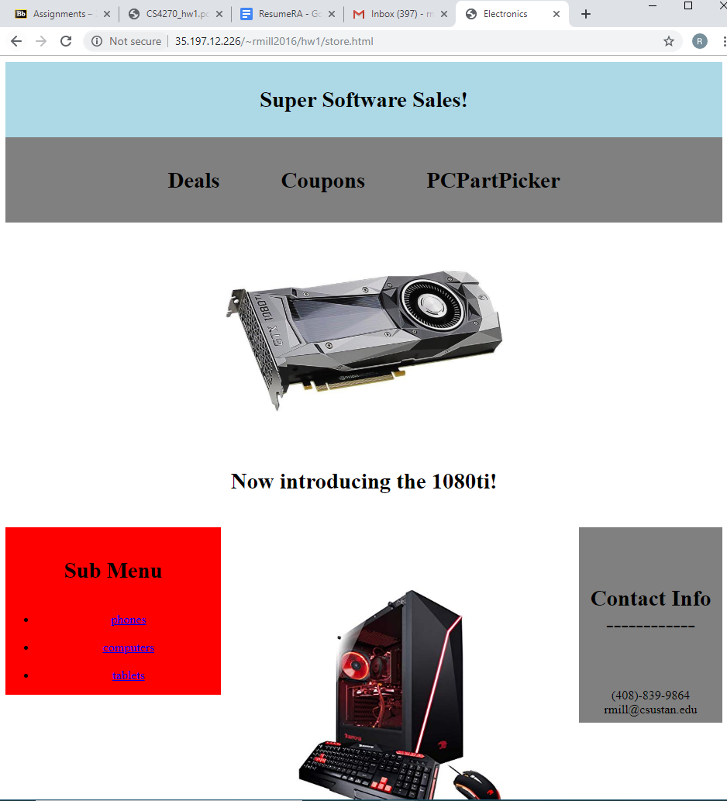
Computer version

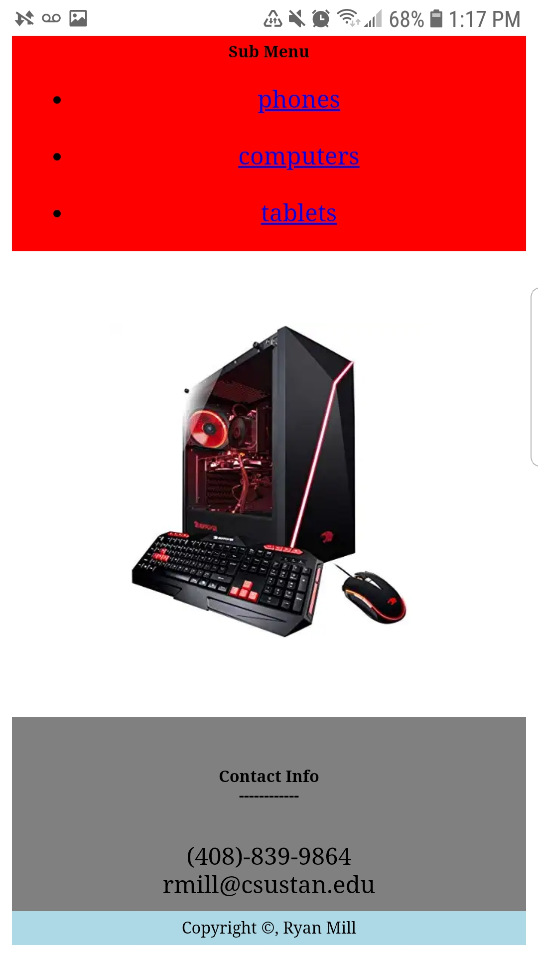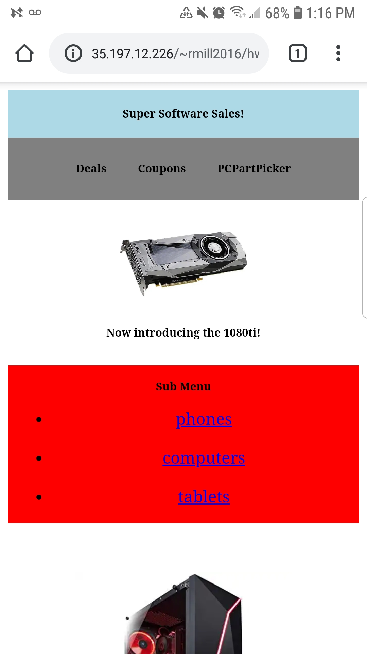
Phone version
-I used responsive layout, text, and images on my webpage that had a set width to 100% but scaled into another format if the width was equal to 620px, this is the average width for a phone/mobile device. I also used viewport that would scale based on the width of the window which would change for the mobile device.
-I used styles like font size for header, top menu, main menu, side info, and content. I used classes for top menu, side info, and content because they would have styles for font size and color that is applied to the whole class.

