Ryan Mill
October 24, 2019
Google IP Address: 35.197.12.226
Report Document for campustour.html

Part 1: CSS lab
- For this assignment I needed to spend some time catching up on the CSS lab. The lab taught me how to create multiple .html files and interlace them via different CSS code. I learned how to change text through external, internal, and inline CSS.
- I compared and tested the difference the external CSS code would change the text for the html files. At first the difference was the color, ‘hello’ text went from yellow to red based on the location of the CSS code in the HTML file.

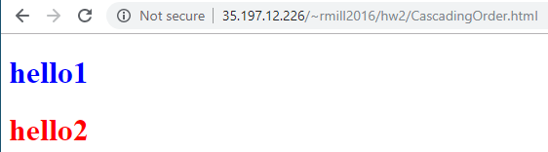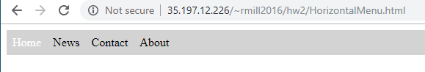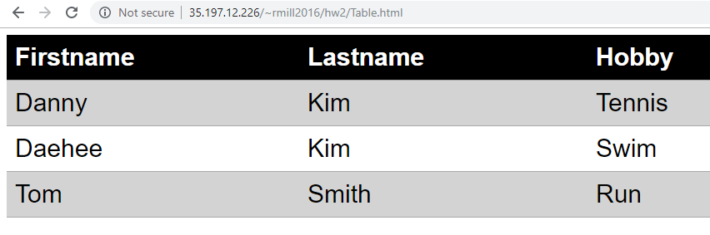

Part 2: Campus Map
- I needed to first download the map of the campus as a png or jpg file. I then needed to create three <area shape> tags for rectangle, circle, and polygon on different locations of the map. Lastly for this assignment I need to create three different html web pages linking to the information of the information for the building, (library, DBH, UPD). I filled in basic information of the buildings after that
- In order to complete this assignment I needed to review how to use <area shape>. I went back to the tutorial to learn about how the coordinates work for the different shapes, the polygon took some time for the coordinates especially.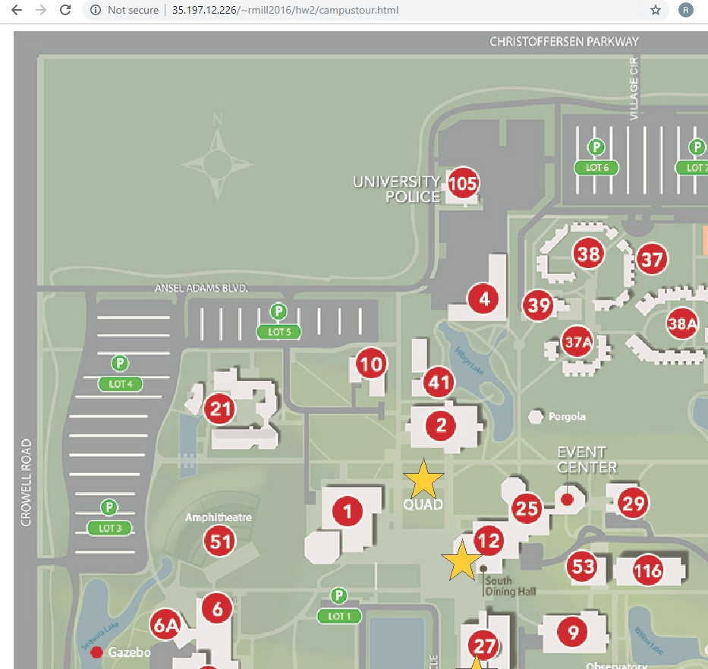
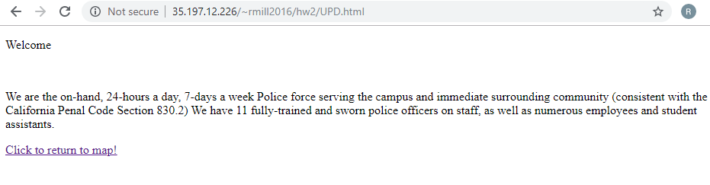

HTML links:
http://35.197.12.226/~rmill2016/hw2/campustour.html
http://35.197.12.226/~rmill2016/hw2/UPD.html
http://35.197.12.226/~rmill2016/hw2/Library.html
http://35.197.12.226/~rmill2016/hw2/DBH.html

