Ryan Mill
November 15, 2019
http://35.197.12.226/

CS4270: Homework3

Part 1:
Within the Woocommerce plugin I found that I can set up various products, my cart, and checkout page. I am also in the process of setting up the paypal process method for checking out products, although that would require me to obtain an API using my own paypal first. The automatic tax calculations are in place and I used some of the widgets originally from Woocommerce also.
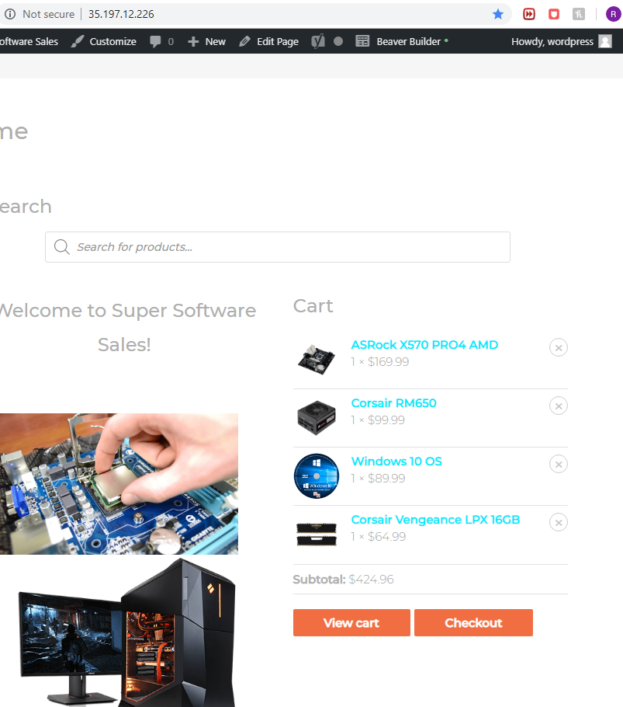
Part 2:
I ended up finding three plugins that I installed and activated on my website. I used Beaver Builder Plugin, AJAX Search, and bbPress. The Beaver Builder Plugin is available on the wordpress plugin store and it provides the ability to easily drag and drop widgets in real time for ease of use for creating websites. It allows placing widgets from Woocommerce, WordPress, and stable/default widgets, all of which I used to create my site.
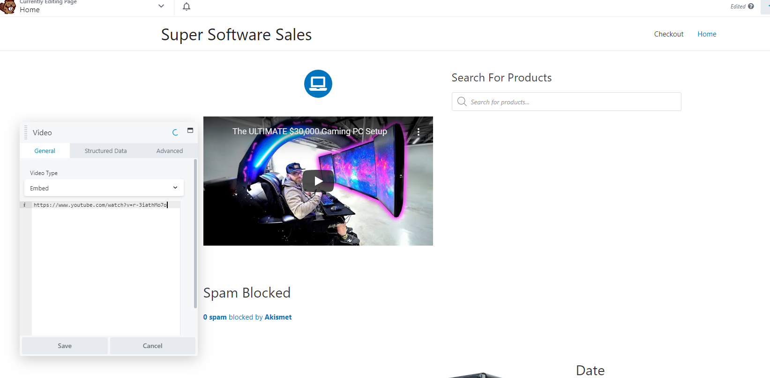
Next I used the plugin called AJAX Search. AJAX Search is specifically designed to be compatible with Woocommerce and is also bundled into another plugin called Ivory Search. This plugin allowed me to create an auto search function within my search bar that showed pictures and prices of the products matching those key terms once typed. I implemented it into my website in my home page and checkout page.
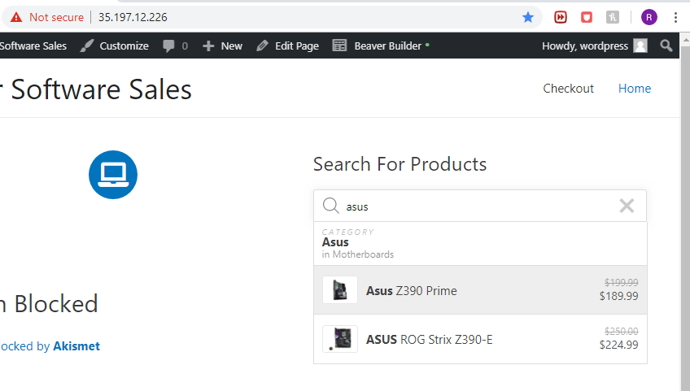

Lastly I used a plugin called bbPress. This is a plugin designed to create forums, posts, and other community building processes on the website. I implemented it into my website by creating a forum discussion about the website and I added a few reviews and topics for my website. The forums are a separate thing from my website, but the link is found on the website itself.

