Ryan Mill

April 28th, 2020

CS3000: Homework3

Google IP Address: 34.82.67.72

Network address provided: 150.23.0.0/16

**Part 1:**

The question is asking to create a FTPServer within the google cloud instance and create a FTPClient within the virtual machine on my host computer. In order to create the server and client, I needed to use commands such as mkdir, cd, cp, and mv. Within the .java code I added several methods including send file, receive file, run, and main. I learned how if implemented correctly, multiple clients are able to connect through the IP Address and listening port to 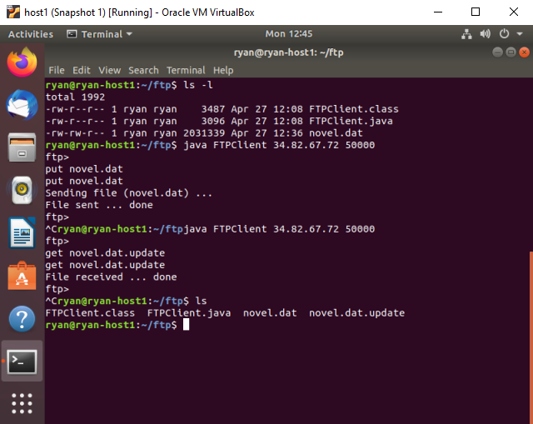transfer files.

I started by creating the directory that the ftp client would take place in. Once the file was created I started the server and client and connected them. I used the commands within the send file method in order to send the novel.dat file. AFter receiving confirmation of uploading the file, I checked that the byte size remained the same on the server 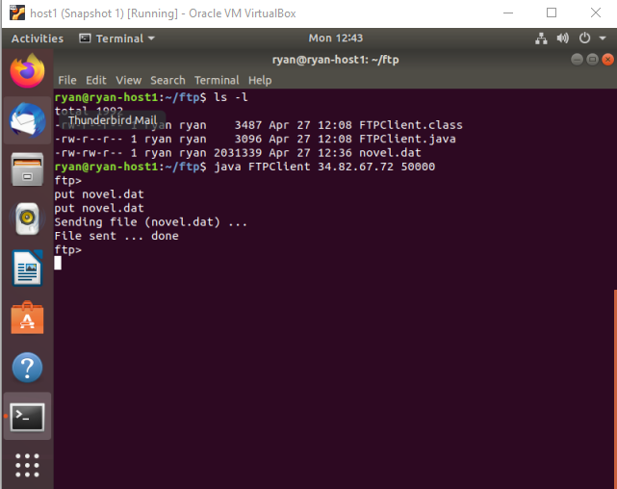side.

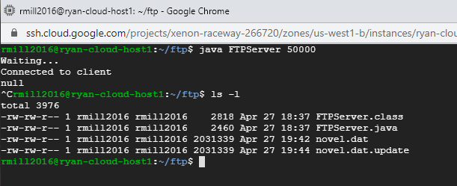

**Part 2:**

Step 1: I needed to subnet the provided ip address into four subnetworks. Each network would need to be calculated in order to find Subnet IP Address and Broadcasting IP Address for each subnetwork. I also needed to know the default subnet mask for the specific network class. The provided ip address is class B meaning the default subnet mask for the network is 255.255.0.0, although the subnet mask changes based on the network bits and host bits borrowed. I learned from doing this exercise how to implement multiple local ip addresses within a network by using subnetting. I also got a nice review on binary bits. Here is my work.

Provided ip address: 150.23.0.0/16 ← this tells me the network is class B and the number of network bits is 16. Therefore the default subnet mask is 11111111.11111111.00000000.00000000 or in decimal form → 255.255.0.0

Now I followed the question asking for four subnetworks, this informs me that I need to use 2n network bits, n being the number of host bits borrowed. 22=4 subnetworks.

Network id = 150.23 host id = 00000000.00000000 ← the first two bits within the octets are borrowed so instead the network id for the four subnetworks looks like this:

Subnetwork1 = 150.23.00000000.00000000 | subnet ip address = 150.23.0.0/18

=150.23.00111111.11111111 Broadcasting ip address = 150.23.63.255/18

Subnetwork2 = 150.23.01000000.00000000 | subnet ip address = 150.23.64.0/18

=150.23.01111111.11111111 Broadcasting ip address = 150.23.127.255/18

Subnetwork3 = 150.23.10000000.00000000 | subnet ip address = 150.23.128.0/18

=150.23.10111111.11111111 Broadcasting ip address = 150.23.191.255/18

Subnetwork4 = 150.23.11000000.00000000 | subnet ip address = 150.23.192.0/18

=150.23.11111111.11111111 Broadcasting ip address = 150.23.255.255/18

Step 2:

Subnetwork 1

Gateway IP address (R) = 150.23.0.1

Host IP address (H1) = 150.23.0.10

255.255.00000000.00000000

Subnet mask = 255.255.192.0

Subnetwork2

Gateway IP address (R) = 150.23.64.1

Host IP address (H2) = 150.23.64.10

255.255.01000000.00000000

Subnet mask = 255.255.192.0

Subnetwork3

Gateway IP address (R) = 150.23.128.1

Host IP address (H3) = 150.23.128.10

255.255.01111111.00000000

Subnet mask = 255.255.192.0

Subnetwork4

Gateway IP address (R) = 150.23.192.1

Host IP address (H4) = 150.23.192.10

255.255.11111111.00000000

Subnet mask = 255.255.192.0

Step 3:

This step consisted of building a network using the network emulator called GNS3. The problem required me to use the host ip address, subnet masks, and gateway ip addresses in order to create the network. I used all that information from step 2. I learned through doing this exercise that configuring the router was the most important part in ensuring that the hosts can ping each other. I had problems earlier because I set the ip addresses for the router connections to 150.23.0.2 instead of 150.23.0.1 with the subnet mask of 255.255.192.0. This was the problem I was having from pinging the other hosts.

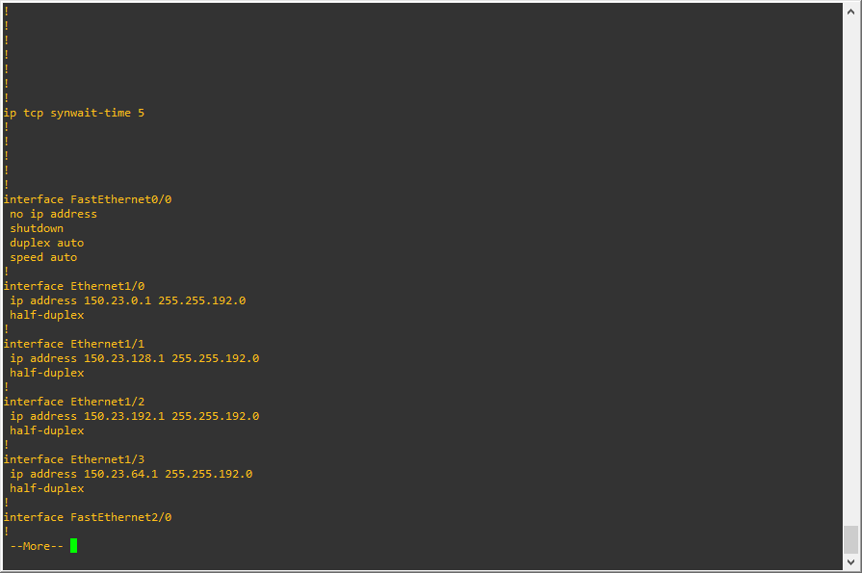

Here is a screenshot of the router, once I fixed the problem I was having. I did not configure the router correctly, I needed to use the gateway address instead.

Step 4:

Ping from R: to H1, H2, H3, and H4

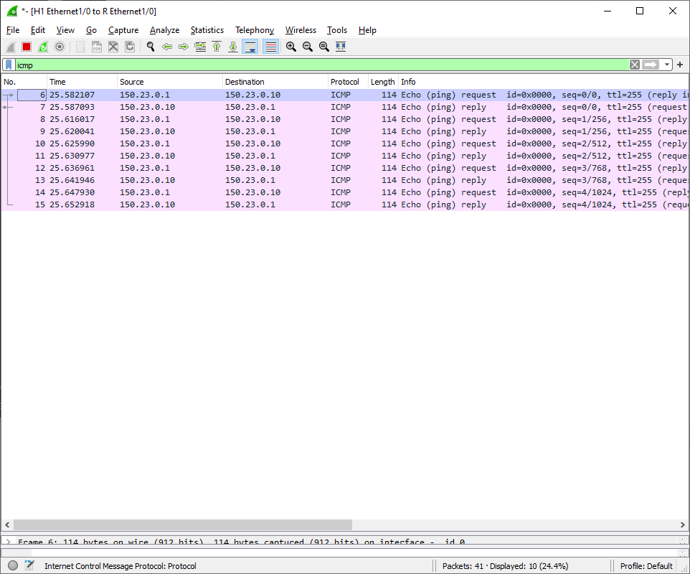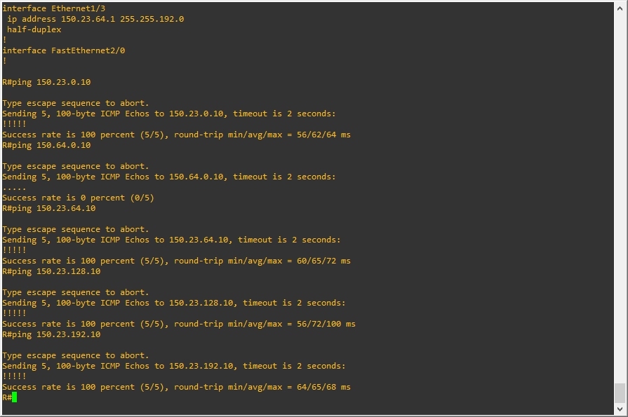

Ping from H1: to H2, H3, and H4

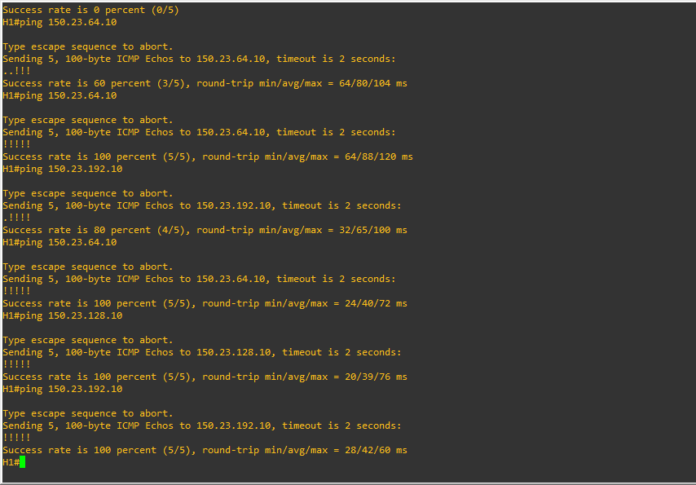

Ping from H2: to H3 and H4

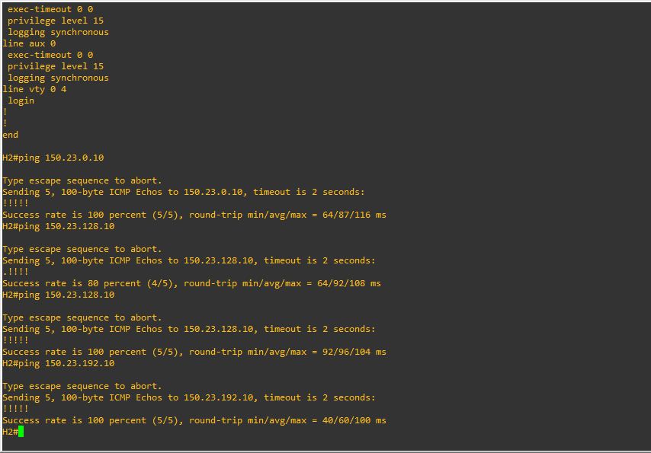

Ping from H3: to H4

