Ryan Mill

CS 3000-001

May 9, 2020

Homework 4

1. Source node X, least cost path to all network nodes.

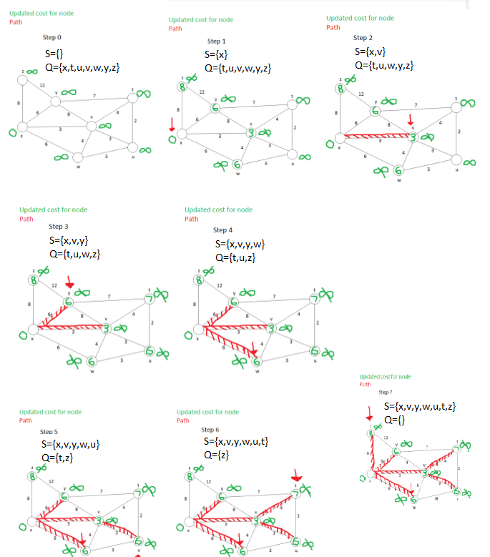

Note: Had a problem with this image, will color nodes for question 2!

1. Source nodes
   1. From T to all network nodes:

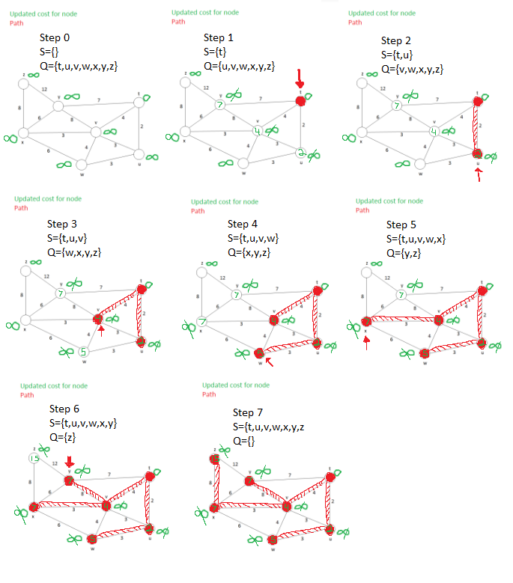

* 1. From Z to all network nodes:

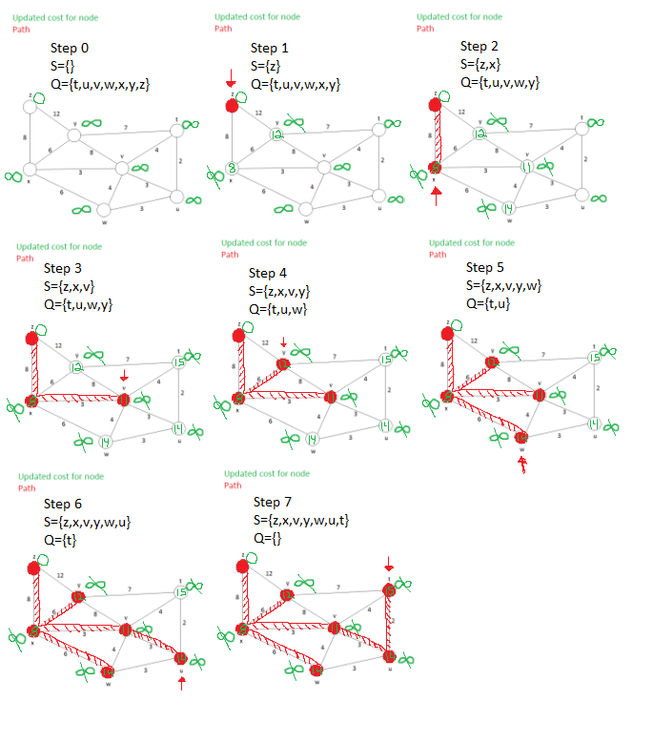

1. Distance-vector Algorithm

Distance vector table at time t

|  |  |  |  |  |  |
| --- | --- | --- | --- | --- | --- |
| From\To | u | v | x | y | z |
| v | inf | inf | inf | inf | inf |
| x | inf | inf | inf | inf | inf |
| z | inf | 6 | 2 | inf | 0 |

Distance vector table at time t+1

|  |  |  |  |  |  |
| --- | --- | --- | --- | --- | --- |
| From\To | u | v | x | y | z |
| v | 1 | 0 | 3 | inf | 6 |
| x | inf | 3 | 0 | 3 | 2 |
| z | 7 | 5 | 2 | 5 | 0 |

Distance vector table at time t+2

|  |  |  |  |  |  |
| --- | --- | --- | --- | --- | --- |
| From\To | u | v | x | y | z |
| v | 1 | 0 | 3 | 3 | 5 |
| x | 4 | 3 | 0 | 3 | 2 |
| z | 6 | 5 | 2 | 5 | 0 |

1. Subnetting Networks

Work:

Provided network: 130.195.0.0/16

Default subnet mask: 255.255.0.0

**Organization 1** needs 350 hosts = 29 bits = 512 > 350, 9 bits for host part

Subnet prefix = 16(network)+(16hostbits-9hostbits needed)=23

Subnet IP: 130.95.00000000.00000000 => 130.95.0.0/23

Broadcasting IP: 130.95.00000001.11111111 => 130.95.1.255/23

**Organization 2** needs 1500 hosts = 211 bits = 2048 > 1500, 11 bits for host part

Subnet prefix: = 16(network)+(16hostbits-11 hostbits needed) = 21

Subnet IP: 130.95.00001000.00000000 => 130.95.8.0/21

Broadcasting IP: 130.95.00001111.11111111 => 130.95.15.255/21

**Organization 3** needs 400 hosts = 29 bits = 512 > 400, 9 bits for host part

Subnet prefix = 16(network)+(16hostbits-9hostbits needed) = 23

Subnet IP: 130.95.00000010.00000000 => 130.95.2.0/23

Broadcasting IP: 130.95.00000011.11111111 => 130.95.3.255/23

**Organization 4** needs 4000 hosts = 212 = 4096 > 4000, 12 bits for host part

Subnet prefix = 16(network)+(16hostbits - 12hostbits needed) = 20

Subnet IP: 130.95.00010000.00000000 => 130.95.16.0/20

Broadcasting IP: 130.95.00011111.11111111 => 130.95.31.255/20

|  |  |  |
| --- | --- | --- |
|  | Notation of CIDR  Address allocation | Range of Addresses allocated |
| Organization 1 | 130.95.0.0/23 | 130.95.0.0-130.95.1.255 |
| Organization 2 | 130.95.8.0/21 | 130.95.8.0-130.95.15.255 |
| Organization 3 | 130.95.2.0/23 | 130.95.2.0-130.95.3.255 |
| Organization 4 | 130.95.16.0/20 | 130.95.16.0-130.95.31.255 |

GAP calculation work:

|-----------------------------|----------------------------------|

130.95.0.0-130.95.1.255|130.95.2.0-130.95.3.255|

|-----------GAP----------------|--------------------------------|

|130.95.4.0-130.95.7.255|130.95.8.0-130.95.15.255|

|-----------------------------------|-----------------GAP---------------| There are two gaps between

|130.95.16.0-130.95.31.255|130.95.32.0-130.95.255.255| Organizations 2&3 and after 4!

1. eBGP and iBGP Networks
   1. Router 3c learns about x from eBGP
   2. Router 3a learns about x from iBGP
   3. Router 1c learns about x from eBGP
   4. Router 1d learns about x from iBGP

