Ryan Mill

November 9, 2019

CS4950: Homework 2

Part 1: Practice commands on Redis server

* For this assignment I needed to use commands on Redis for key and value pairs. I needed to add information to the database using a key and value system. I also practice using stacks and queues on redis and practiced popping city information off. I lastly needed to create some information for computer science students and business students.
* I addressed the problem by reviewing through the old tutorials what the basic commands are for redis. I just needed a refresher and I was able to complete the practice commands with redis.
* I learned to do most of the things I learned doing on the mongo Database, because many of the commands are similar to redis.

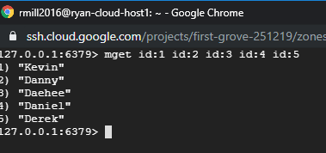

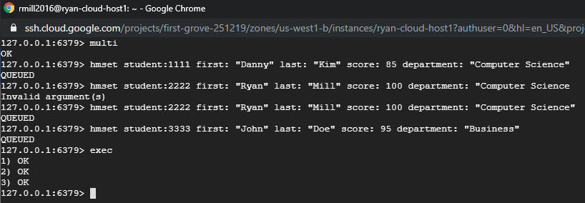

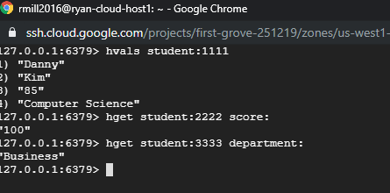

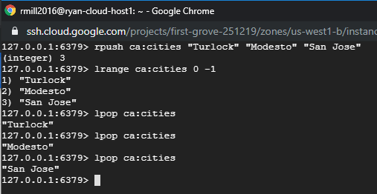

Part 2: Prepare data for employee Web service application

* For this part I needed to create a key-value database for the different salaries for students and staff in Redis. I needed to use hash key commands and sorted set commands.
* I was able to complete this part fairly easy because I just needed to review the different commands from the tutorial for sorted sets.
* I learned how to make a database for key-value using redis commands.

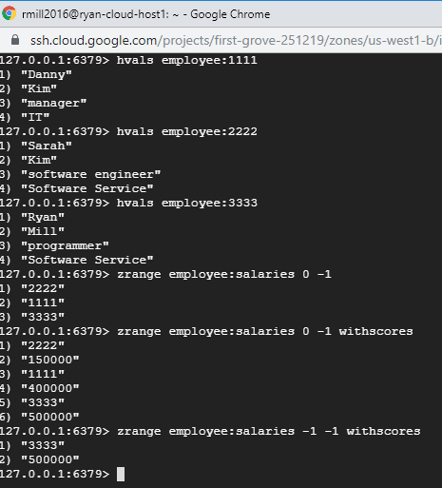

Part 3: Develop a Java Program

* For this part I needed to create a java program that is able to implement and fetch data from the redis server remotely in json data format.
* To complete this I wrote the code in java eclipse and ran that data. Unfortunately I had to transfer my previously working code to another computer, which somehow caused problems. I don’t have the screenshots of when it was working I am going to show the pictures of the problem.
* I learned how to access the redis server automatically.

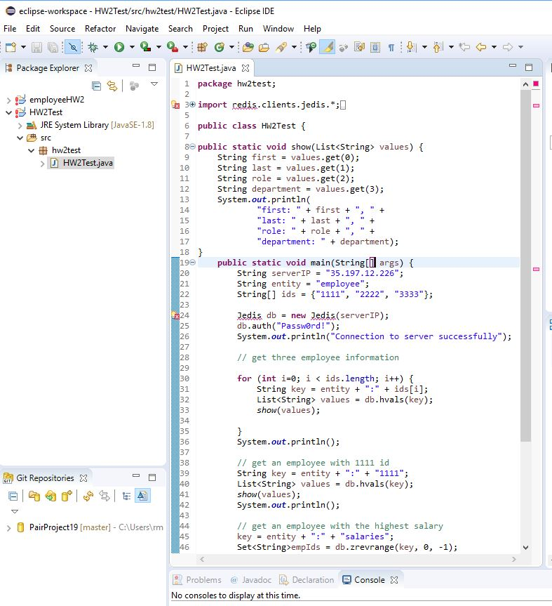

Part 4: Develop employee Web Service Application

* For this part I needed to create a web service application for employee data.
* In order to attempt to solve this I was able to code down on eclipse Enterprise as much as I could but unfortunately I had problems with getting the code to work because I had to transfer my work to another computer. I have posted the screenshots of where I am having problems.
* I learned from this section more of how to access the redis server remotely through eclipse.

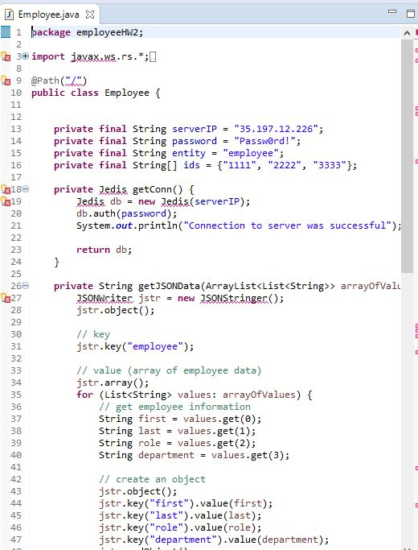

Part 5: Deploy employee web service application

* My goal for this part is just to deploy to my external ip address what I did with the employee class in eclipse.
* Unfortunately again, I had problems with getting my code to work, which I take fault because I had plenty of time to get help on getting my code to work.
* I learned from my time management mistakes to get help earlier so I do not need to try and code at the last minute.