Robert Minkler

Module 1.2

Aug 12, 2024

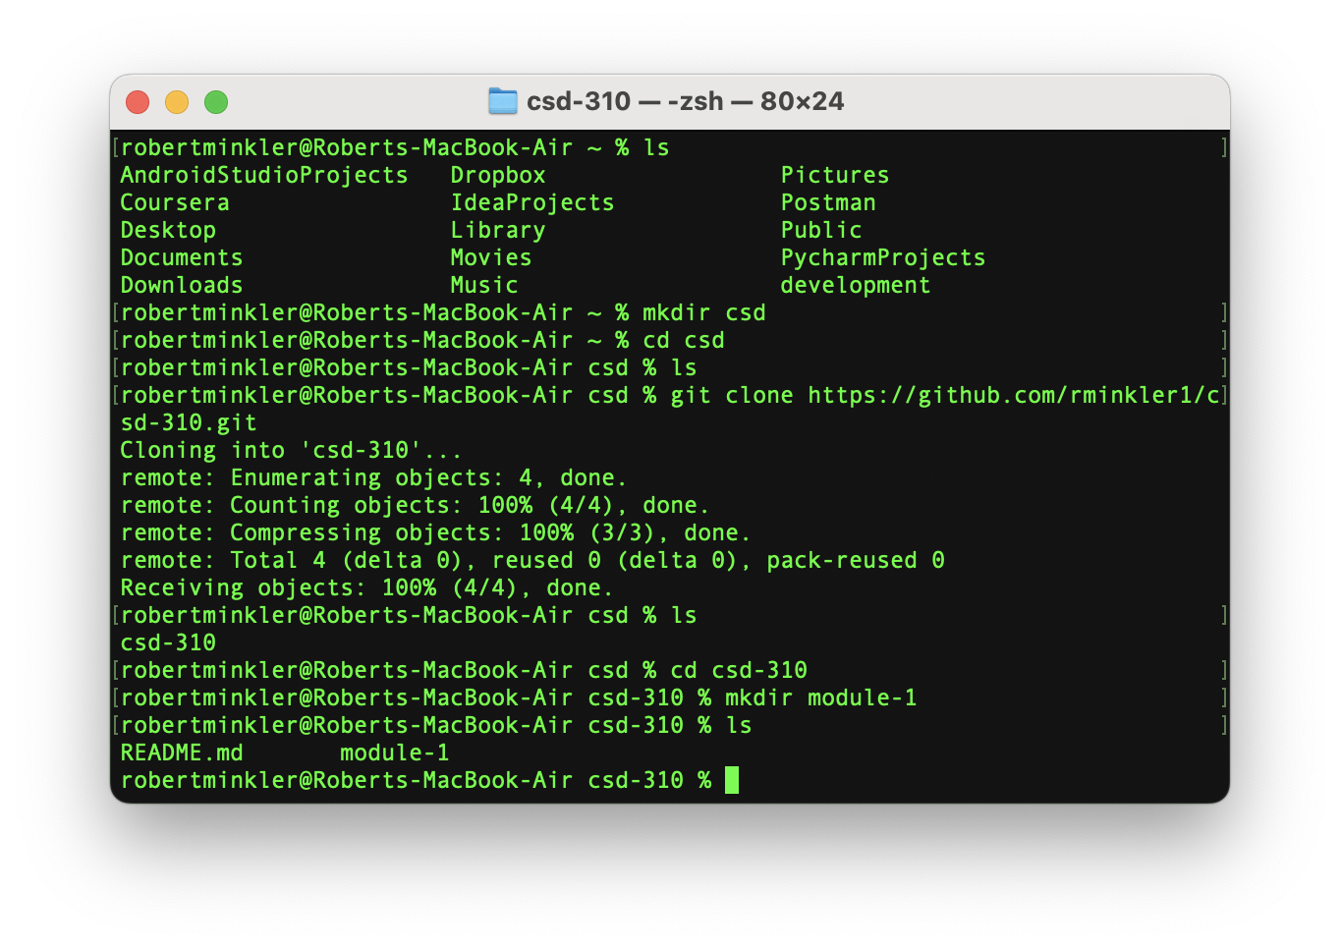

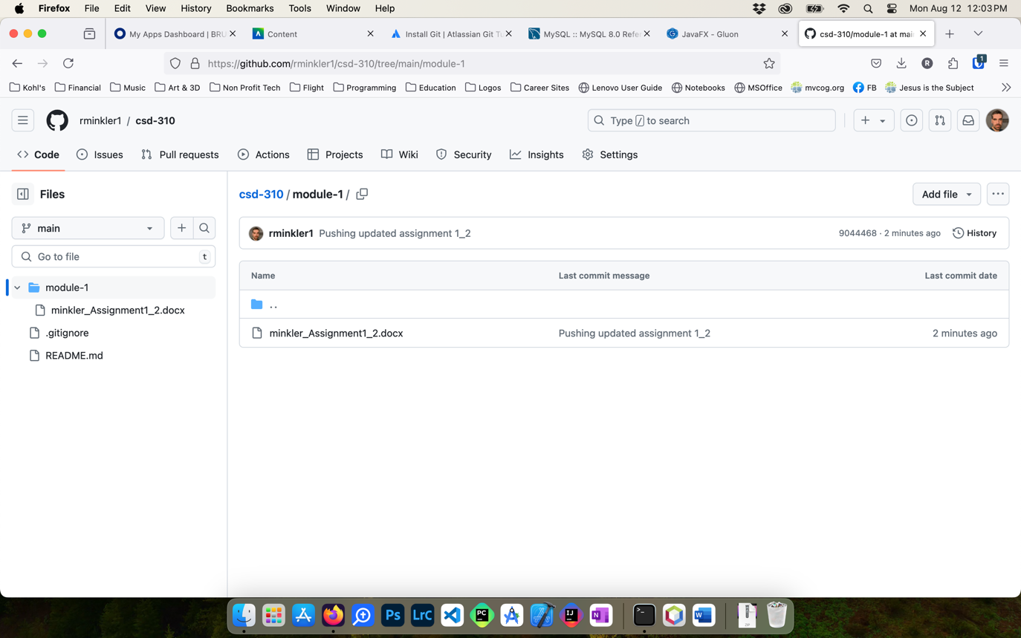

<https://github.com/rminkler1/csd-310/tree/main/module-1>