Robert Minkler

CSD 310 Assignment 5.2

MySQL Functions

September 5, 2024

CAST is a very useful command for converting data into a specified datatype. It can convert a string into a date or time object, as shown in my example. It can be used to convert data into the appropriate type before storing it in the database or to change the stored data into a new type at retrieval.

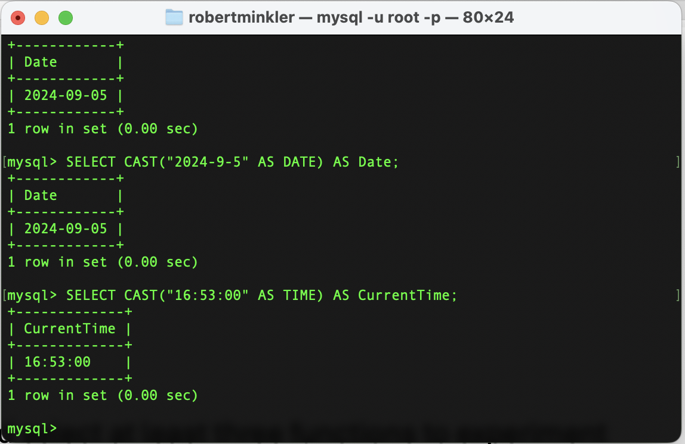

CONV is used to convert a number from one base system to another and returns the result as a string. This can be useful to convert a number between a binary (base 2), hex (base 16), or base 10 number. Colors are often stored as RGB values from 0 to 255. Some systems such as websites, will define colors using the hex values, while other systems require the values in base 10 form.

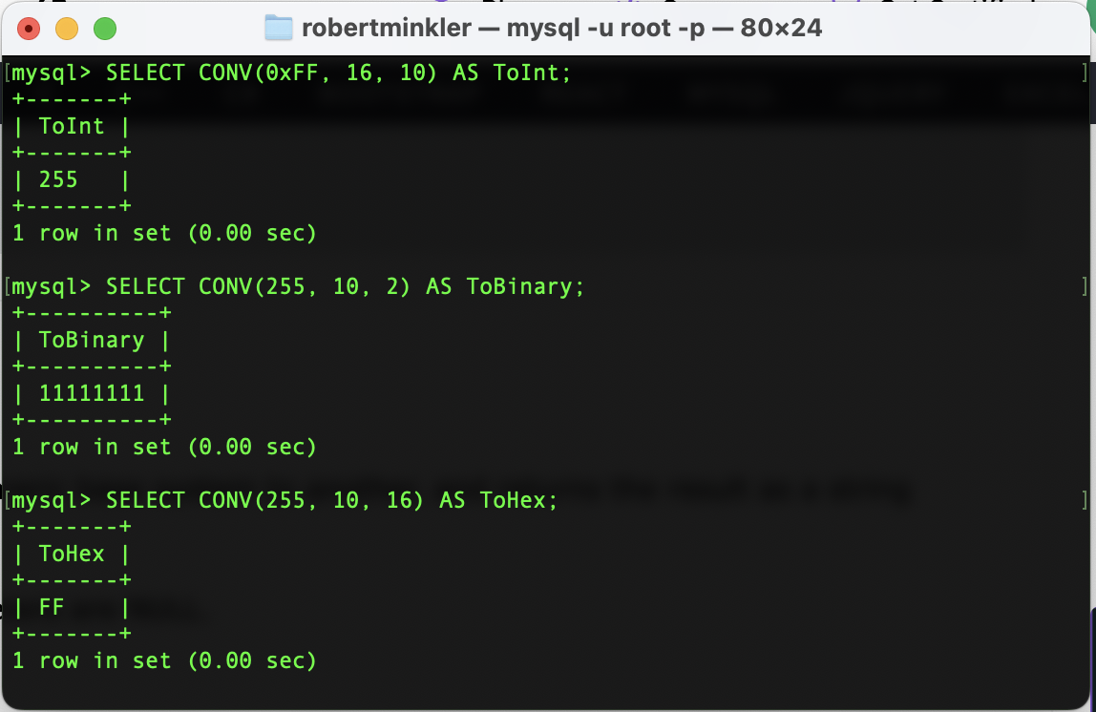

RAND() can be used to generate a pseudorandom floating point number between 0 and less than 1. It can be used to generate random numbers for a range of uses. Using some mathematical functions within the query, we can generate a random number in nearly any range we need. MySQL random numbers are not designed to be in cryptographic functions.

