Robert Minkler

CSD 310 Assignment 6.2

Movies: Setup

Sep 11, 2024

Run SQL script:

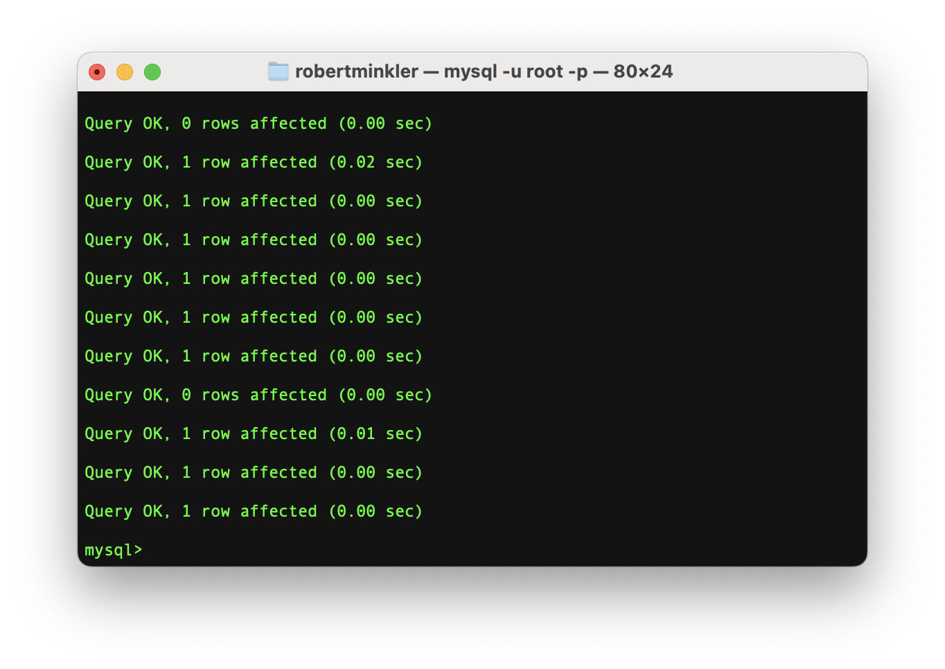

Show tables:

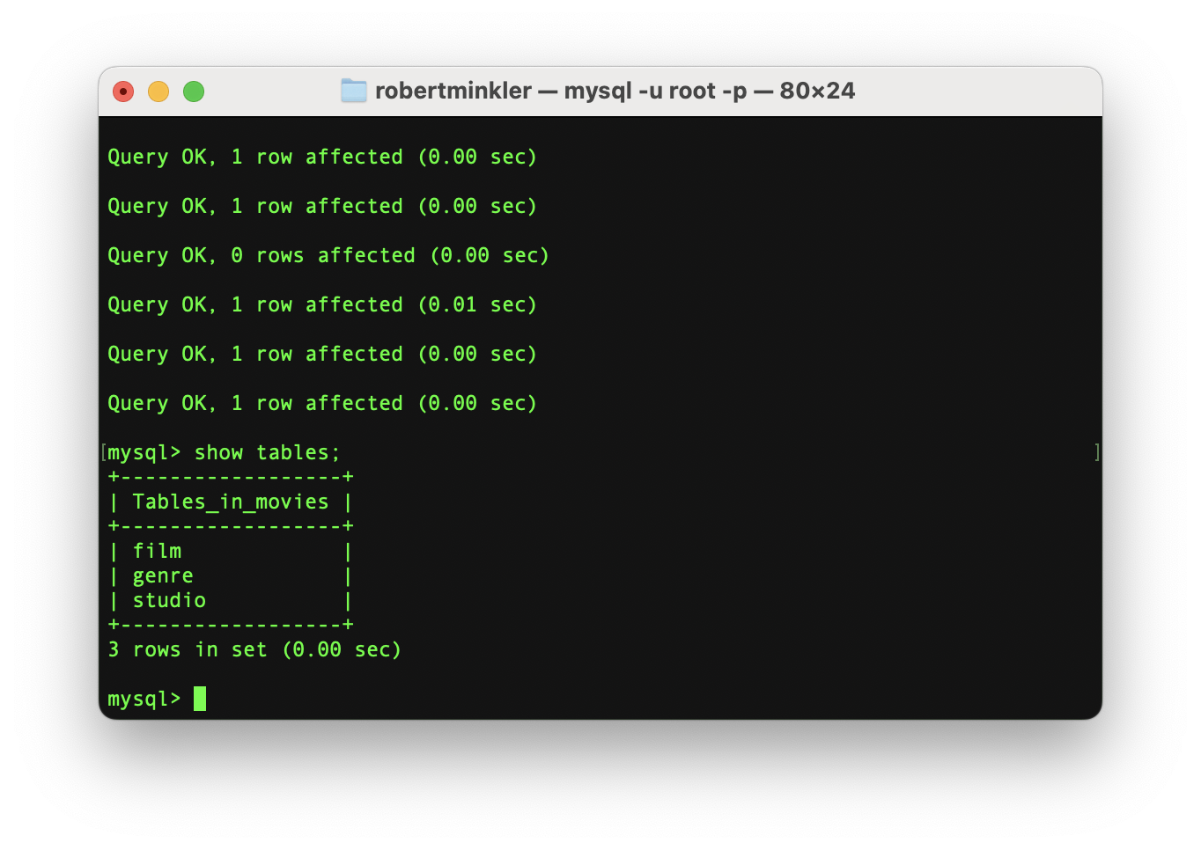

Run Python Script to connect to the database:

Github repository link:

<https://github.com/rminkler1/csd-310/tree/main/module-6>