Robert Minkler

Oct 29, 2024

Assignment 3.2

GitHub Pages

HTML Validation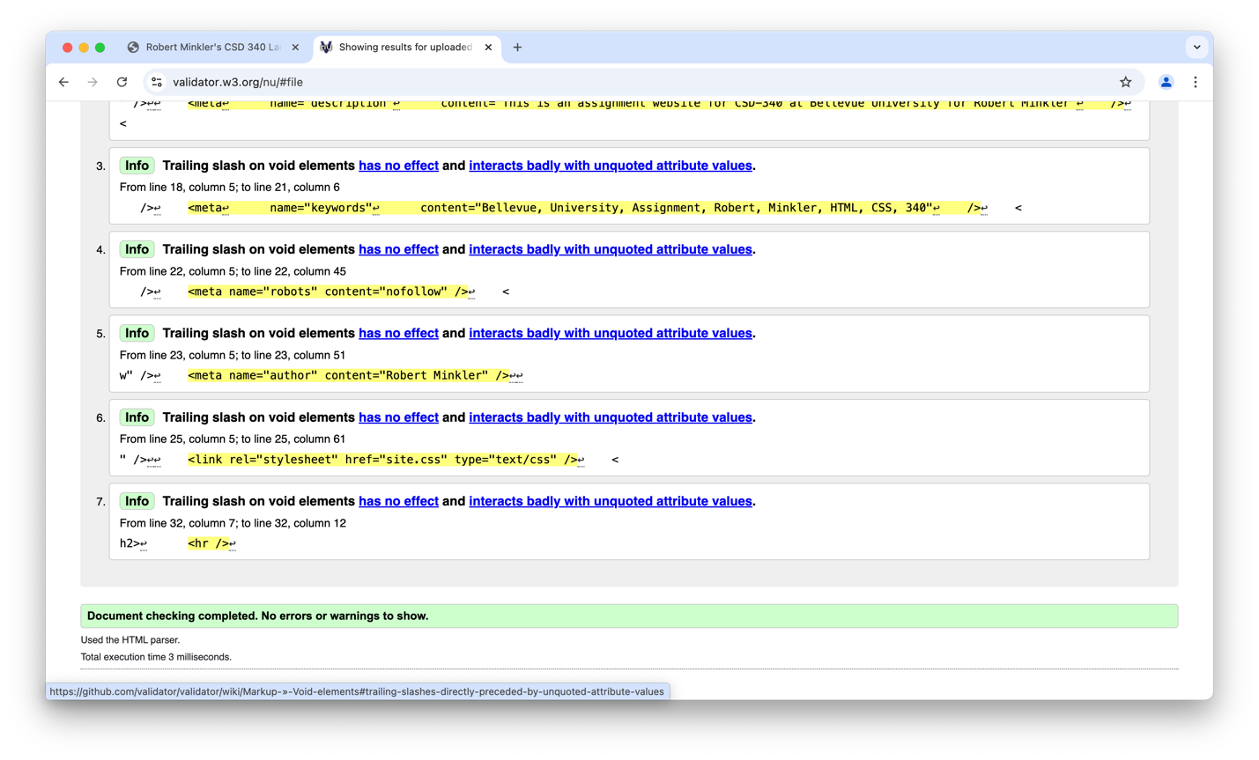

CSS Validation

