Robert Minkler

October 21, 2024

CSD 340

Assignment 1.3 - Building a Web Page Exercise, Part 1

Starter Code with Errors: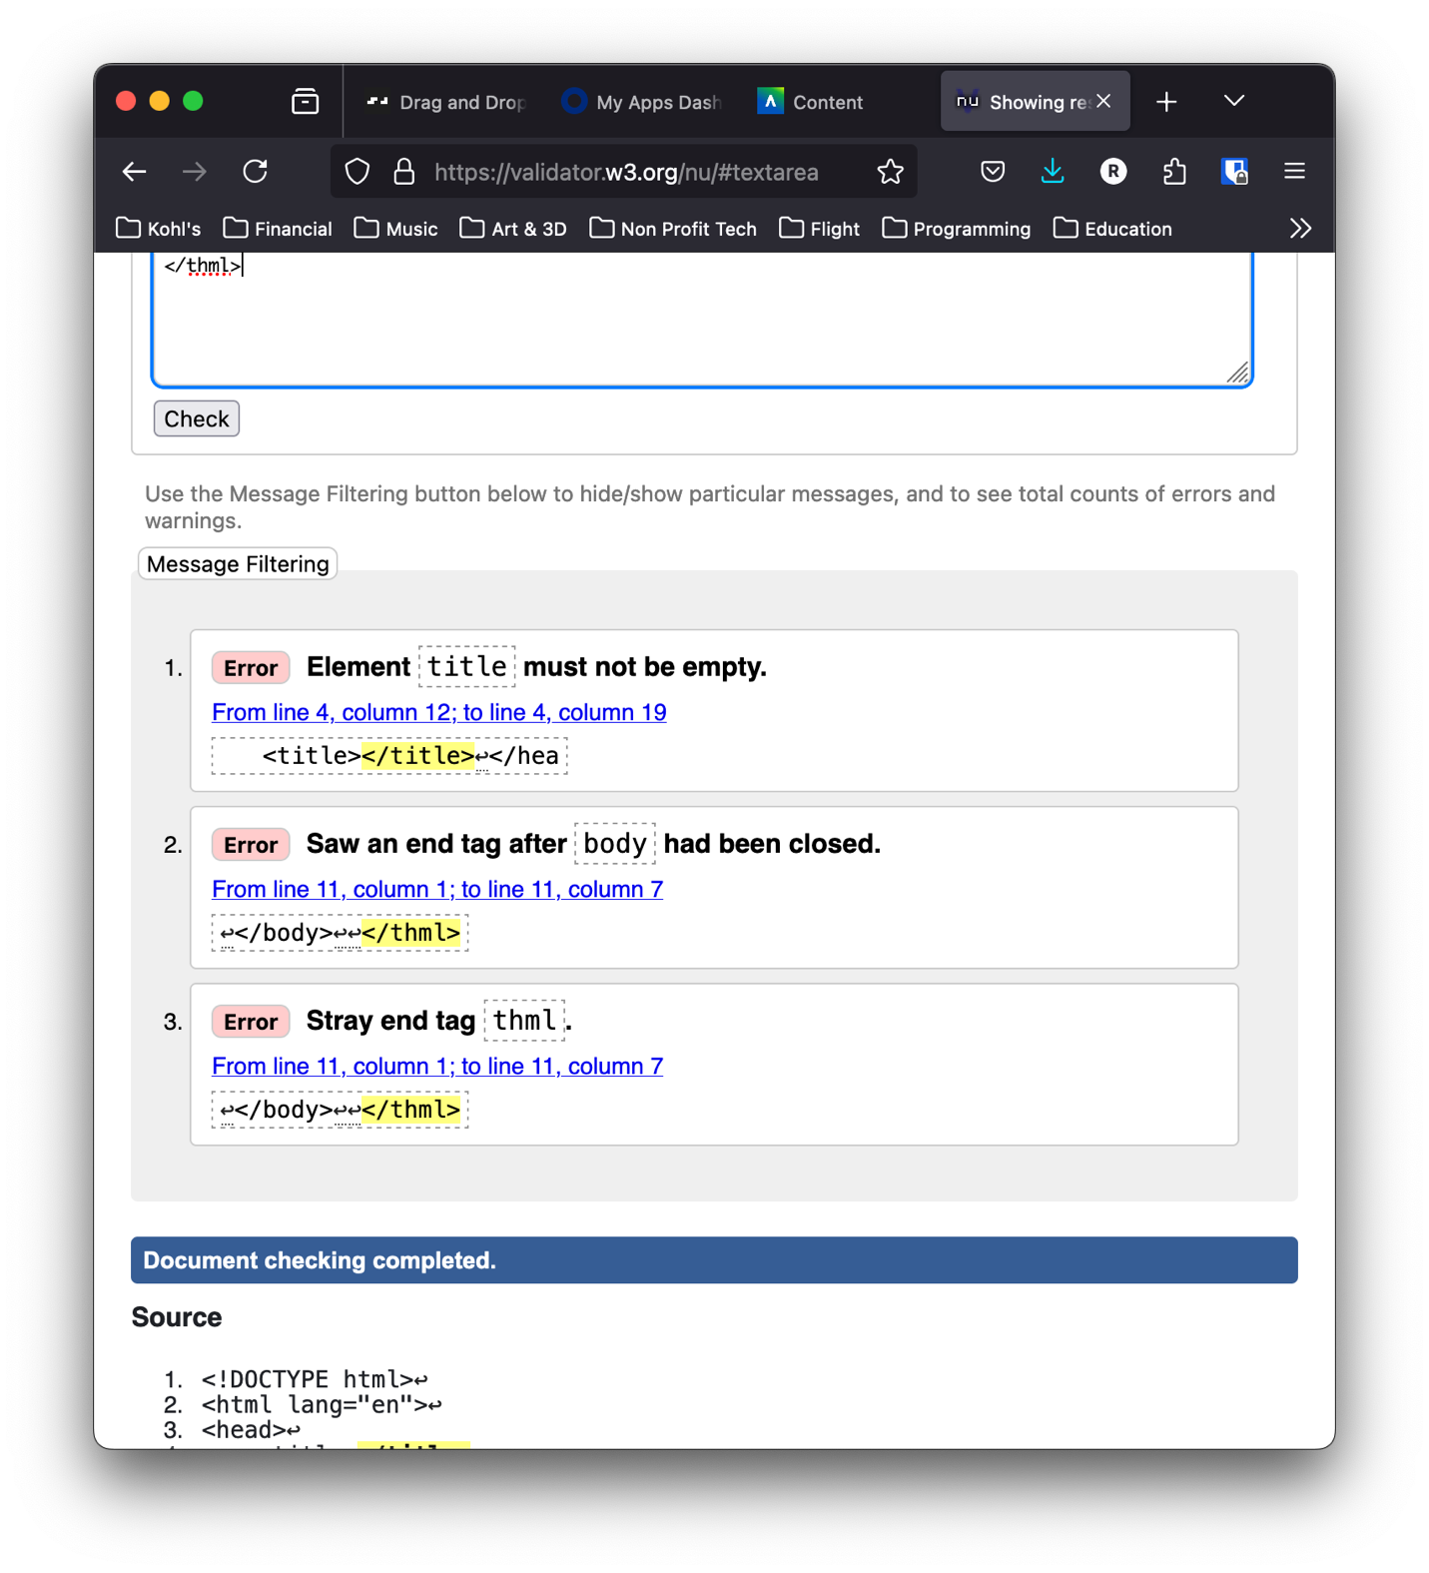

Fixed the errors: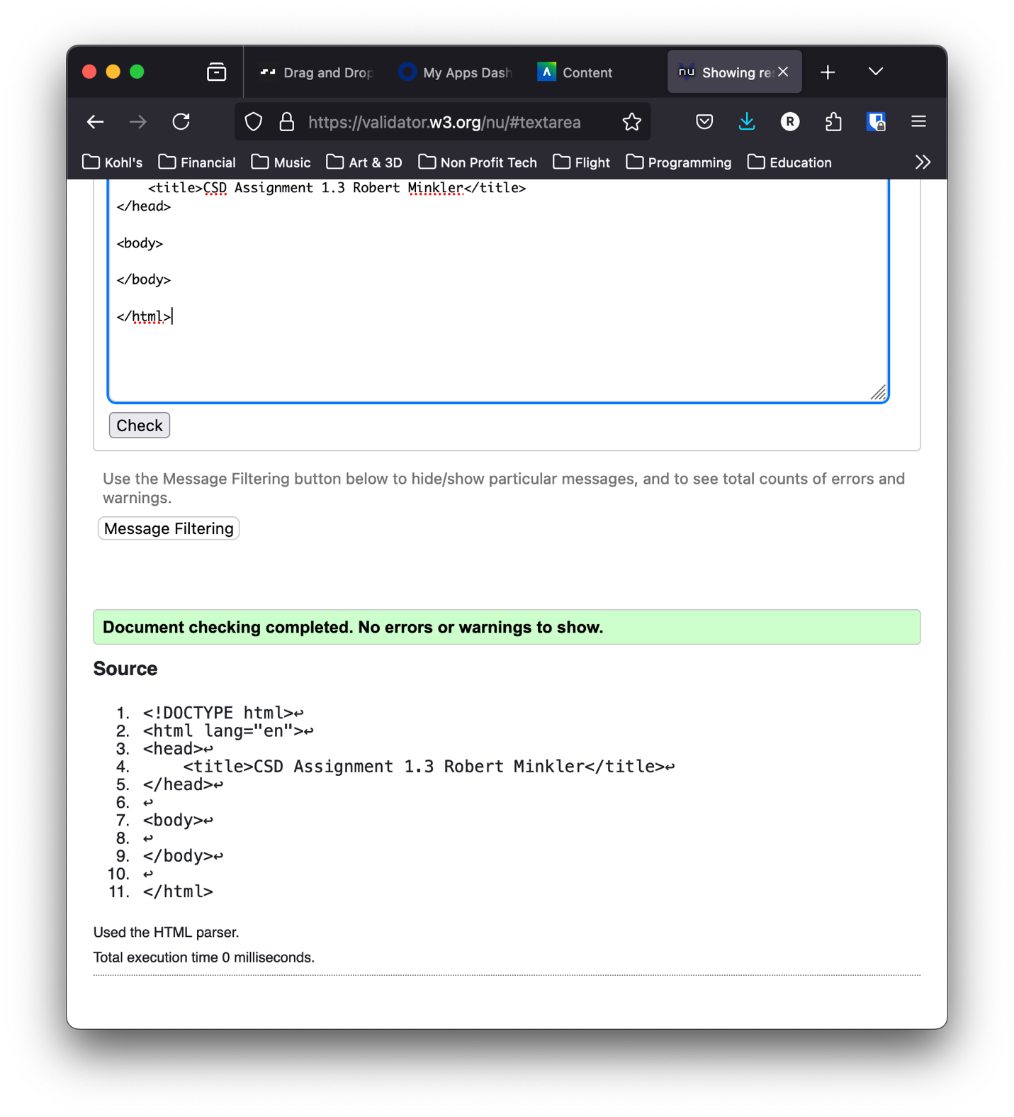

Add additional elements and revalidate: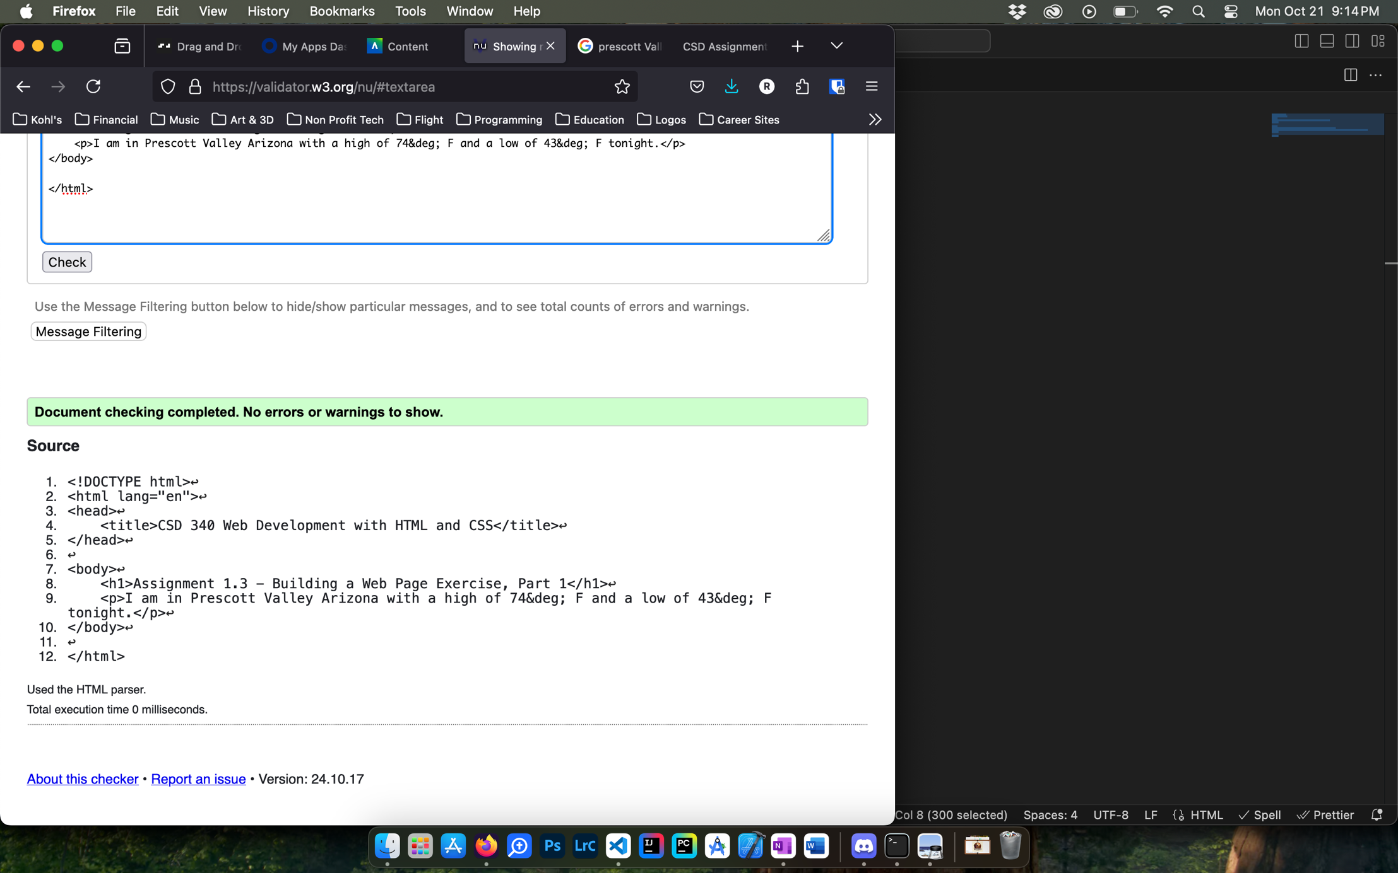

Webpage in my browser: