Robert Minkler

Oct 29, 2024

Assignment 3.2

GitHub Pages

GitHub Repository: <https://github.com/rminkler1/csd-340>

GitHub Pages: <https://rminkler1.github.io/csd-340/>

HTML Validation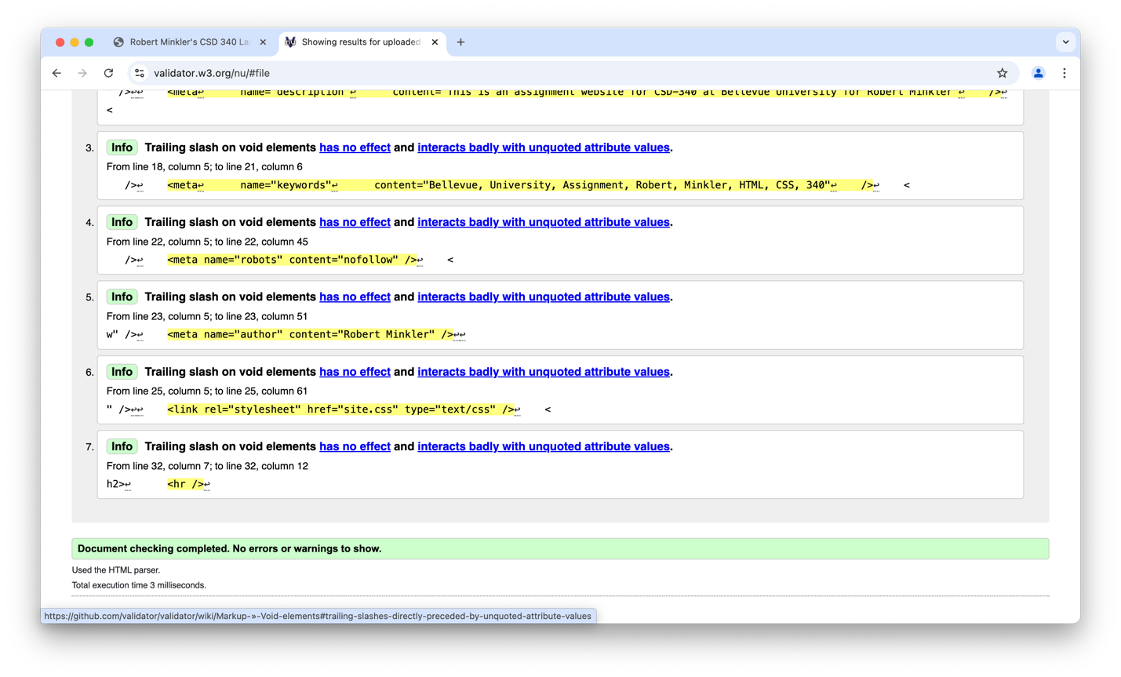

CSS Validation

