# Robert Minkler

CSD 340 Assignment 5.2

bioSite: Ideas, Sketches, and Inspiration

Nov 8, 2024

# Front-end Style Guide

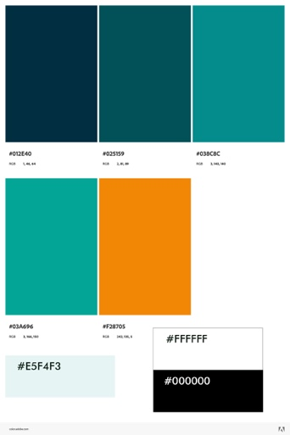

Selected Color palette

font-family: Tahoma, Helvetica, sans-serif;

Page Header at the top of all pages

Page footer at the bottom of all pages

Image Card

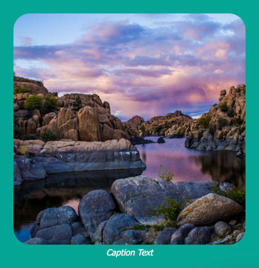Classes:

card-img

card-caption

card-figure

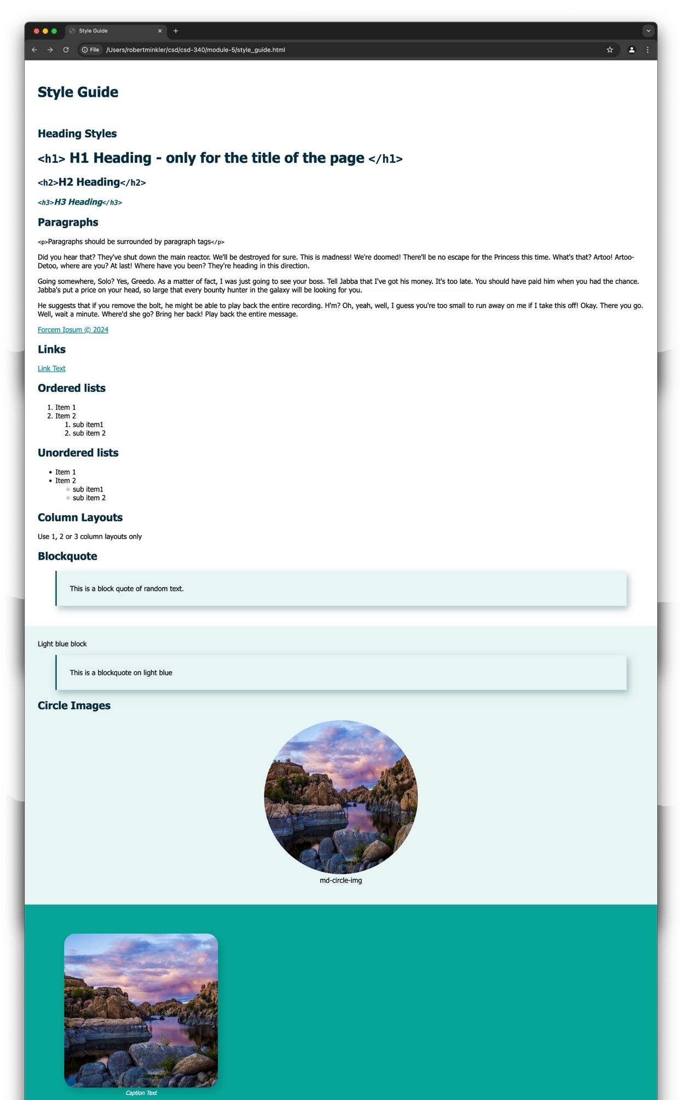

# Wireframes, sketches, or prototypes

## Landing Page

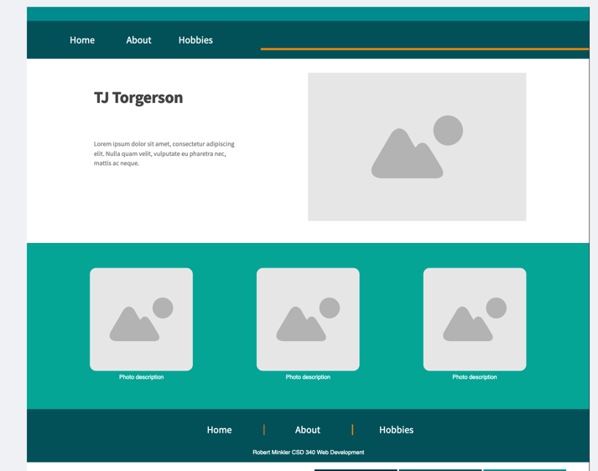

## Single column content - About

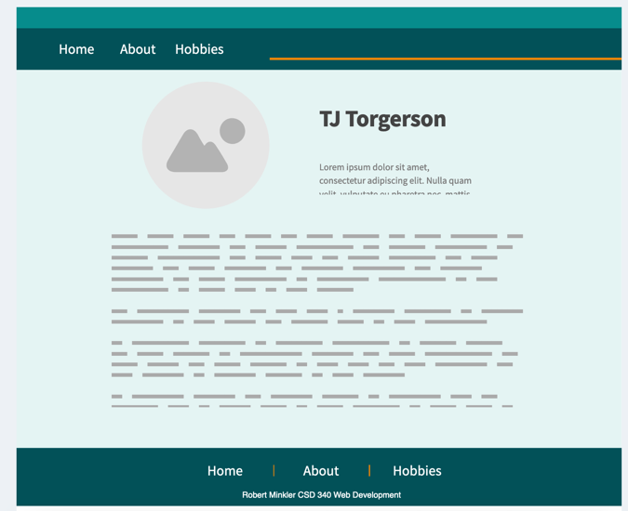

## Photo plus text - Hobbies

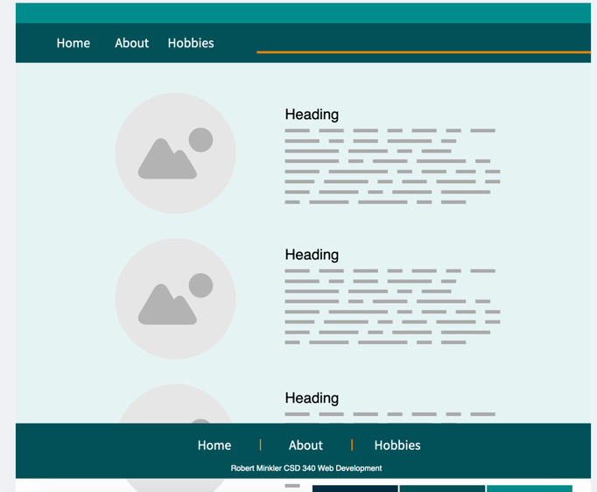

10 interview questions

1. Who are you?
   1. TJ Father of 3 Husband of one pastor executive director of Ashland Community Kitchen
2. What is an interesting fact about you?
   1. Lived in 7 states
3. What would you want a biography about you to focus on? What would you want people to know about you that they don’t already know?
   1. Pastoral Ministry stuff
4. What causes are you passionate about?
   1. Helping those in need and preaching about Jesus
5. What is your favorite part of your job as a Nazarene Pastor?
   1. Preaching, visitations, 1 on 1 mentorship, teaching
6. Tell me a little about your education history and current goals.
   1. Nazarene Bible college major in pastoral ministry and bible theology. Working towards masters in theological studies at Nazarene theological seminary
7. You recently started another position for a local charity. With two jobs, school, and a family, how do you balance all of that?
   1. I don’t. push forward.
8. What are some of your favorite pastimes or hobbies?
   1. relaxing
   2. build websites
   3. video production
   4. balloon animals
   5. board games
   6. Collecting Hobbies
   7. Doing things where I learn something
   8. Collecting Books
9. You have moved across the country over the last several years. Where have you lived, and what was your favorite place?
   1. Ashland KY
10. What is your favorite color?
    1. Blue
11. Who is the greatest superhero, and why?
    1. Superman

## a short bio of the subject

TJ Torgerson

TJ is a dedicated father of three boys, a husband, the Pastor at Summit Nazarene, the Executive Director of Ashland Community Kitchen, and a student at Nazarene Theological Seminary. He enjoys sharing about Jesus Christ through his preaching and teaching at Summit Nazarene. TJ genuinely cares about those around him to lead them to a greater hope. As the Executive Director of Ashland Community Kitchen, he works tirelessly to feed his community. Overseeing two non-profits is no small task. If that wasn’t enough, he is continuing to work toward his Master’s in Theological Studies at the Nazarene Theological Seminary so he can be better equipped to serve, lead, and teach.

He has lived in seven states, from Washington and Oregon in the West to Maine in the East, and currently resides in Ashland, Kentucky. You would think he would fall in love with the coastal cities he has lived in, yet his favorite place is Ashland, Kentucky, with Ava, Missouri, as a close second.

He stays busy with all his work responsibilities, but when he finds time, he has a wide range of hobbies and interests. You might even say that one of his hobbies is finding new hobbies that stimulate the mind.

He enjoys building websites for the organizations he works for and has his own website at <https://www.livingintheway.com/>, where he shares the message of Christ, produces an audio podcast, and shares some of the books he has self-published. He also enjoys video production, building balloon animals, and playing board games with his friends and family. He is an avid collector of books and has a wall of books covering a wide range of topics.

If you happen to find him not busy, he might be watching a superhero or Rocky movie. Superman was the first major superhero and still one of the best.

# The images you intend to use in the final project

## 3 Images should be related to the subject's hobbies



Building Balloon Animals

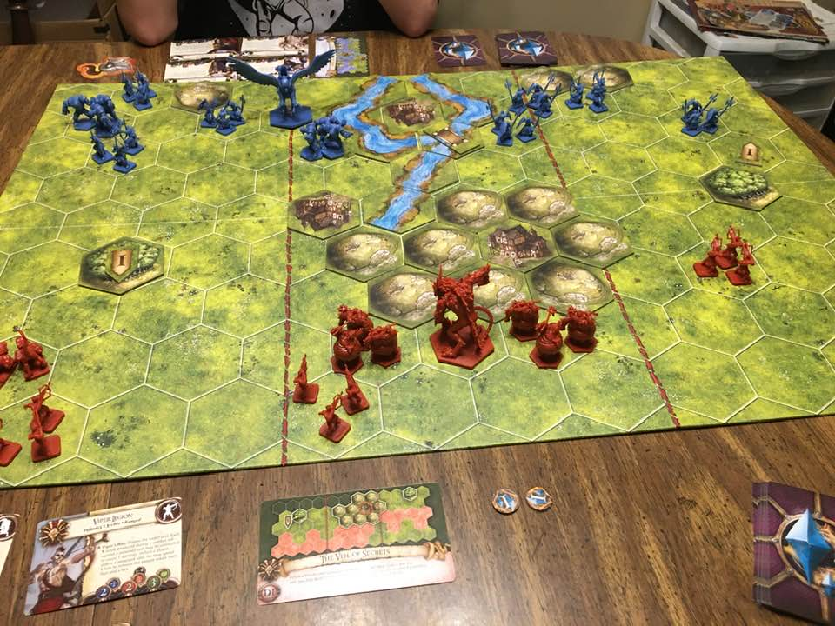

Playing Boardgames with family and friends.

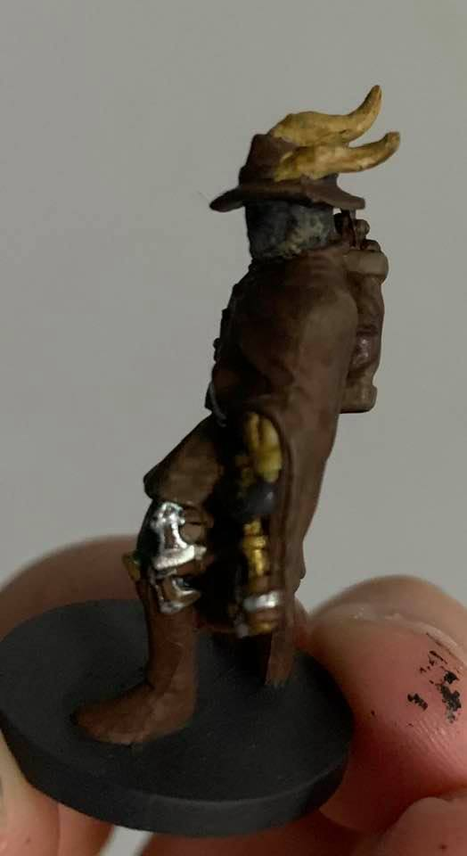

Painting a figurine for a boardgame3 images should be related to the subject’s goals, personal accomplishments, or embellishments

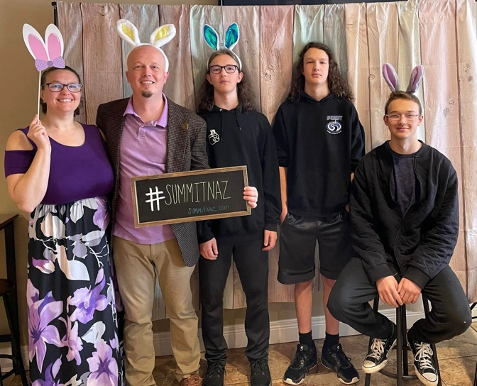

Family

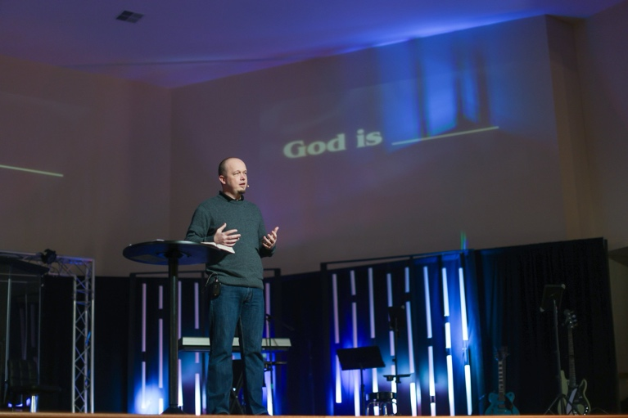

Preaching at Summit Naz

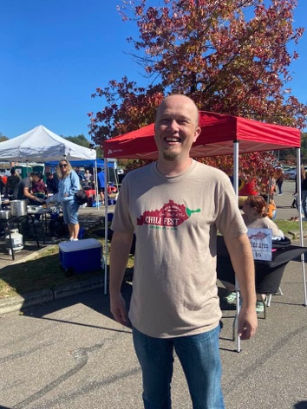

Chili event raising funds for Ashland Community Kitchen

## 1 image should be a portrait of the subject

